

**Assessment Cover Page**

|  |  |
| --- | --- |
| *Student Full Name: Cristhian Elson Pereira Macedo* |  |
| *Student Number: 2024104* |  |
| *Module Title: Statistical Techniques for Data Analysis* |  |
| *Assessment Title: CA1* |  |
| *Assessment Due Date: Sunday, 21st April 2024, 11:59 PM* |  |
| *Date of Submission: Sunday, 21st April 2024, 11:57 PM* |  |

**Declaration**

By submitting this assessment, I confirm that I have read the CCT policy on academic misconduct and understand the implications of submitting work that is not my own or does not appropriately reference material taken from a third party or other source.

I declare it to be my own work and that all material from third parties has been appropriately referenced.

I further confirm that this work has not previously been submitted for assessment by myself or someone else in CCT College Dublin or any other higher education institution.



**Spotify and YouTube Stream Analyses**

**Cristhian Elson Pereira Macedo**

**2024104**

Higher Diploma in Science in Data Analytics for Business

Statistical Techniques for Data Analysis (StatsDA)

Lecturer: Kayoum Khbuli

CCT College Dublin

Dublin, Ireland

2024



**SUMMARY**

Table of Figures AND TABLES v

1. Introduction 9

2. Data Understanding 9

2.1 Importing Libraries 9

2.2 Loading Data 9

2.3 Inspecting the Data Set 9

2.4 Checking types of data 12

3. DATA PREPARATION 13

3.1 Finding Unique Values 13

3.2 Replacing Values (Syntax errors) 15

3.3 Dropping Irrelevant Columns 16

3.4 Renaming Columns 16

3.5 Handling Missing Values 16

3.6 Imputing Missing Values 18

3.7 Handling Duplicate Rows 18

3.8 Type Conversion 18

3.9 Relationships 19

3.10 Statistical Analysis 22

3.11 Dealing Outliers 49

3.12 Scaling / Transformation 51

3.13 Creating Dummies 60

4. MACHINE LEARNING - UNSUPERVISED LEARNING 60

4.1 Principal Component Analysis (PCA) 60

4.2 Creating examples to predict 62

4.2.1 Preparing for Analyses 68

4.2.2 PCA 69

5. CONCLUSIONS 75

6. DATA DICTIONARY 76

References 78

# **Table of Figures AND TABLES**

*Figure 1. Head of the dataset*

*Figure 2. The shape of the dataset.*

*Figure 3. Info of the dataset.*

*Figure 4. Describe of the dataset.*

*Figure 5. Types of features in the dataset.*

*Figure 6. Unique values of Album_type features.*

*Figure 7. Feature’s name of the data.*

*Figure 8. Value counts of Album_type feature.*

*Figure 9. Null values of the features.*

*Figure 10. Percentage of null values of the features.*

*Figure 11. Matrix graphic of the amount of null values between the features.*

*Figure 12. Replacing text values.*

*Figure 13. Removing symbols values.*

*Figure 14. Dropping and head of the features.*

*Figure 15. Renaming and head of the features.*

*Figure 16. The approach was chosen to handle missing values.*

*Figure 17. Matrix graphic of the amount of null values of the features.*

*Figure 18. Checking duplicated observations.*

*Figure 19. Checking the type of features.*

*Figure 20. Code to get the relationships of the features.*

*Figure 21. Heatmap of relationships between the features.*

*Figure 22. kdeplot showing the density of Valence and Energy features.*

*Figure 23. kdeplot showing the density of the Energy feature in comparison to the Album Type.*

*Figure 24. pairplot showing all feature points and their respective connections.*

*Figure 25. displot of Danceability distribution feature.*

*Figure 26. displot of Energy distribution feature.*

*Figure 27. displot of Loudness distribution feature.*

*Figure 28. displot of Speechiness distribution feature.*

*Figure 29. displot of Acousticness distribution feature.*

*Figure 30. displot of Instrumentalness distribution feature.*

*Figure 31. displot of Liveness distribution feature.*

*Figure 32. displot of Valence distribution feature.*

*Figure 33. displot of Tempo distribution feature.*

*Figure 34. displot of Duration (milliseconds) distribution feature.*

*Figure 35. displot of Views distribution feature.*

*Figure 36. displot of Likes distribution feature.*

*Figure 37. displot of Comments distribution feature.*

*Figure 38. displot of Stream distribution feature.*

*Figure 39. boxplot of all numeric features.*

*Figure 40. boxplot of Danceability, Energy, Loudness, Speechiness, Acousticness, Instrumentalness, Liveness features.*

*Figure 41. boxplot of Valence, Tempo, Duration (milliseconds), Views, Likes, Comments, Stream features.*

*Figure 42. histplot of the frequency of Album type between album, single or compilation albums.*

*Figure 43. pie of the frequency of Album type between album, single or compilation albums.*

*Figure 44. scatter plot of Views and Likes distribution.*

*Figure 45. scatter plot of Views and Likes distribution using plotly.express.*

*Figure 46. scatter plot of Views and Comments distribution.*

*Figure 47. scatter plot of Views and Comments distribution using plotly.express.*

*Figure 48. histogram plot of the most views on YouTube by Artist using plotly.express.*

*Figure 49. treemap of the most Stream on Spotify by Artist using plotly.express.*

*Figure 50. table of the sum of the most Streams on Spotify by Artist.*

*Figure 51. Statistical results of the feature Danceability.*

Figure 52. boxplot of all features before handling outliers.

Figure 53. Interquartile technique to handling outliers.

Figure 54. shape of df and df_outliers.

Figure 55. boxplot of all features after handling outliers.

Figure 56. New data frames to analyse scalation and outliers.

Figure 57. boxplot of df_MinMaxScaler scaled.

Figure 58. boxplot of df_StandardScaler scaled.

Figure 59. boxplot of df_Normalisation scaled.

Figure 60. boxplot of df_RobustScaler scaled.

Figure 61. boxplot of df_MinMaxScaler scaled and dealt with outliers.

Figure 62. boxplot of df_StandardScaler scaled and dealt with outliers.

Figure 63. boxplot of df_Normalisation scaled and dealt with outliers.

Figure 64. boxplot of df_RobustScaler scaled and dealt with outliers.

Figure 65. Head of df_scaled after scaled and dealt with outliers.

Figure 66. Dummies in Album Type feature.

Figure 67. no_label variable getting all numerical features.

Figure 68. PCA plot.

Figure 69. PCA transform code.

Figure 70. PCA 7 components variance ratio.

Figure 71. len of df Artist feature.

Figure 72. df_analysis head.

Figure 73. Head of Top 10 artists.

Figure 74. sort_values of the most Artists on Stream value.

Figure 75. Statistical values of Views, Likes, Comments and Stream.

Figure 76. Statistical values of Views, Likes, Comments and Streams in ascending order.

Figure 77. Algorithm chosen using sort_values.

Figure 78. stream_values feature.

Figure 79. array_stream array.

Figure 80. Result of min values of array_stream.

Figure 81. New feature Top_Tracks.

Figure 82. New df Head.

Figure 83. scatterplot of Views and Likes as Top_Tracks hue.

Figure 84. Dealing outliers.

Figure 85. Scaling df_pred data frame and plotting with boxplot.

Figure 86. Head of df_pred data.

Figure 87. PCA algorithms.

Figure 88. Head of df_pca Data Frame.

Figure 89. Head of df_pca Data Frame with Top_Tracks.

Figure 90. df_pca checking null values.

Figure 91. df_pca after dropping null values.

Figure 92. df_array of df_pca.

Figure 93. Splitting the data into train and test.

Figure 94. Importing new classes, libraries and so on.

Figure 95. models of Machine learning algorithms.

Figure 96. Results of Machine Learning algorithms.

Figure 97. boxplot off Machine Learning algorithms results.

Figure 98. model of Decision Tree Classifier.

Figure 99. Score of validation and predictions.

Figure 100. Confusion matrix of validation and predictions.

Figure 101. Classification report of validation and predictions.

Table 01. Table of statistical math and their respective formulas.

# **Introduction**

This project there is goal to complete the first Assessment Task for the module Statistical Techniques for Data Analysis from the course Higher Diploma in Science in Data Analytics for Business by CCT College Dublin. This project will address an Exploratory Data Analysis focused on statistics analyses in the “Spotify and YouTube” dataset available on the Kaggle platform on [this link](https://www.kaggle.com/datasets/salvatorerastelli/spotify-and-youtube/data), also creating an example to predict hypotheses using machine learning and more.

This data set has a usability of 10.00 marked on the website, using the license: CC0: Public Domain, “Dataset of songs of various artist in the world and for each song is present: Several statistics of the music version on spotify, including the number of streams; Number of views of the official music video of the song on youtube.” (Marco Guarisco, Marco Sallustio and Salvatore Rastelli, 2023).

# **Data Understanding**

In this first stage, it will cover the first impressions and analyses of the chosen data set.

# **Importing Libraries**

The first step before starting the analyses is importing the required libraries to use such as pandas to manipulate the data, also importing numpy, seaborn, matplotlib and sklearn libraries to be read once it is needed, in case it needs other libraries will be imported when necessary it comes.

# **Loading Data**

Loading the data set “.csv” file using the pandas function “.read_csv” into the data frame whose name is “df” to import the data set to the .ipynb notebook document, named CristhianMacedo_StatisticalTecHDip_CA1.ipynb using Jupyter Notebook and Anaconda Navigator.

# **Inspecting the Data Set**

After using the command “.head()” to get the first impression of the data showing the first 5 observations as default in this case, returning that this dataset has 28 columns (features), a content data dictionary is available on this document in the Data Dictionary section describing what each feature means with their respective names.

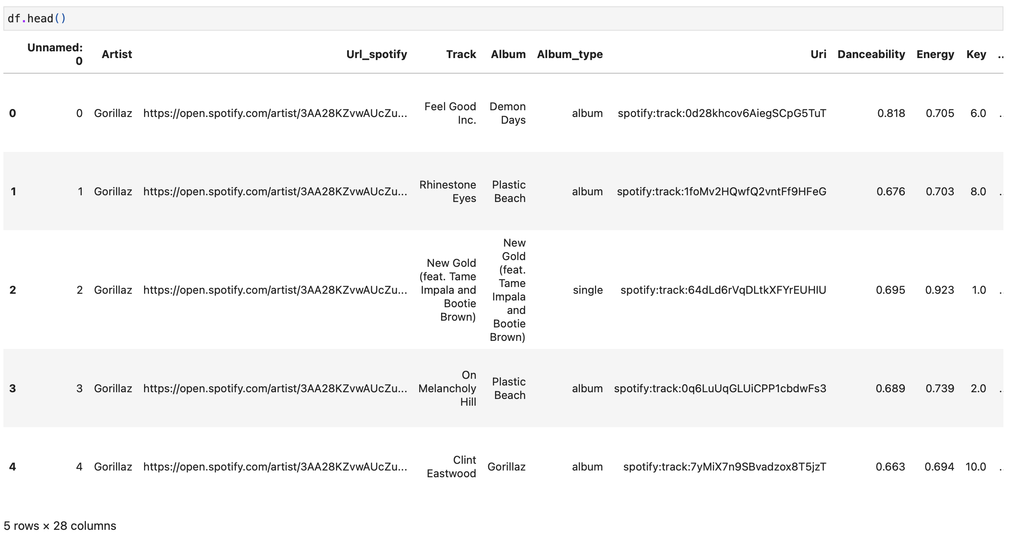

*Figure 1. Head of the dataset.*

Using the command “.shape” shows us the shape of this data set in this case 20718 observations (rows) and 28 features (columns), also using “.info()” to get a concise summary of the Data frame.



*Figure 2. The shape of the dataset.*

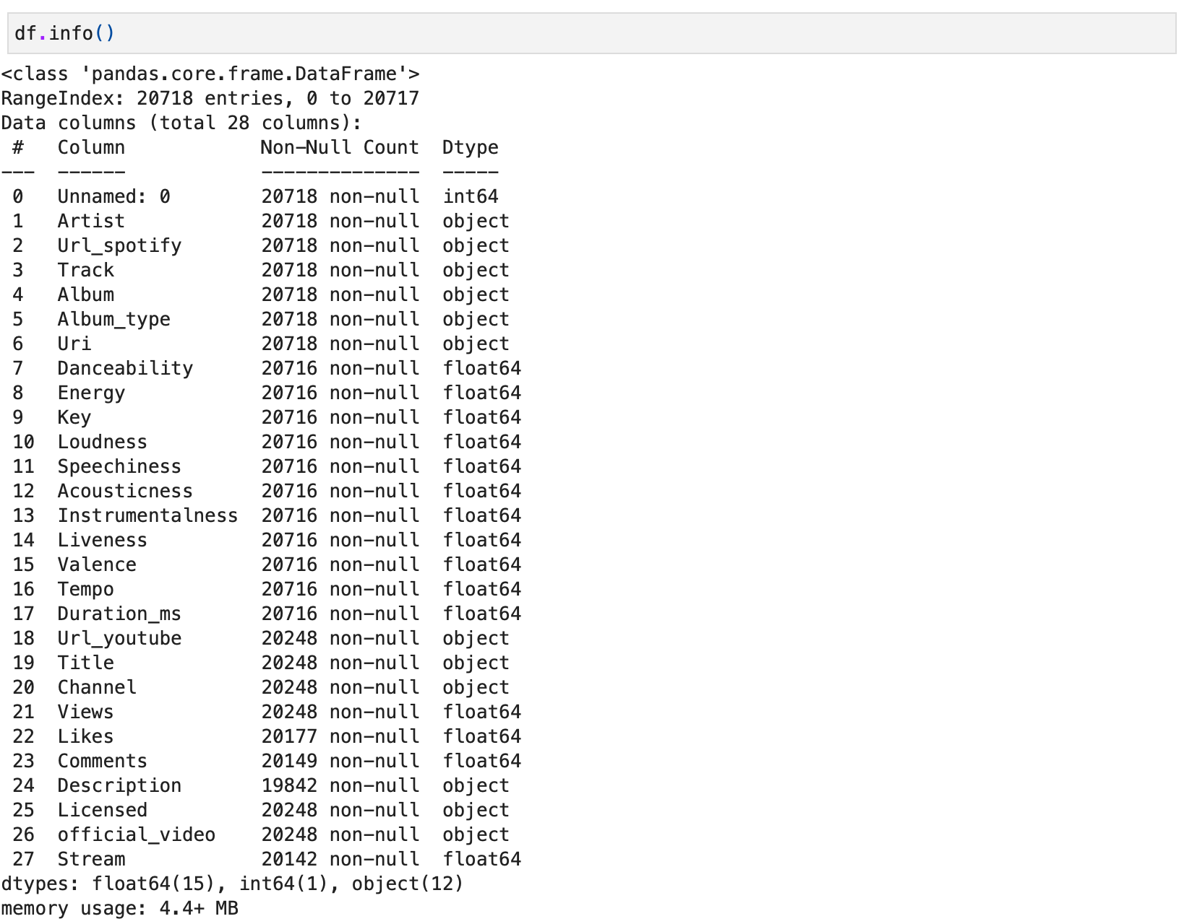

*Figure 3. Info of the dataset.*

The ".describe()" function shows us a little more about each feature, we can see statistics information about count, mean, standard deviation, min, Q1 25%, Q2 50%, Q3 75% and max for each numerical feature.

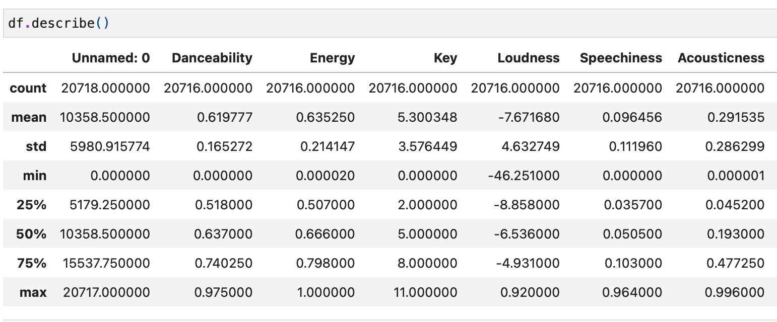

*Figure 4. Describe of the dataset.*

Also left a commented code to show a good Profile Report about the data set itself with an overview, alert and reproduction of it, containing information about EDA, if there are or not missing cells, duplicated rows, variable types, Mean, Max, Min, Negative and Zero values, memory size and so on, graphics of the distribution, the command “pip install ydata-profiling” is required to use this.

# **Checking types of data**

In the types of data checking, it was used the command “dtypes()” to get information on each feature with their respective data types.

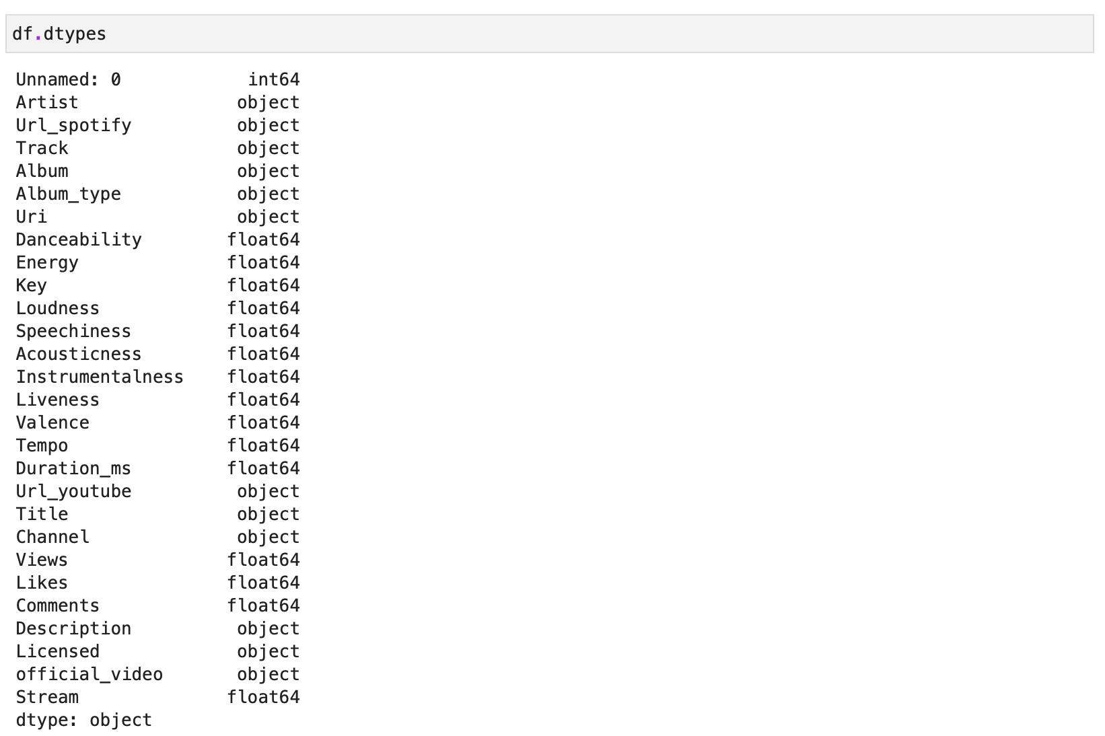

*Figure 5. Types of features in the dataset.*

Also used the command “.unique()” to get the unique values of the features to understand better.



*Figure 6. Unique values of Album_type features.*

Until here these commands were essential to understand the data set and get more info, this data frame has 20718 observations and 28 features to be analysed, looks like there are no different data types as described in the data dictionary at the end of this document.

# **DATA PREPARATION**

Now more familiar with the data set it is time to prepare the data set and make some analyses and more.

# **Finding Unique Values**

Used the command “.columns” to get all feature names to use in the next steps.

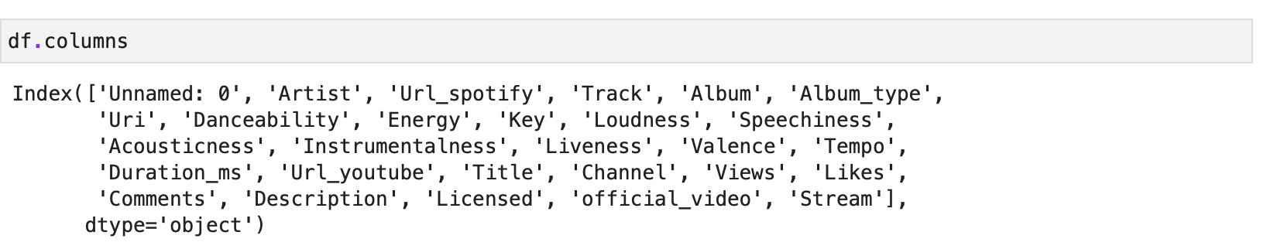

*Figure 7. Feature’s name of the data.*

Next the method ".value_counts()" was used to "Return a Series containing the frequency of each distinct row in the Dataframe." (The Pandas Development Team, 2024d), it was helpful to use in classification features to understand better what was going on, also used “.unique()” to check the values together with.

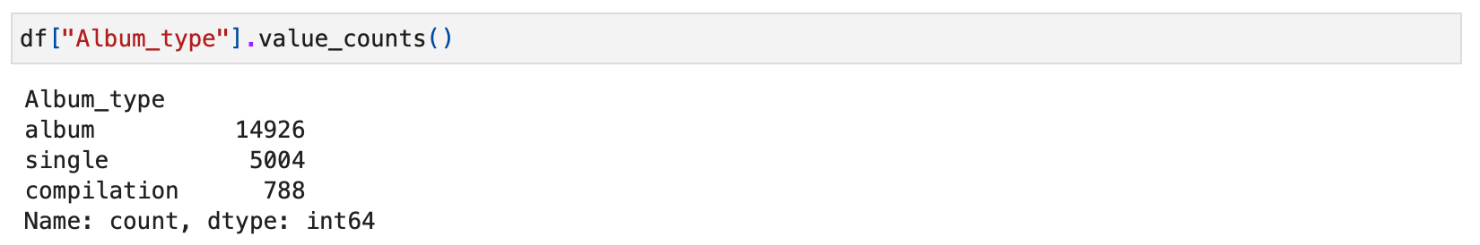

*Figure 8. Value counts of Album_type feature.*

It uses the command “.isnull().sum()” to get the amount of any missing values existent. In this case the features: (Danceability, Energy, Key, Loudness, Speechiness, Acousticness, Instrumentalness, Liveness, Valence, Tempo, Duration_ms, Url_youtube, Title, Channel, Views, Likes, Comments, Description, Licensed, official_video, Stream) all of them there are some missing values.

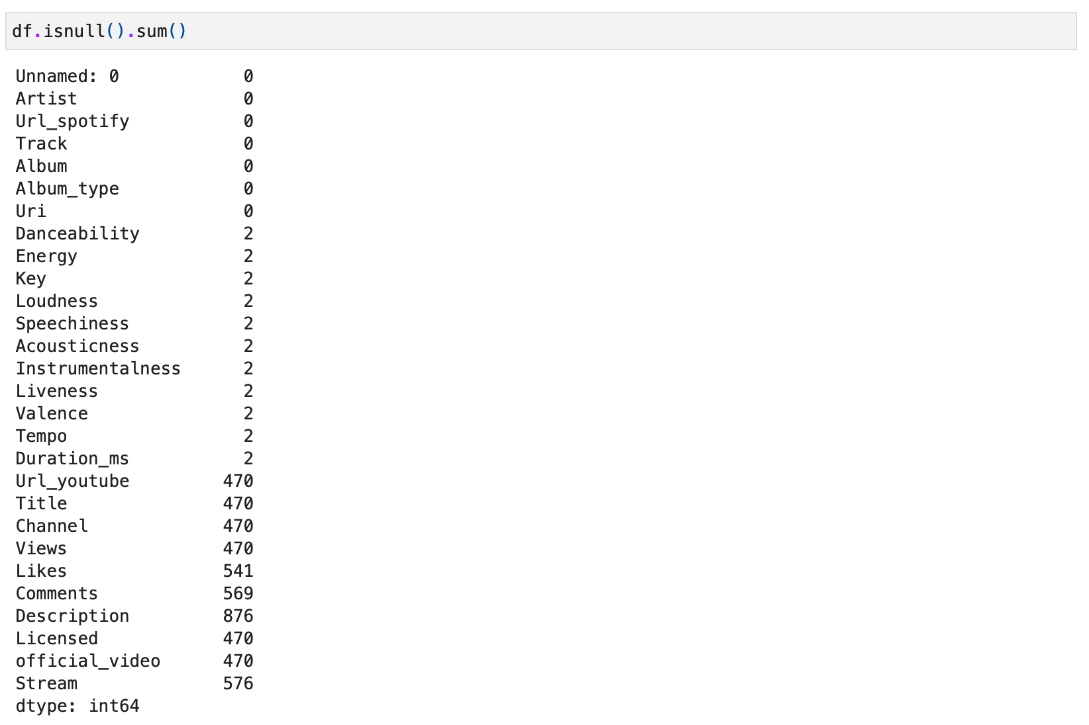

*Figure 9. Null values of the features.*

Next use “.isnull().mean() * 100” to get the percentage of data missing.

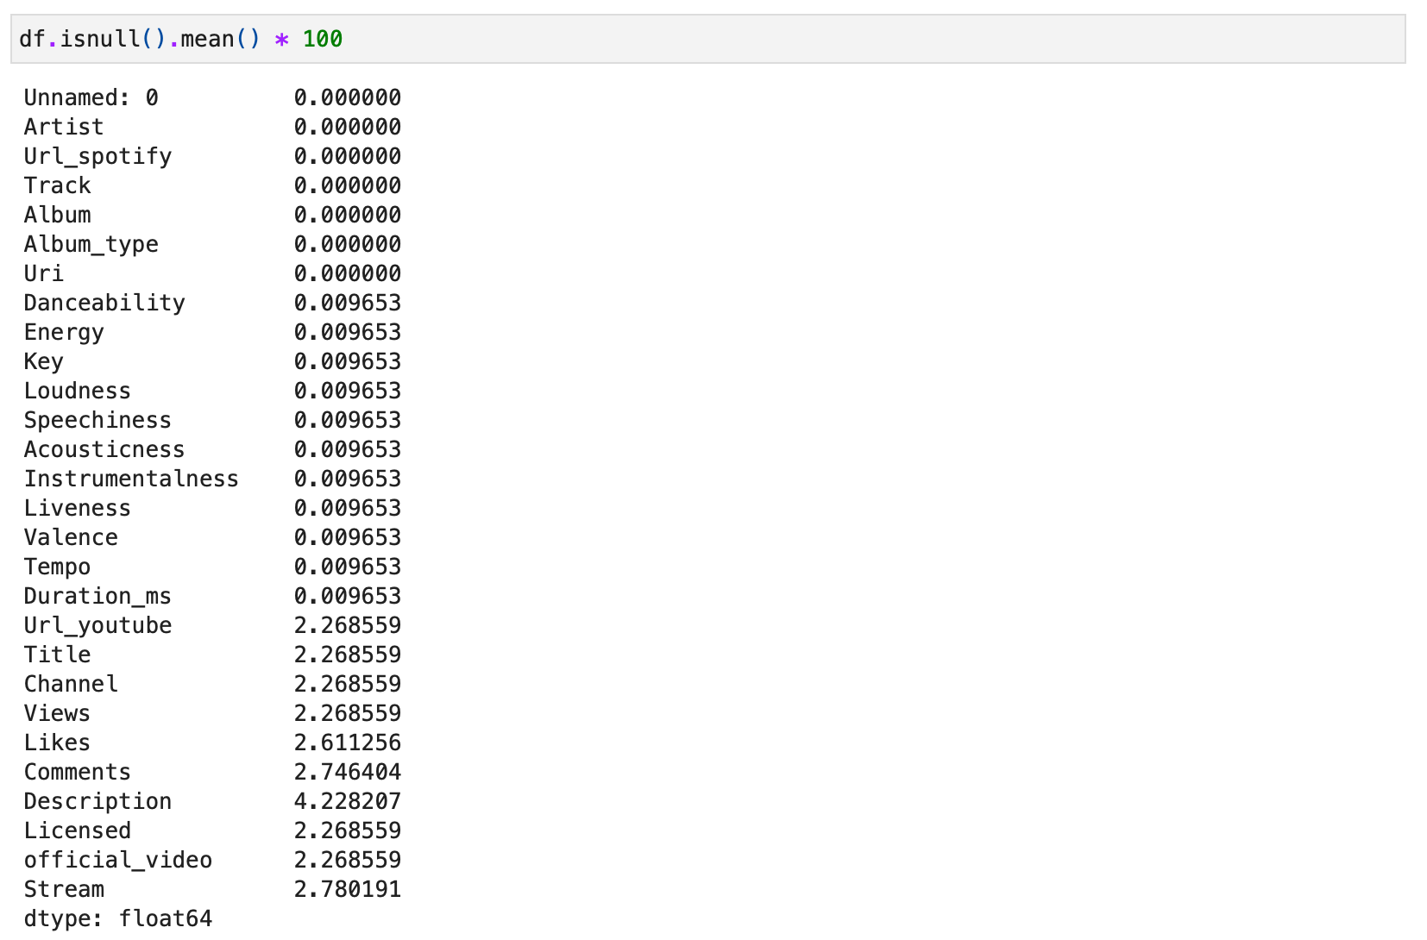

*Figure 10. Percentage of null values of the features.*

And to better visualize in graphic it was used in a matrix graphic imported from missingno library that shows us the features missing values, required the installation of missingno using the code “pip install missingno”.

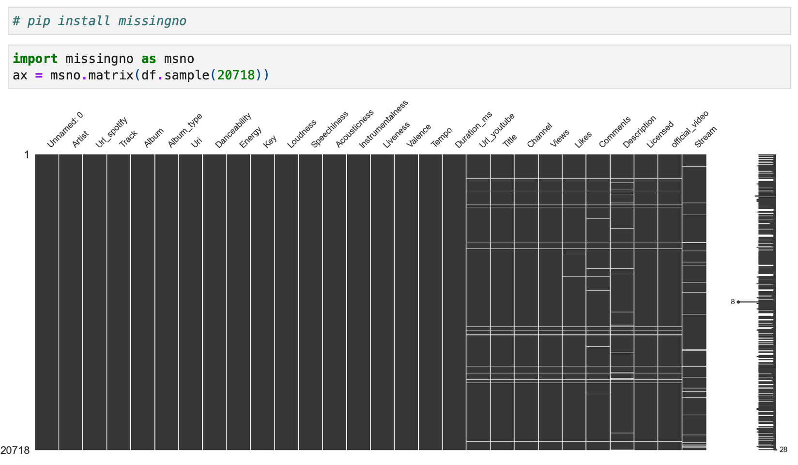

*Figure 11. Matrix graphic of the amount of null values between the features.*

# **Replacing Values (Syntax errors)**

After analyses were found a few different characters in the feature Artist like $, *, |, Ø, √, ! and so on. Believe that $ should be S, Ø should be O and ! should be i, so used the method replace to correct the texts.



*Figure 12. Replacing text values.*

Also to make sure that no other different symbols existed, it was used the “re.sub()” method due to the other symbols were unknown it was used approach from an example found online on towardsdatascience that is "another alternative is the sub() method in the re package that provides regular expression matching operations." (Myrianthous, 2022)



*Figure 13. Removing symbols values.*

# **Dropping Irrelevant Columns**

After analyses were chosen some irrelevant features to be dropped: Unnamed: 0, Url_spotify, Uri, Key, Url_youtube, Title, Description

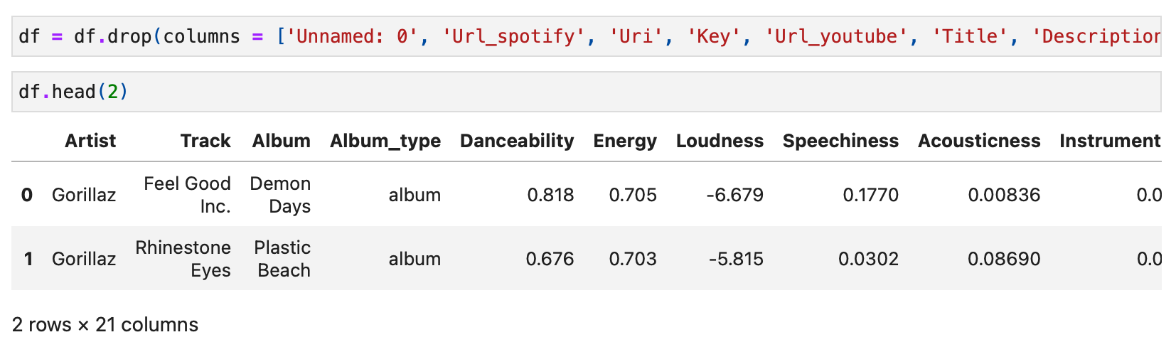

*Figure 14. Dropping and head of the features.*

# **Renaming Columns**

After analyses renaming some features to better visualisation: Album_type to Album Type, Duration_ms to Duration (milliseconds) and official_video to Official Video.

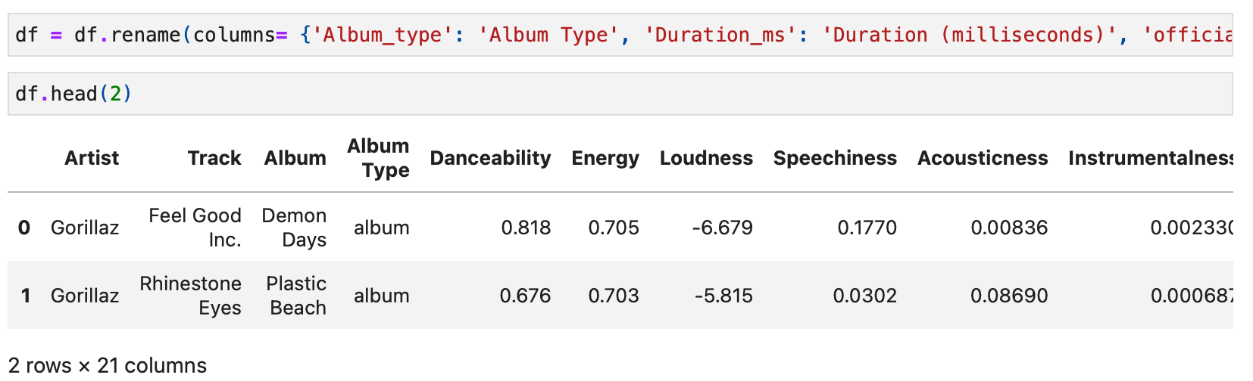

*Figure 15. Renaming and head of the features.*

# **Handling Missing Values**

Creating a variable whose name is "`missing_value_formats`" to save some different characters and input in the dataset to patronize all of them as NaN to be easy to handle next, and next replacing the values and dropping them all, due it is just approximately 3% to 5% of the data missing. Also could use another approach such as getting the mean values, or median values, filling by the top or down and so on to handle those missing values.

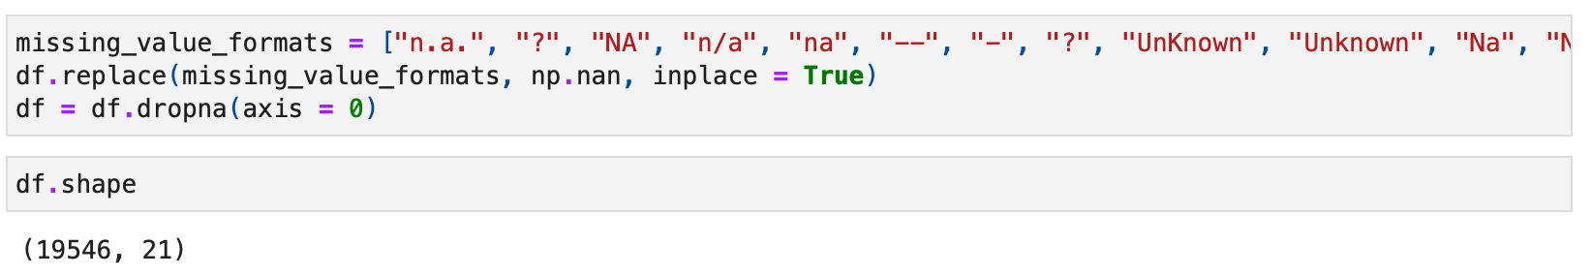

*Figure 16. The approach was chosen to handle missing values.*

In the beginning, a data set with 20718 observations was imported, after dealing with the missing values has 19546 observations now, less 1172 observations from the original one, and checked if worked with a graphic and the command “.isnull().sum()”.

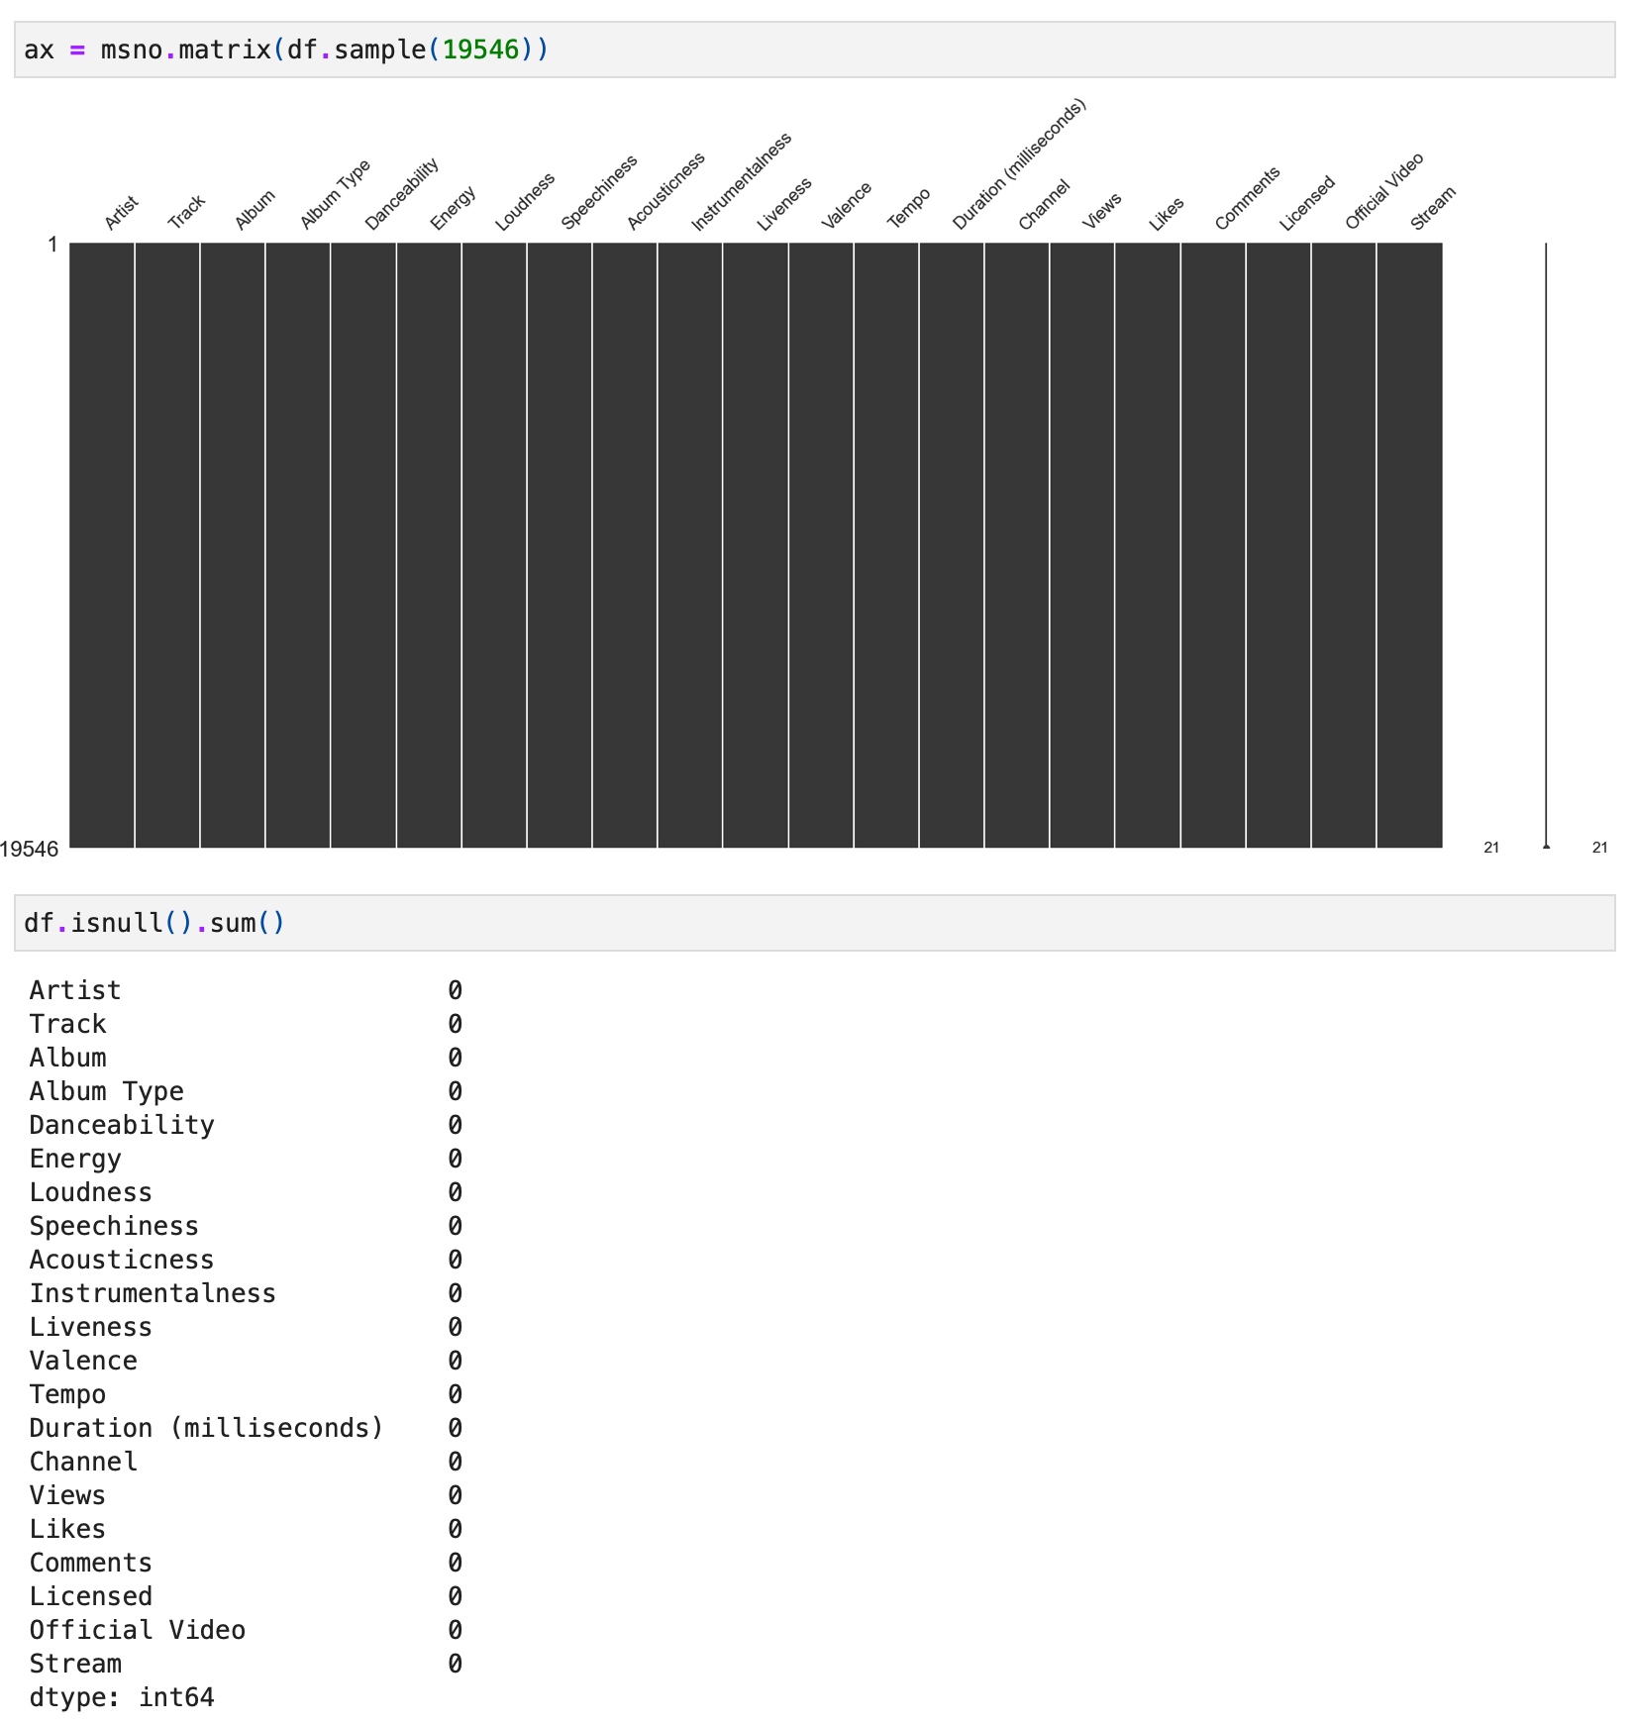

*Figure 17. Matrix graphic of the amount of null values of the features.*

# **Imputing Missing Values**

Opted to drop all observations with missing values but as described before could use another approach such as getting the mean values, or median values, filling by the top or down and so on to imputing those missing values.

# **Handling Duplicate Rows**

Checked if there exist duplicate observations, in this case, there are none to be handled.

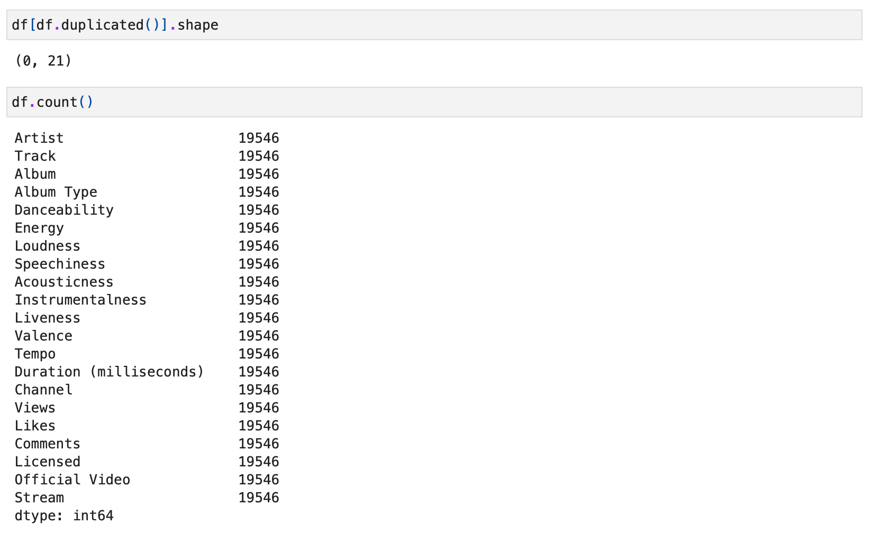

*Figure 18. Checking duplicated observations.*

# **Type Conversion**

Until here there are no features to be converted to the respective type, but in case it is needed it will use the command “.astype()”.

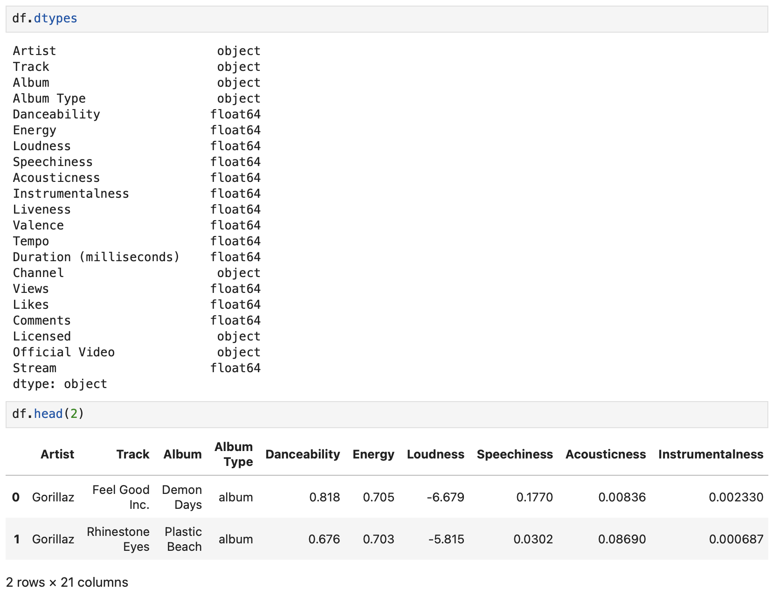

*Figure 19. Checking the type of features.*

# **Relationships**

Checking the relationships of the features, creating a new data frame whose name is "df_numeric" and getting just numeric columns from "df" data frame, after using the algorithm “.corr” in the "df_numeric.corr()" to save the correlations in a new variable "correlation_matrix" to show the correlation matrix and check the relations between them using a heatmap.

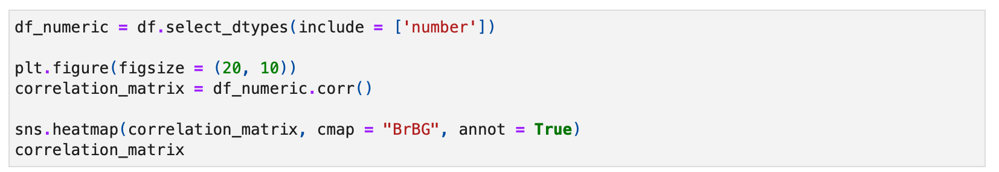

*Figure 20. Code to get the relationships of the features.*

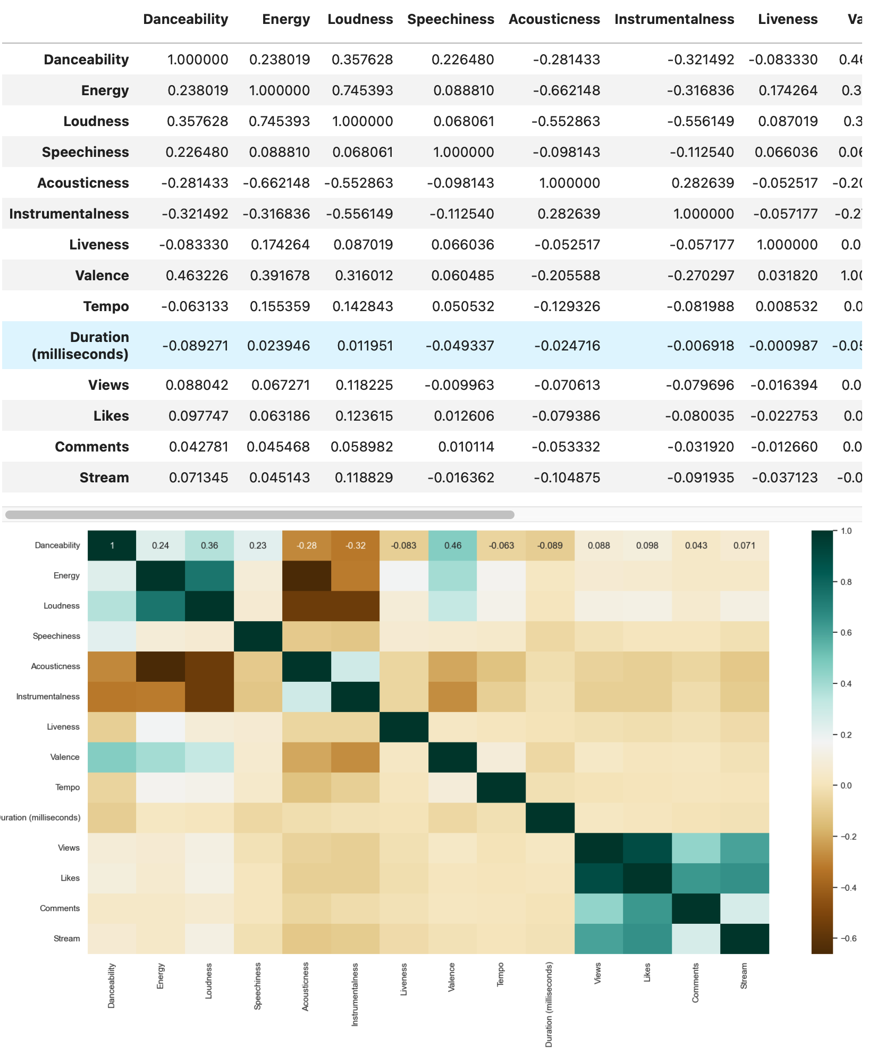

*Figure 21. Heatmap of relationships between the features.*

After that, it was noticed that the features Views, Likes, Comments and Stream have a strong signal correlation between them, also a good signal from the features Valence, Loudness, Energy and Danceability.

Examples for kdeplot learned from seaborn.kdeplot documentation. "A kernel density estimate (KDE) plot is a method for visualizing the distribution of observations in a dataset, analogous to a histogram. KDE represents the data using a continuous probability density curve in one or more dimensions." (Seaborn, 2012).

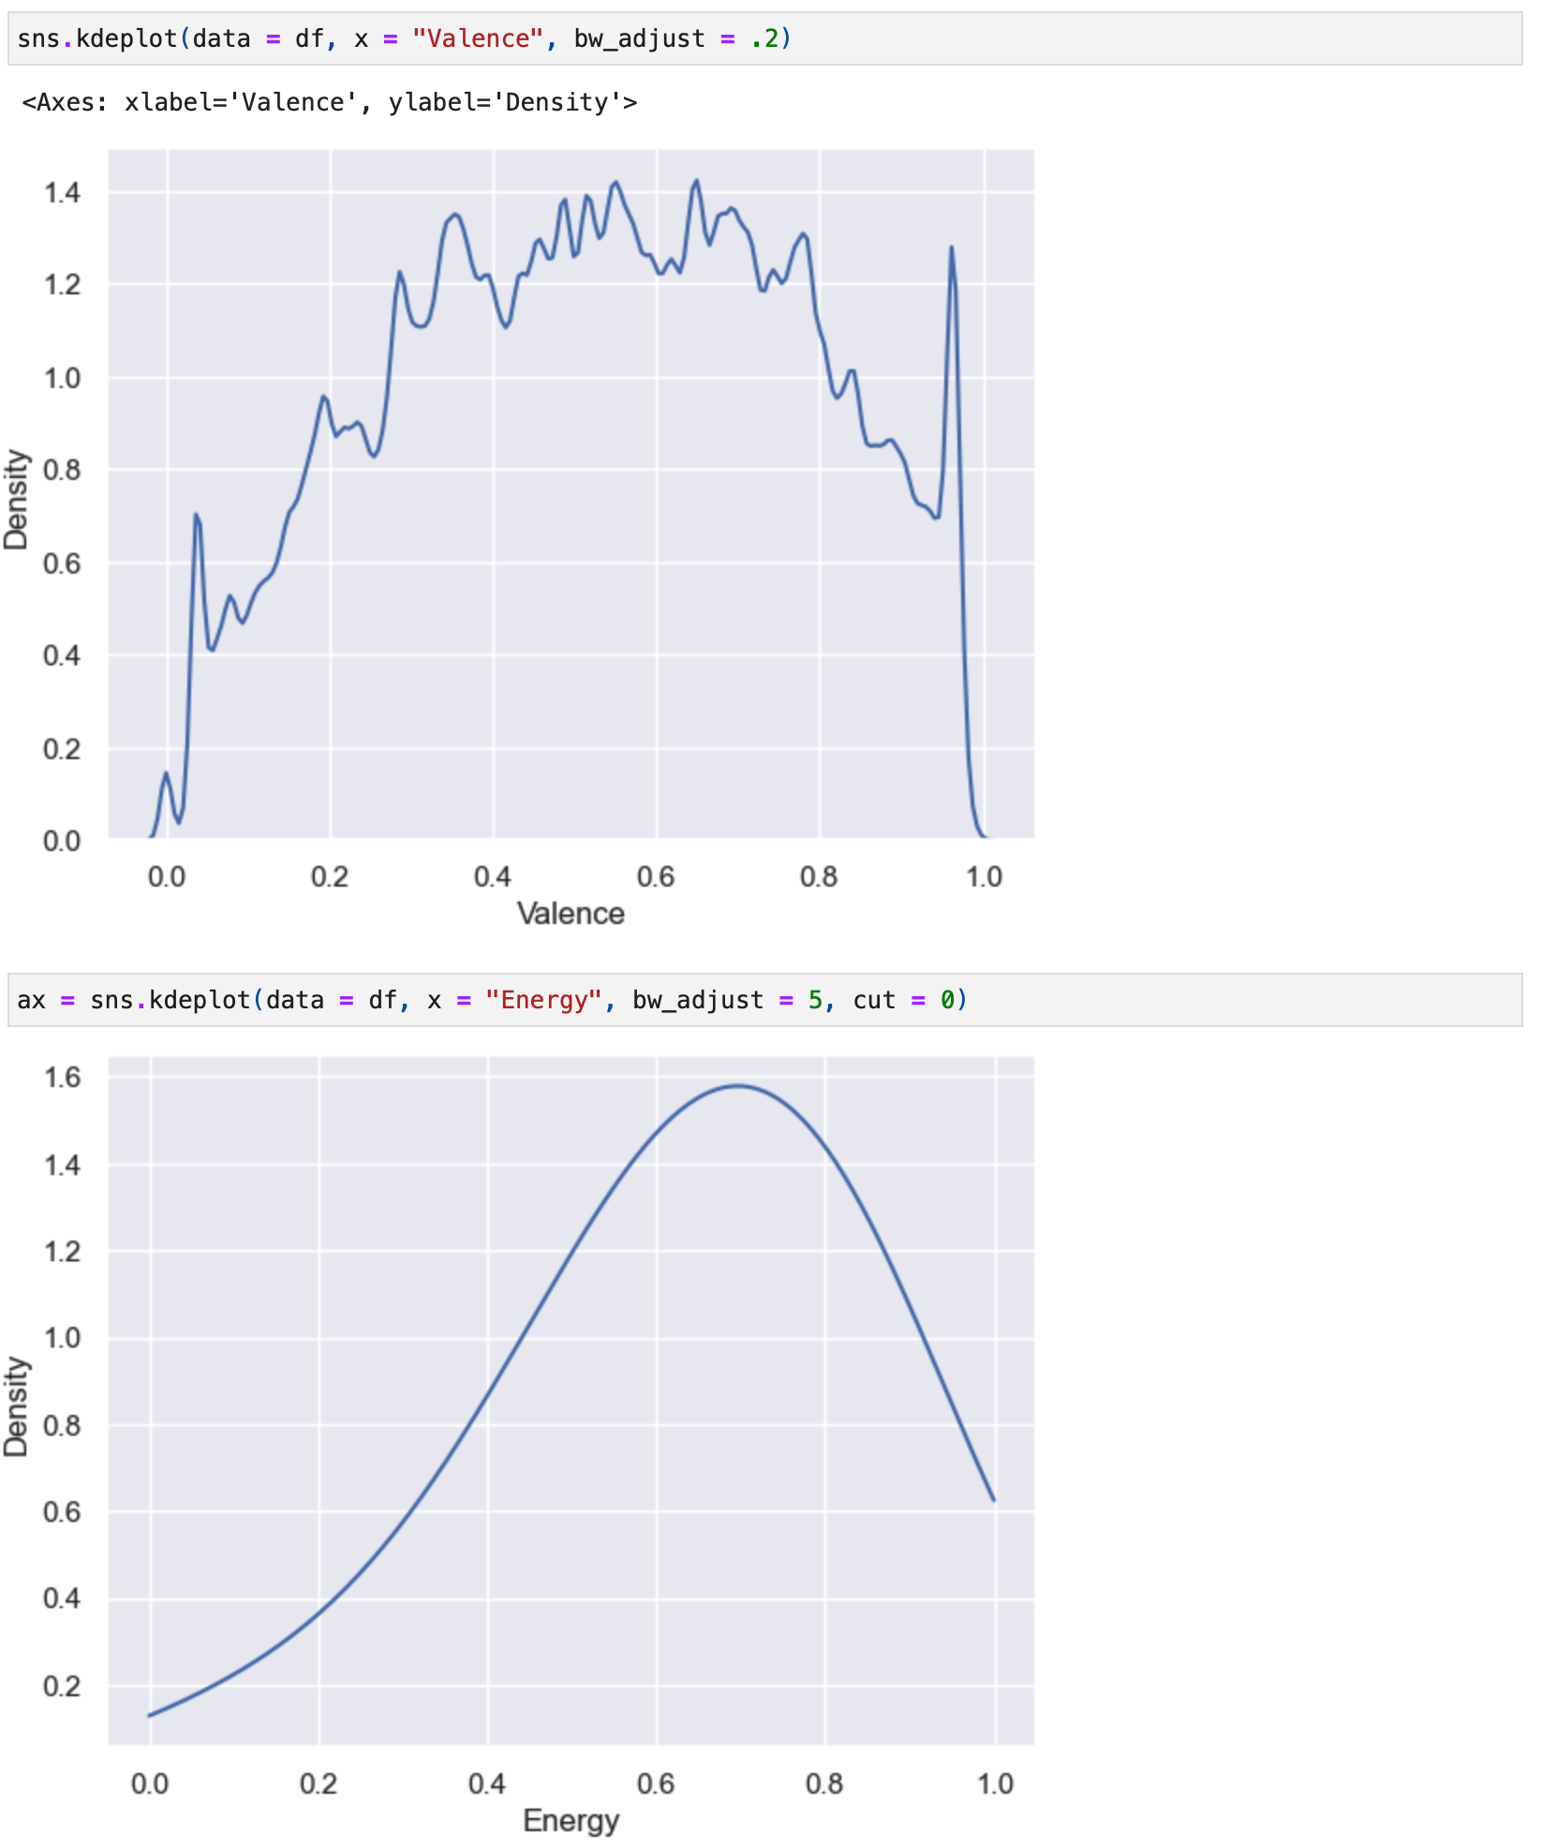

*Figure 22. kdeplot showing the density of Valence and Energy features.*

"Relative to a histogram, KDE can produce a plot that is less cluttered and more interpretable, especially when drawing multiple distributions." (Seaborn, 2012).

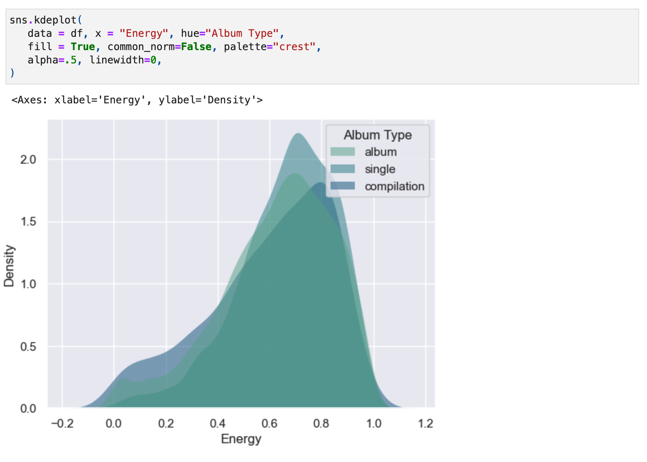

*Figure 23. kdeplot showing the density of the Energy feature in comparison to the Album Type.*

# **Statistical Analysis**

Creating a pair plot to visualise all the features and their respective signals.

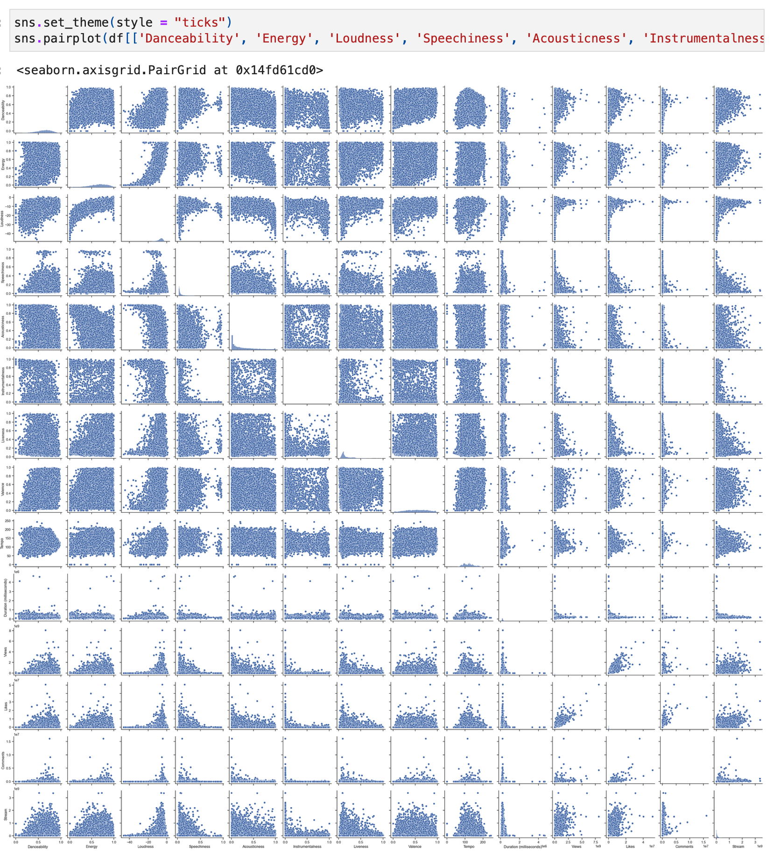

*Figure 24. pairplot showing all feature points and their respective connections.*

Next, it was created a few histograms using the graphic “.displot” from the library seaborn to check the distribution of all numerical features below: Danceability, Energy, Loudness, Speechiness, Acousticness, Instrumentalness, Liveness, Valence, Tempo, Duration (milliseconds), Views, Likes, Comments, Stream.

The examples below will be refined with a mark to show us the mean and median on the graphic, the example got from the GitHub Gist using the command ".axvline" to get a "Distribution plot with mean and median" (Cereniyim, 2019), also checked about the parameters on matplotlib website for "Add a vertical line across the Axes" (The Matplotlib Development Team, 2024).

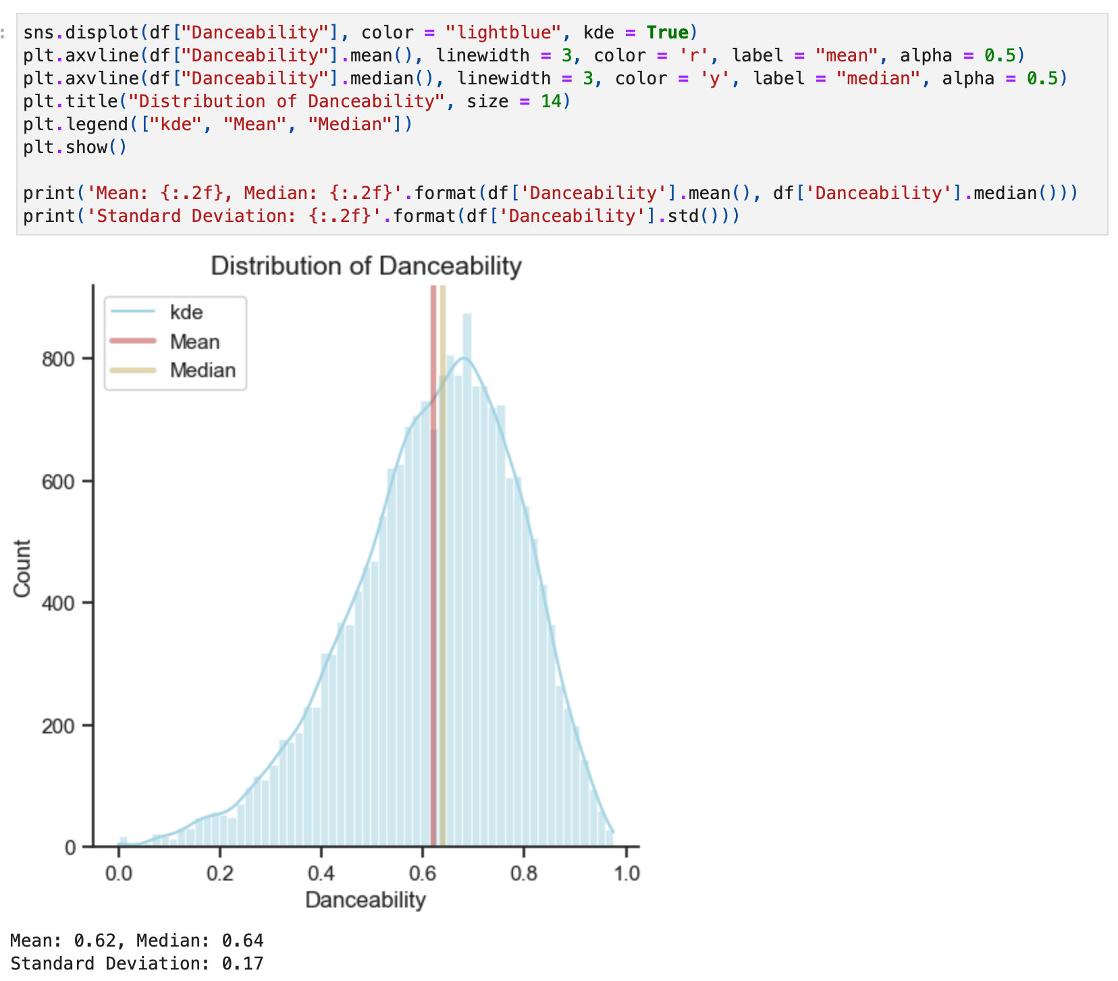

*Figure 25. displot of Danceability distribution feature.*

**Distribution of Danceability:** The distribution is skewed to the left side showing that most of the songs are suitable for dancing based on a combination of musical elements including tempo, rhythm stability, beat strength, and overall regularity. A value of 0.0 is the least danceable and 1.0 is most danceable.

Statistical Values: Mean: **0.62**, Median: **0.64** and Standard Deviation: **0.17**

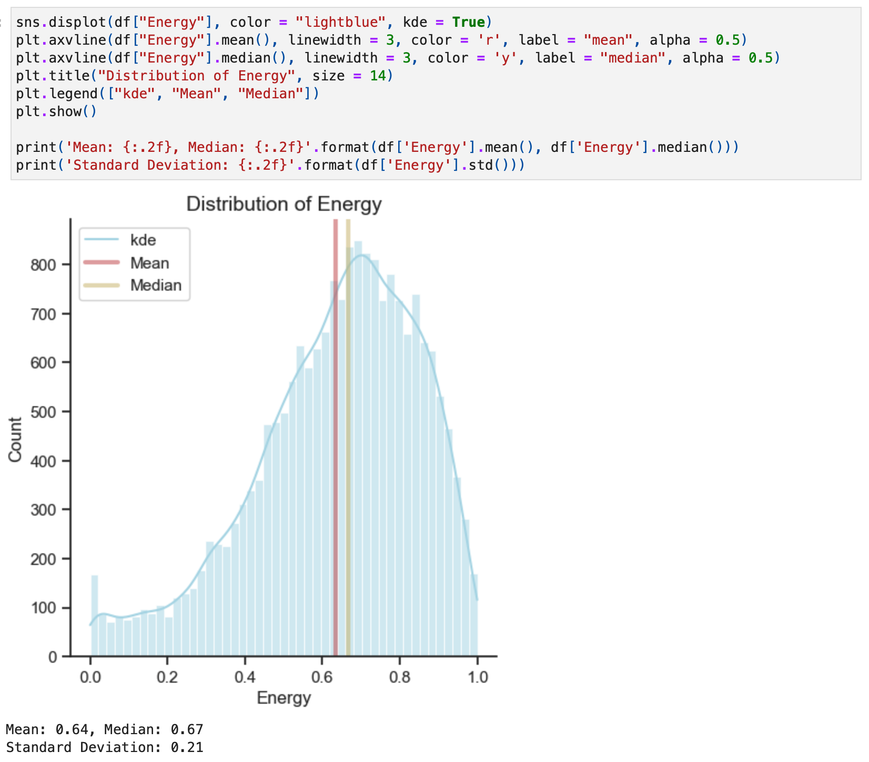

*Figure 26. displot of Energy distribution feature.*

**Distribution of Energy:** The distribution is skewed to the left side showing that the most of the songs are energetic feel fast, loud, and noisy. From 0.0 to 1.0 represents a perceptual measure of intensity and activity.

Statistical Values: Mean: **0.64**, Median: **0.67** and Standard Deviation: **0.21**

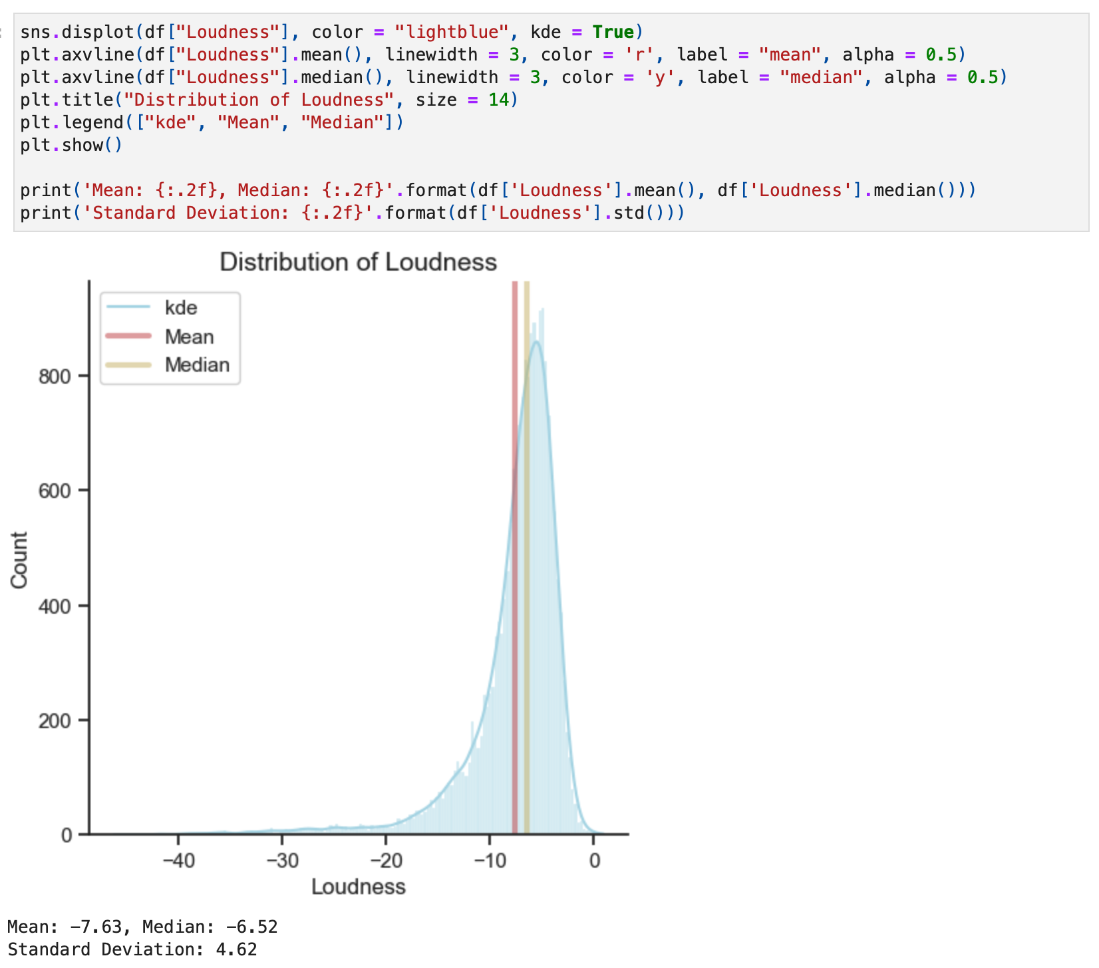

*Figure 27. displot of Loudness distribution feature.*

**Distribution of Loudness:** The distribution is skewed to the left side showing that most of the songs are not prejudicial to the ears considering the quality of a sound that is the primary psychological correlate of physical strength (amplitude). The overall loudness of a track in decibels (dB).

Statistical Values: Mean: **-7.63**, Median: **-6.52** and Standard Deviation: **4.62**

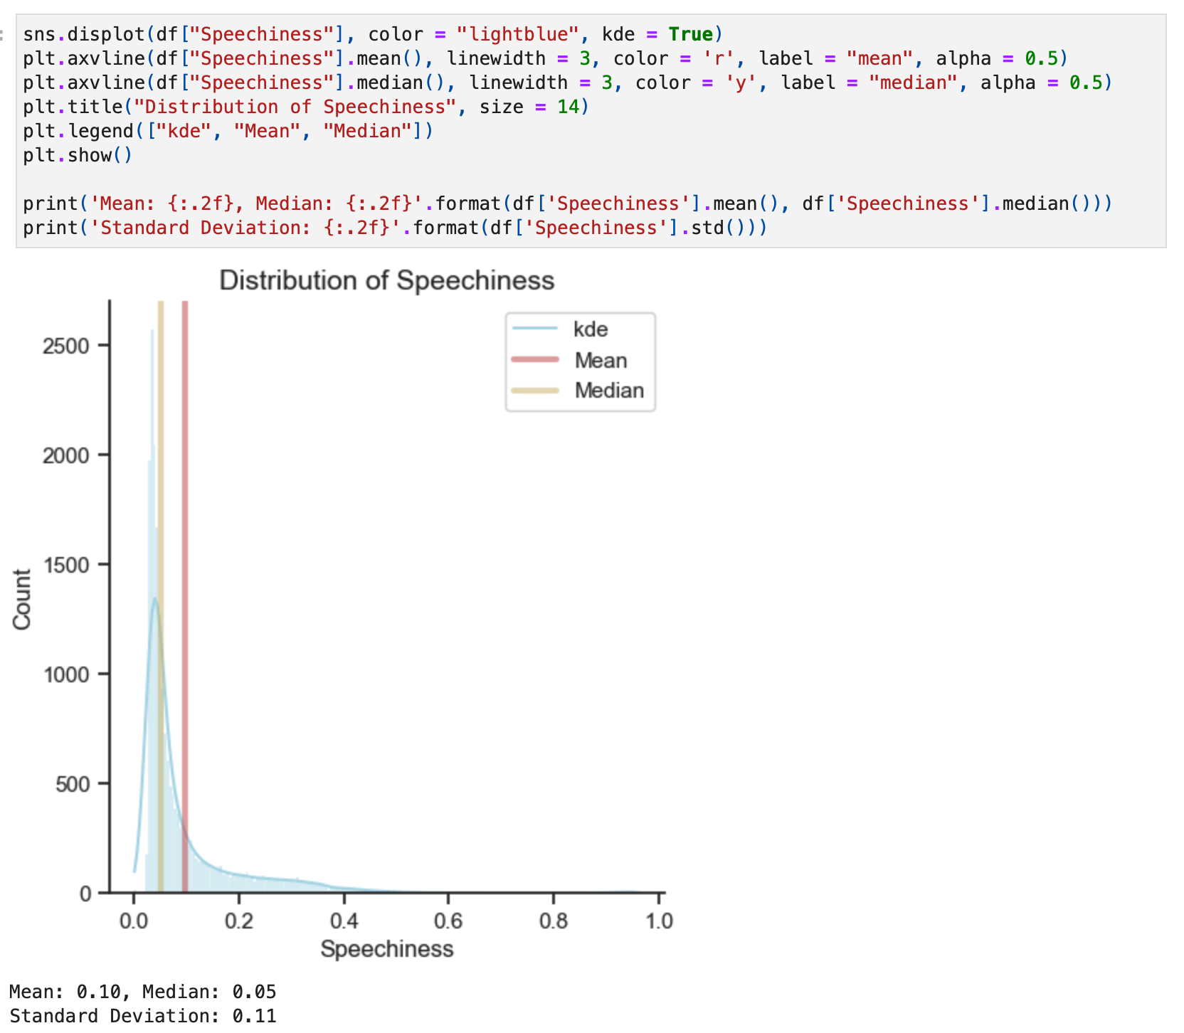

*Figure 28. displot of Speechiness distribution feature.*

**Distribution of Speechiness:** The distribution is skewed to the right side showing the presence of low Speechiness values which means values below 0.33 most likely represent music and other non-speech-like tracks, just a few parts of the songs detect the presence of spoken words in a track.

Statistical Values: Mean: **0.10**, Median: **0.05** and Standard Deviation: **0.11**

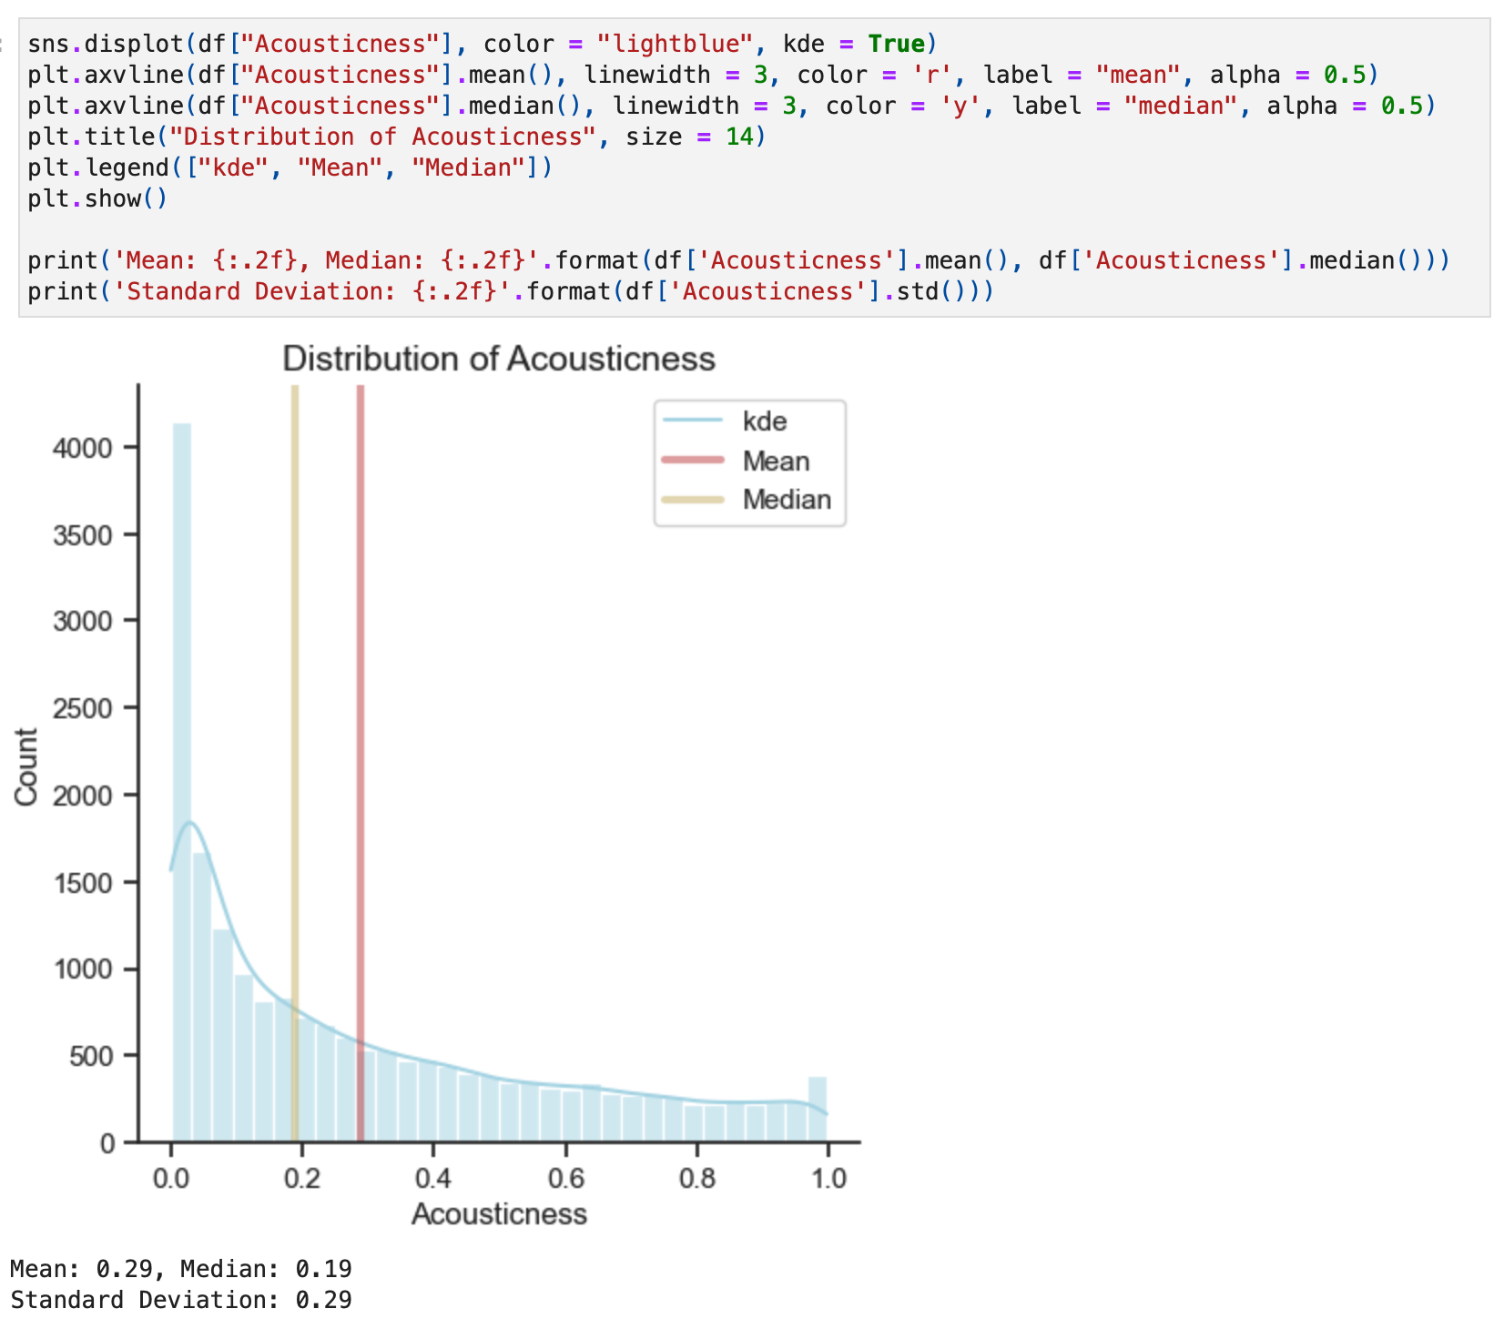

*Figure 29. displot of Acousticness distribution feature.*

**Distribution of Acousticness:** The distribution is skewed to the right side showing that most of the songs are less acoustic than most songs.

Measure from 0.0 to 1.0 of whether the track is acoustic

Statistical Values: Mean: **0.29**, Median: **0.19** and Standard Deviation: **0.29**

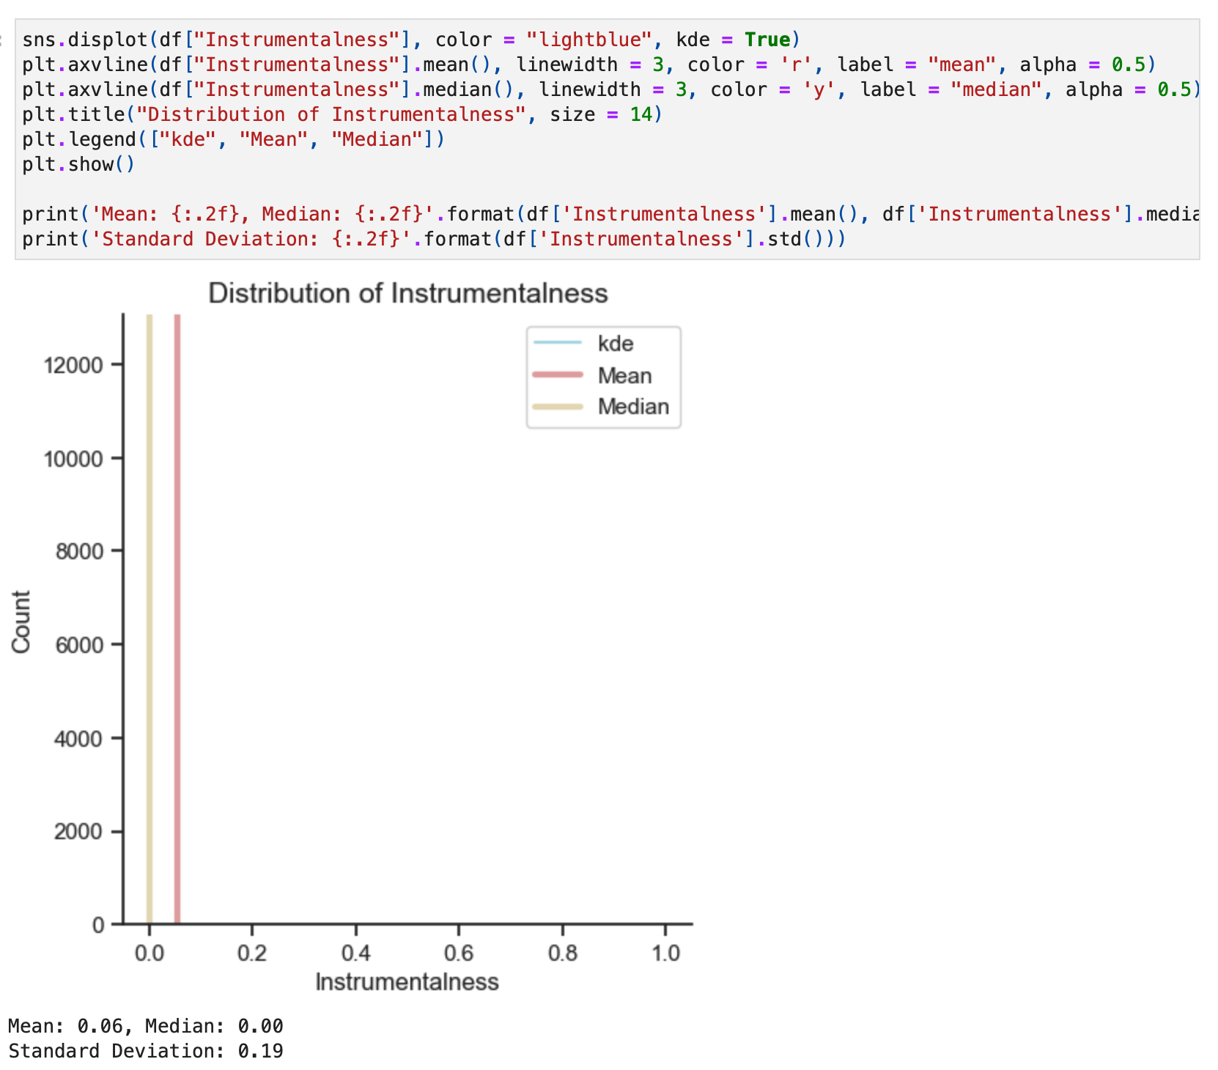

*Figure 30. displot of Instrumentalness distribution feature.*

**Distribution of Instrumentalness:** The distribution is skewed to the right side showing that most songs contain vocals than instrumentals and contain no vocals.

The closer the instrumentalness value is to 1.0, the greater likelihood the track contains no vocal content. Values above 0.5 are intended to represent instrumental tracks, but confidence is higher as the value approaches 1.0.

Statistical Values: Mean: **0.06**, Median: **0.00** and Standard Deviation: **0.19**

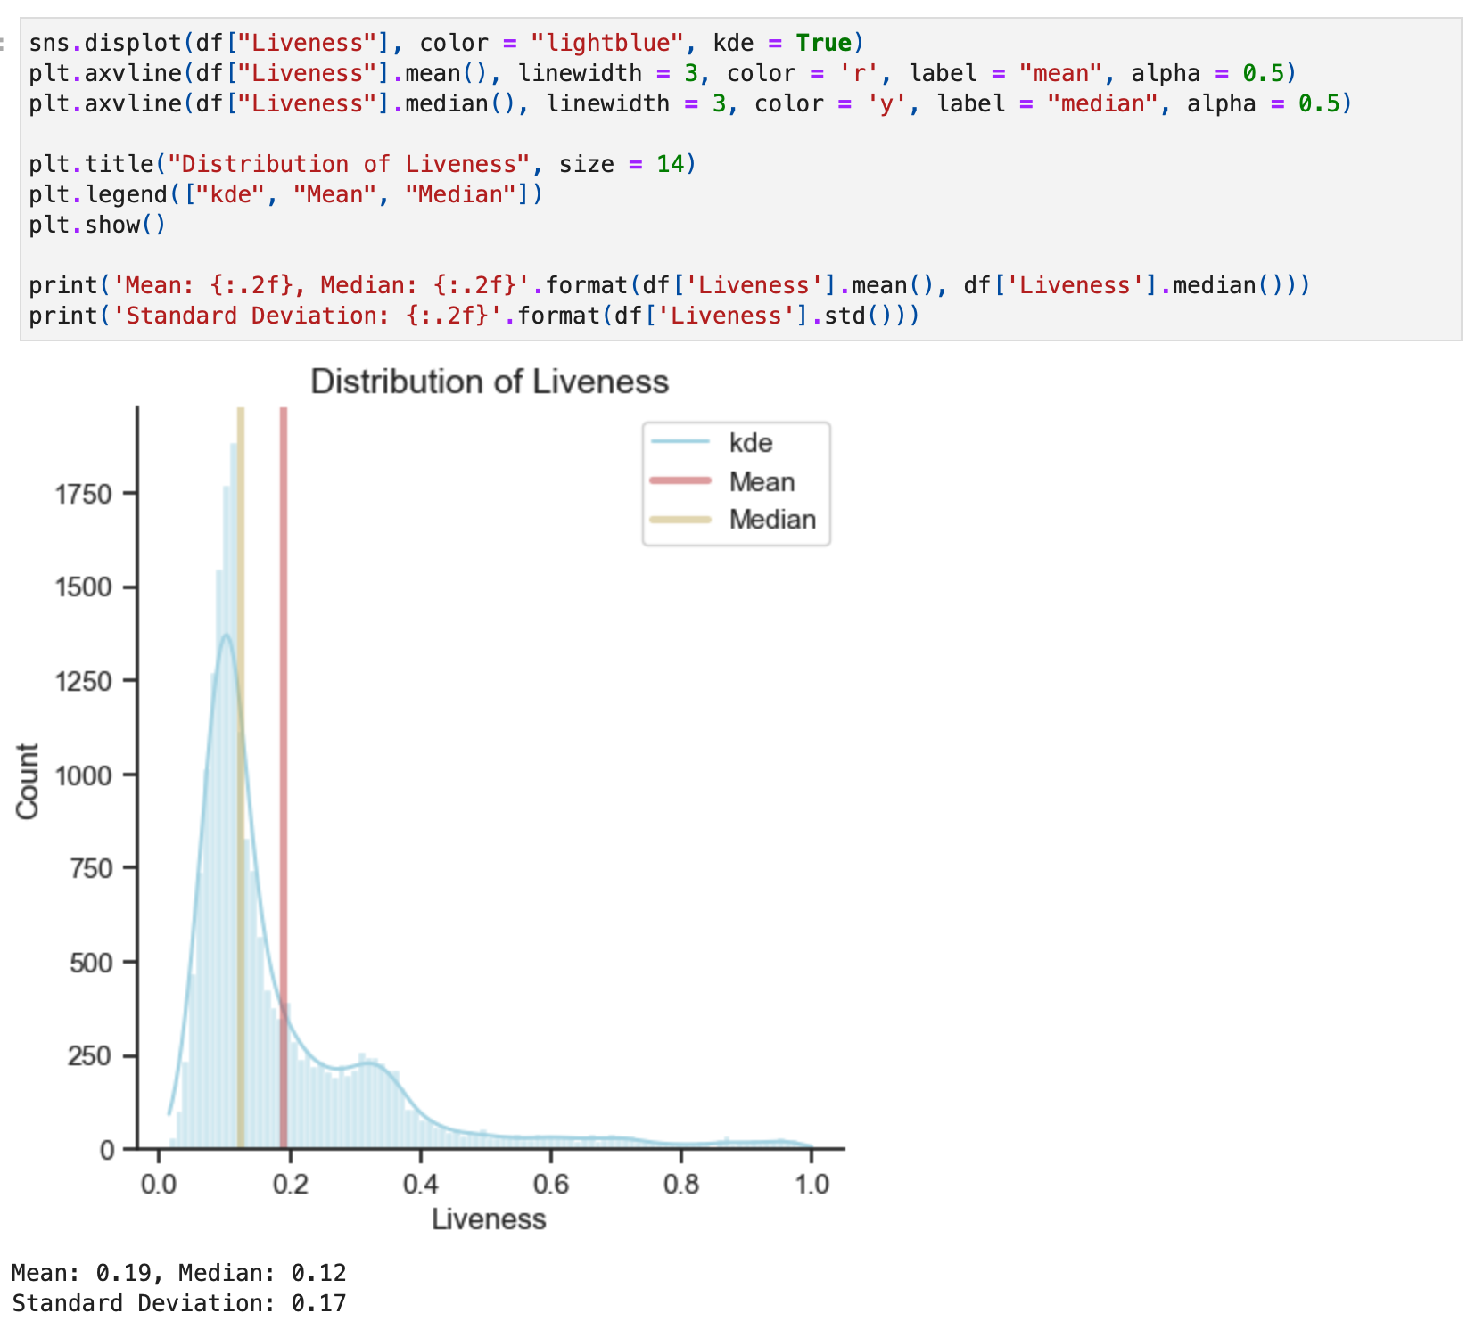

*Figure 31. displot of Liveness distribution feature.*

**Distribution of Liveness:** The distribution is skewed to the right side showing that most of the songs do not have the presence of an audience in the recording. Higher liveness values represent an increased probability that the track was performed live.

Statistical Values: Mean: **0.19**, Median: **0.12** and Standard Deviation: **0.17**

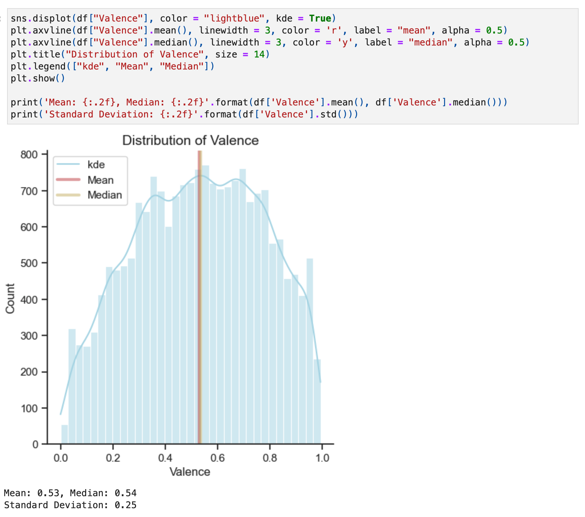

*Figure 32. displot of Valence distribution feature.*

**Distribution of Valence:** The distribution is considered a normal distribution is a symmetric data due to the values Mean/Median being practically in the centre of the graph this distribution shows that there is a good distribution with the median amount of the songs showing positiveness, which is more positive than negative songs.

A measure from 0.0 to 1.0 describing the musical positiveness conveyed by a track. Tracks with high valence sound more positive (e.g. happy, cheerful, euphoric), while tracks with low valence sound more negative (e.g. sad, depressed, angry).

Statistical Values: Mean: **0.53**, Median: **0.54** and Standard Deviation: **0.25**

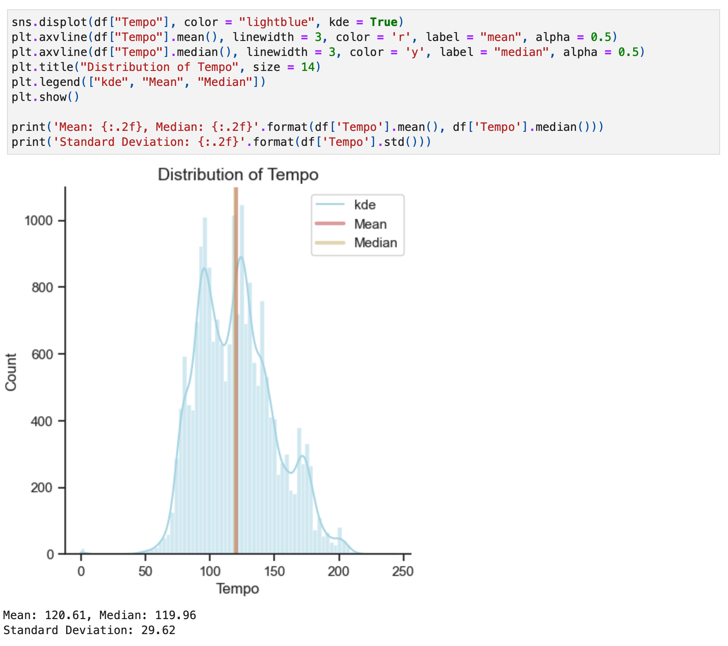

*Figure 33. displot of Tempo distribution feature.*

**Distribution of Tempo:** The distribution is almost a normal distribution but the data is bimodal showing us an up, down, up, down, up, down, this data represent the distribution of an estimated tempo of a track in beats per minute (BPM).

In musical terminology, tempo is the speed or pace of a given piece and derives directly from the average beat duration.

Statistical Values: Mean: **120.61**, Median: **119.96** and Standard Deviation: **29.62**

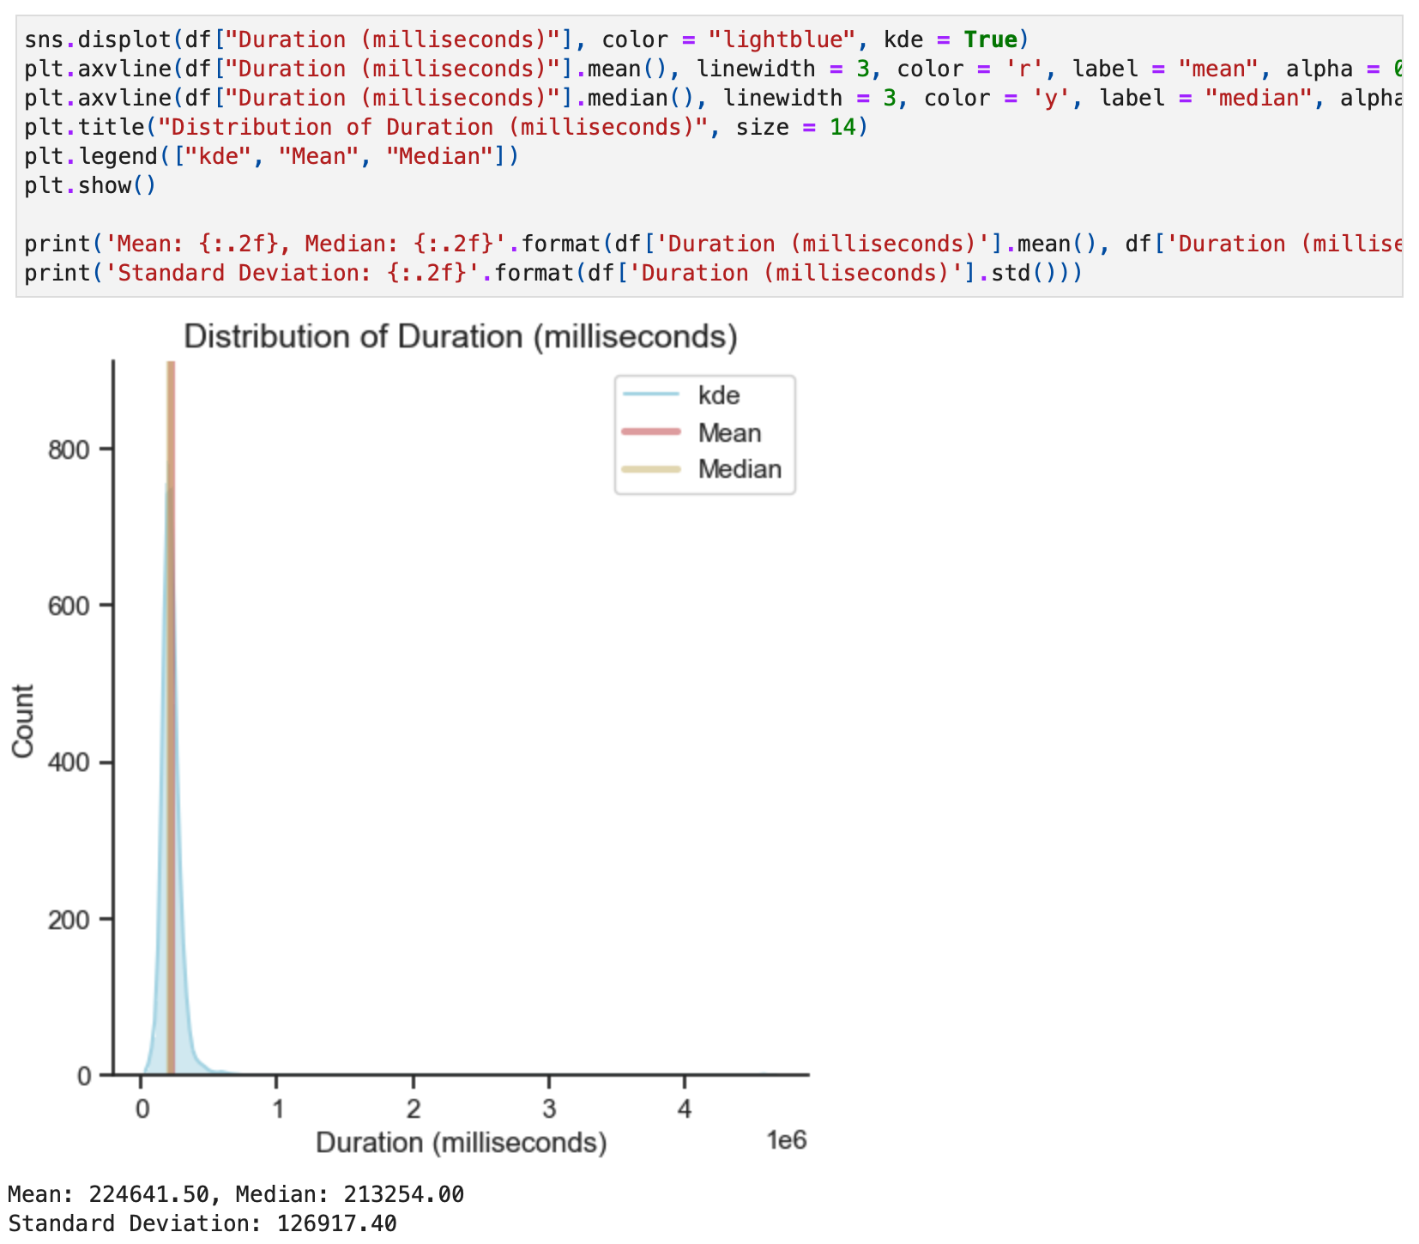

*Figure 34. displot of Duration (milliseconds) distribution feature.*

**Distribution of Duration (milliseconds):** The distribution is skewed to the right side showing that most of the songs have a short duration and the most of songs long duration.

The duration of the track in milliseconds.

Statistical Values: Mean: **224641.50**, Median: **213254.00** and Standard Deviation: **126917.40**

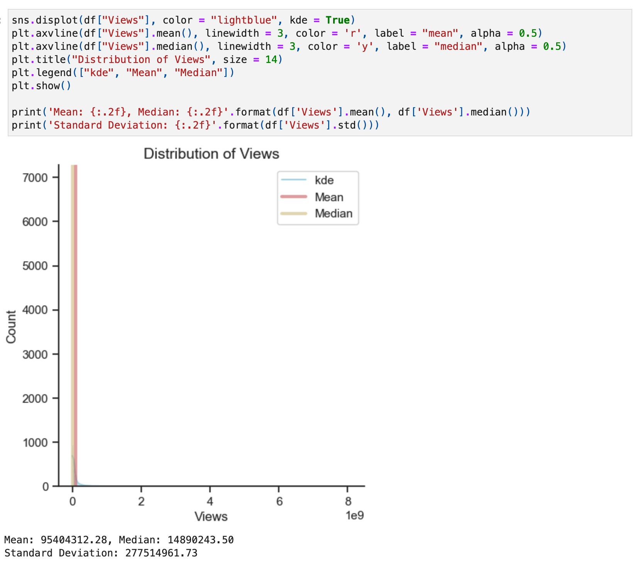

*Figure 35. displot of Views distribution feature.*

**Distribution of Views:** The distribution is skewed to the right side showing the huge amount number of views between the songs.

Statistical Values: Mean: **95404312.28**, Median: **14890243.50** and Standard Deviation: **277514961.73**

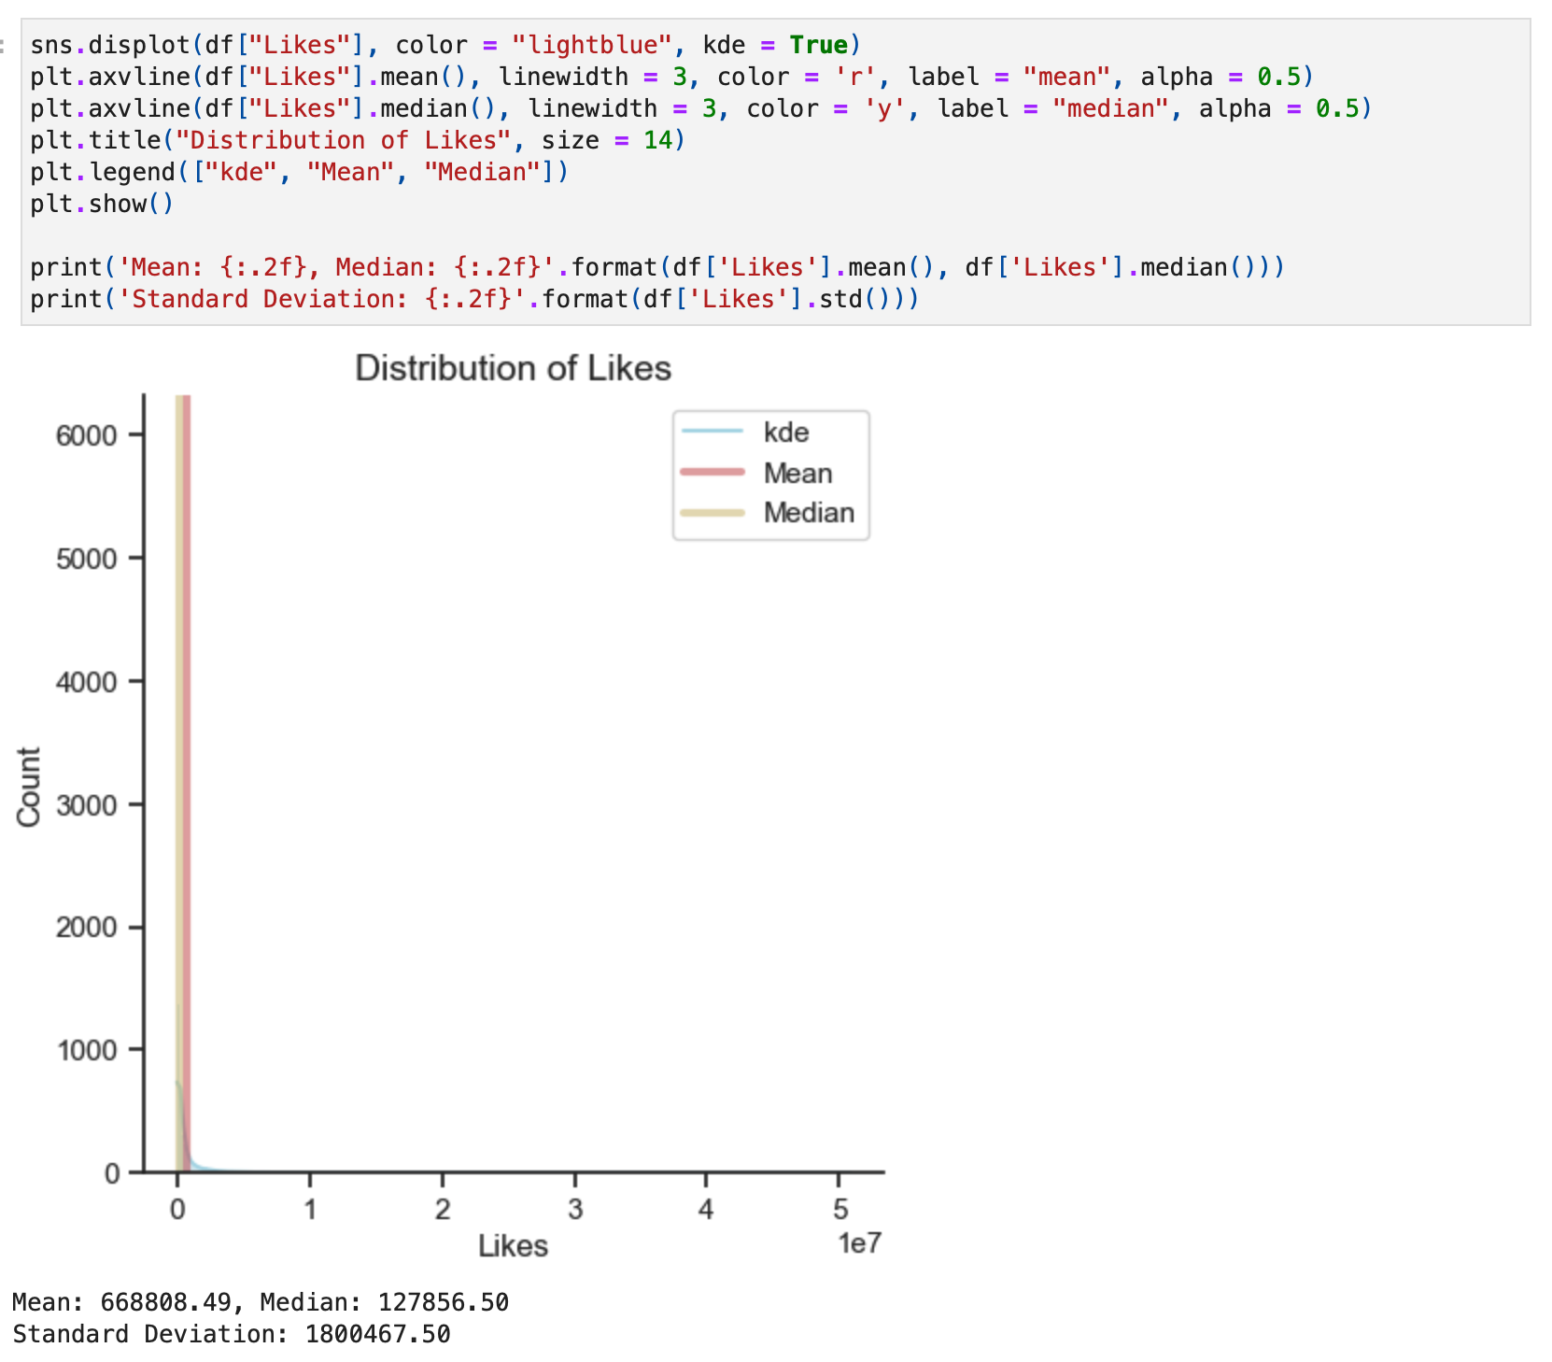

*Figure 36. displot of Likes distribution feature.*

**Distribution of Likes:** The distribution is skewed to the right side showing the huge amount number of likes between the songs.

Statistical Values: Mean: **668808.49**, Median: **127856.50** and Standard Deviation: **1800467.50**

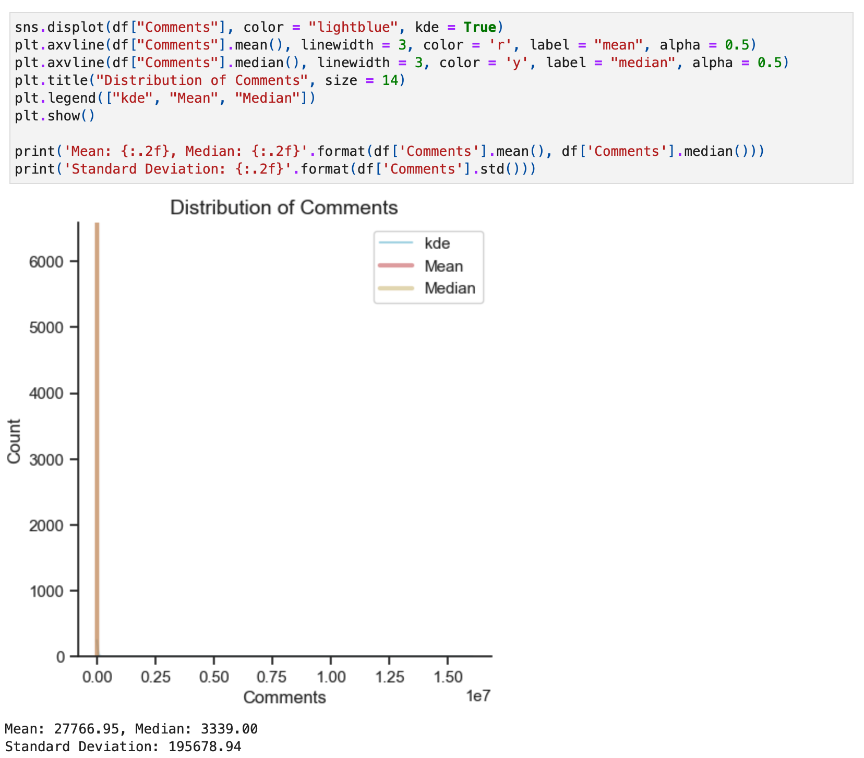

*Figure 37. displot of Comments distribution feature.*

**Distribution of Comments:** The distribution is skewed to the right side showing the huge amount number of comments between the songs.

Statistical Values: Mean: **27766.95**, Median: **3339.00** and Standard Deviation: **195678.94**

Even the database does not describe the scale of Views, Likes and Comments, let's consider that if the majority of values are close to 0, the greater the views, likes and comments on each song.

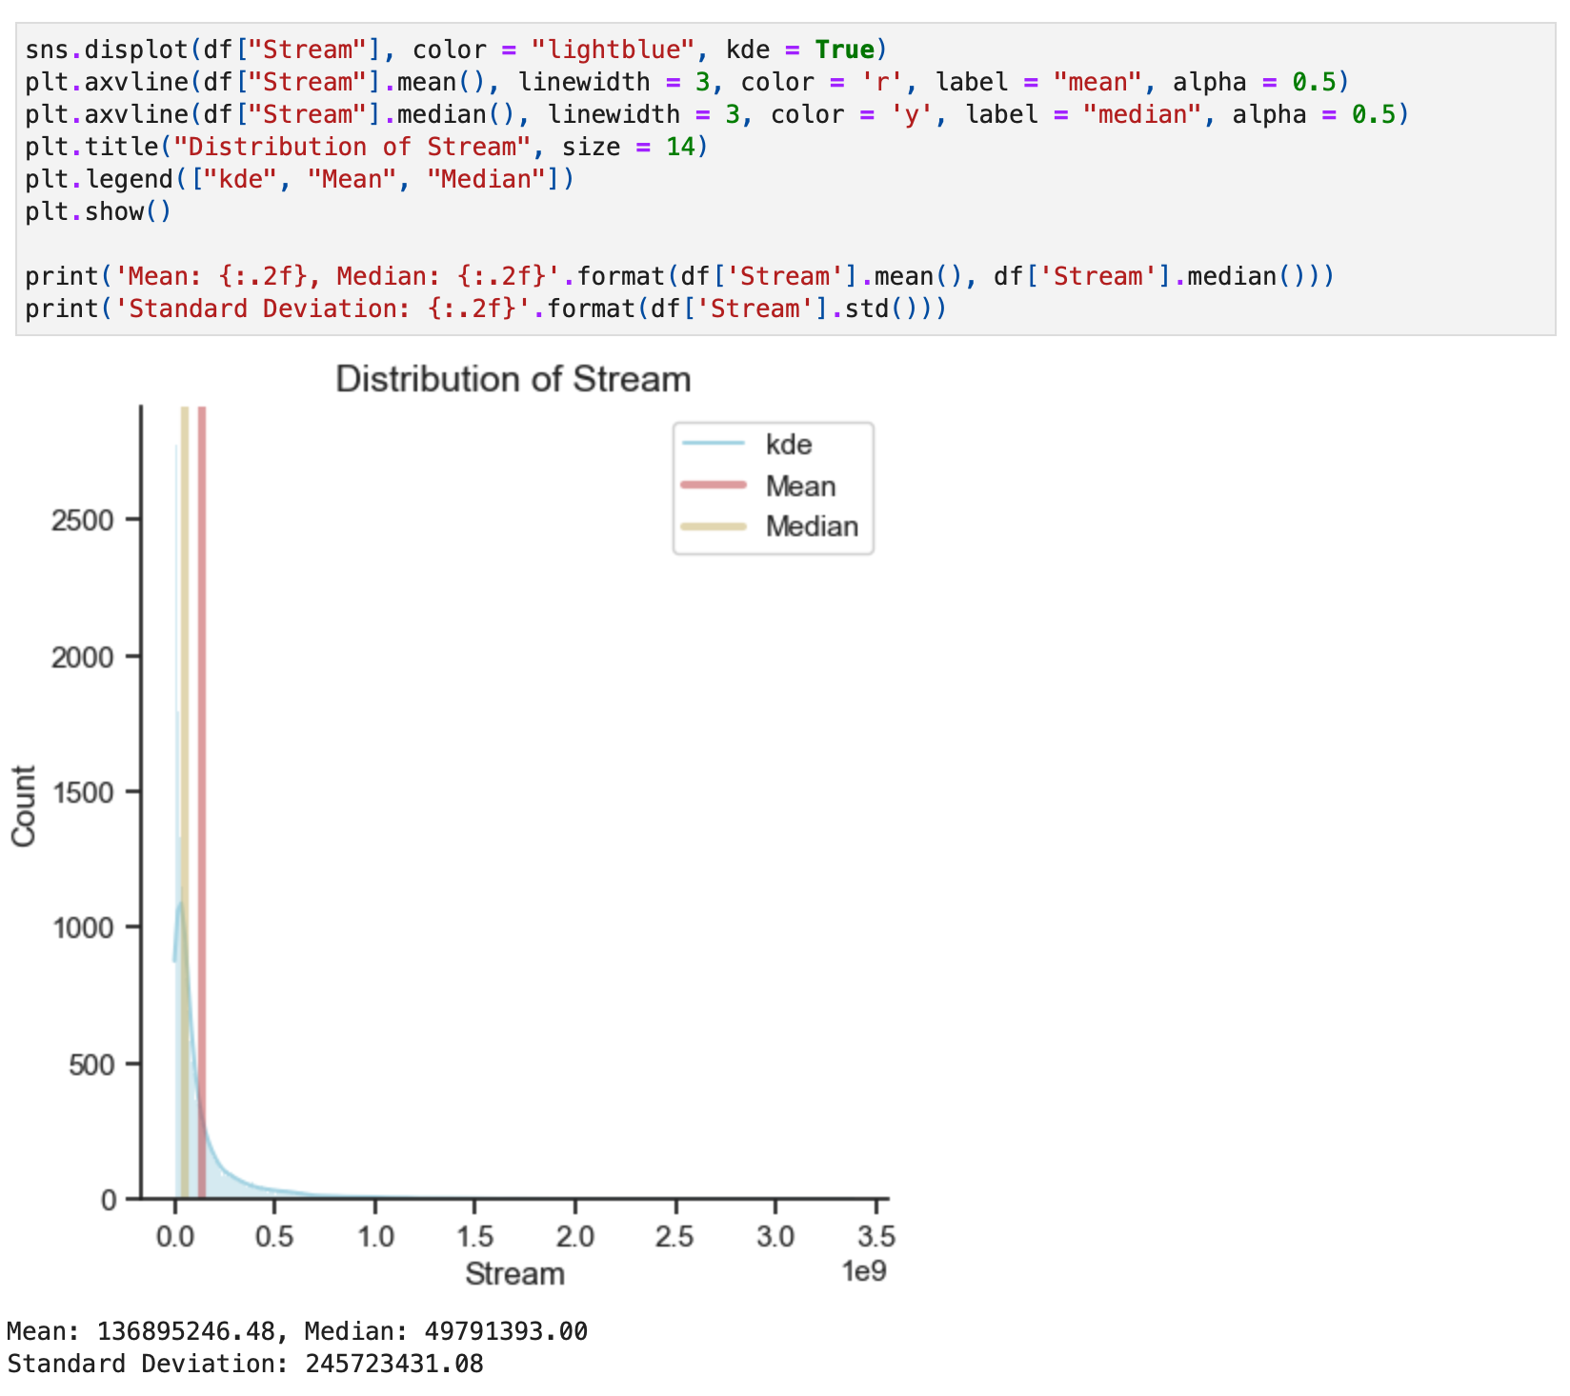

*Figure 38. displot of Stream distribution feature.*

**Distribution of Stream:** The distribution is skewed to the right side showing the number of streams of the song on Spotify.

Statistical Values: Mean: **136895246.48**, Median: **49791393.00** and Standard Deviation: **245723431.08**

Even though the database does not describe the scale of Views, Likes and Comments, let's consider that if the majority of values are close to 0, the greater the views, likes and comments on each song.

Next, create a boxplot to check all features.

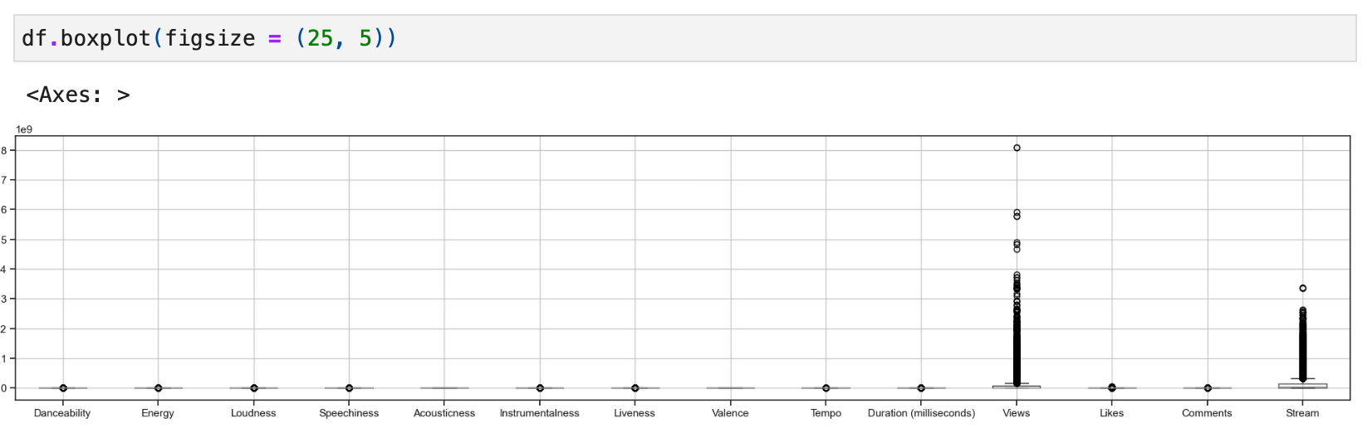

*Figure 39. boxplot of all numeric features.*

Got an example from the website: proclusacademy for creating a "Boxplot With Separate Y-Axis for Each Column" (Yashmeet Singh, 2022).

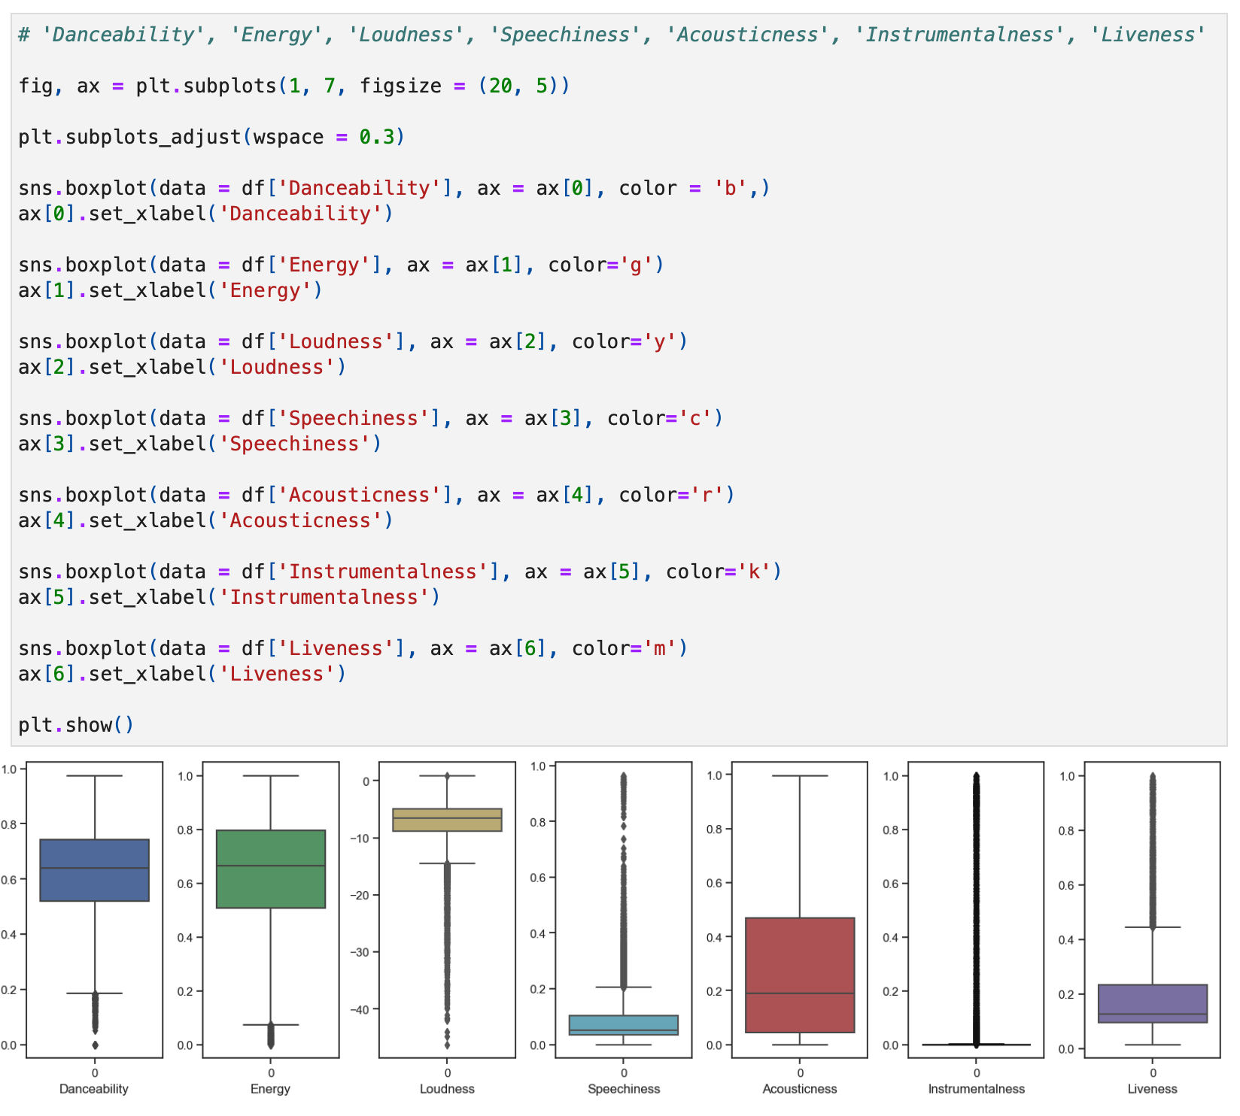

*Figure 40. boxplot of Danceability, Energy, Loudness, Speechiness, Acousticness, Instrumentalness, Liveness features.*

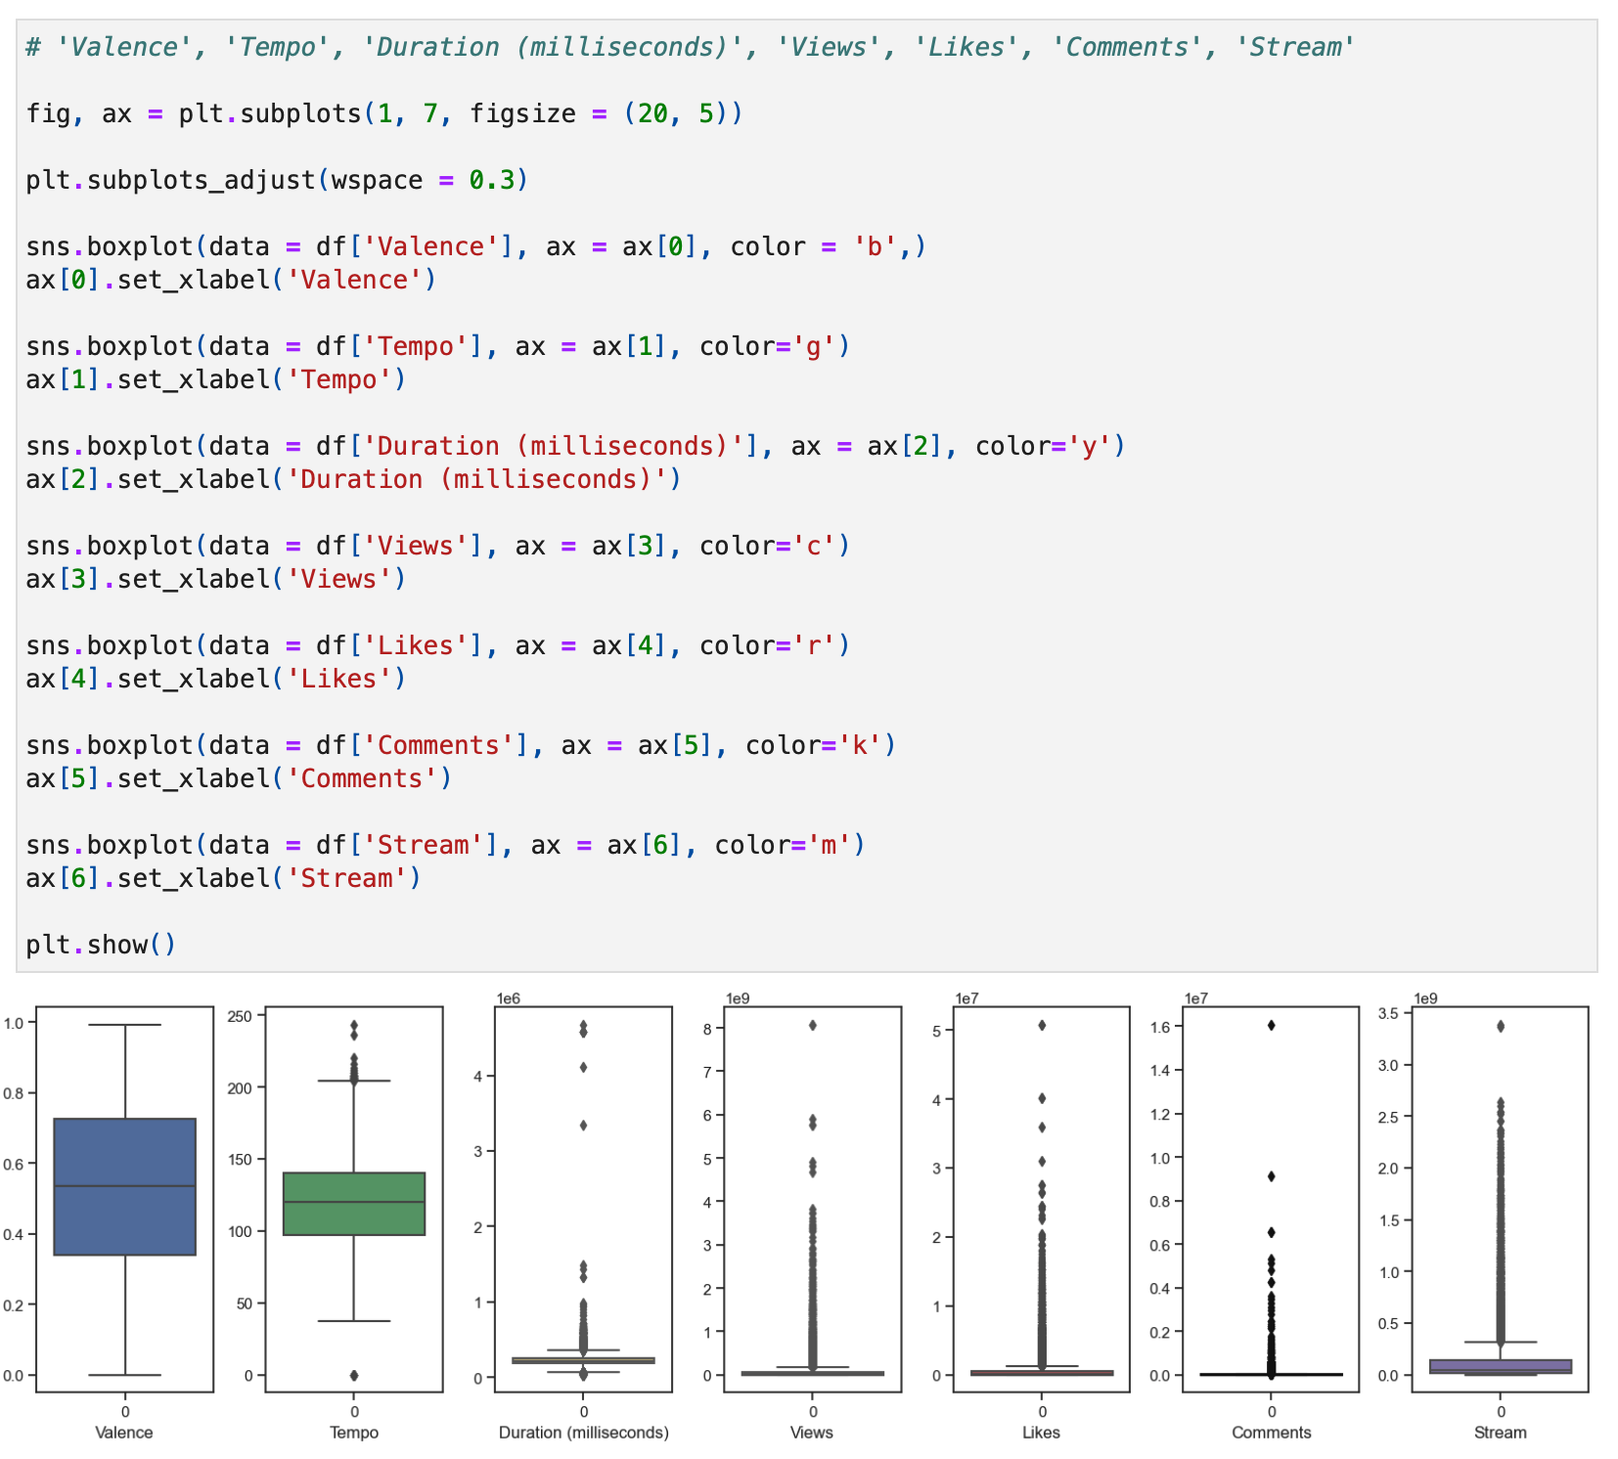

*Figure 41. boxplot of Valence, Tempo, Duration (milliseconds), Views, Likes, Comments, Stream features.*

Boxplot created on top to check the outliers and compare for the features: Danceability, Energy, Loudness, Speechiness, Acousticness, Instrumentalness, Liveness, Valence, Tempo, Duration (milliseconds), Views, Likes, Comments and Stream.

Create a histplot to get the visualisation of the frequency of Album Type between (Album, Single or Compilation).

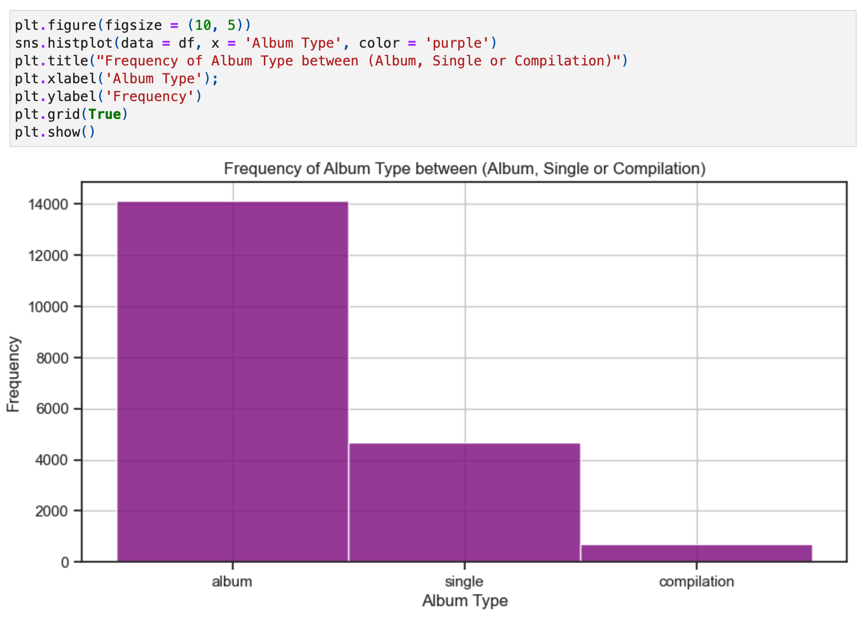

*Figure 42. histplot of the frequency of Album type between album, single or compilation albums.*

Create a pie to get these results in percentage, example learned from W3Schools "Creating Pie Charts" (W3Schools, 2024).

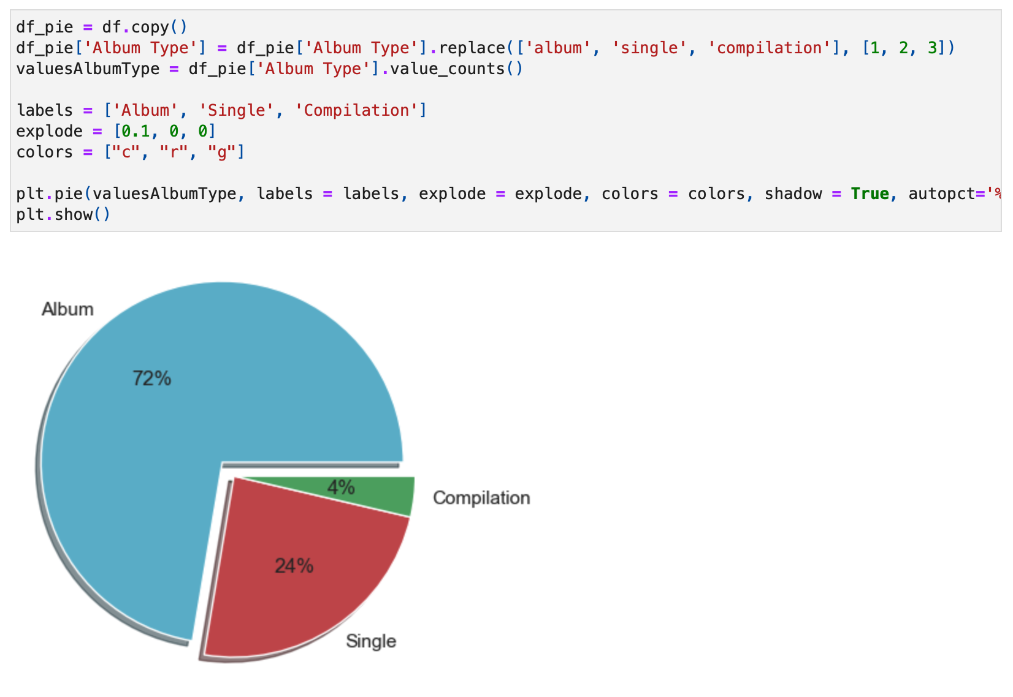

*Figure 43. pie of the frequency of Album type between album, single or compilation albums.*

Use the scatter next to see in the graphic how the features Views and Likes as distributed between them.

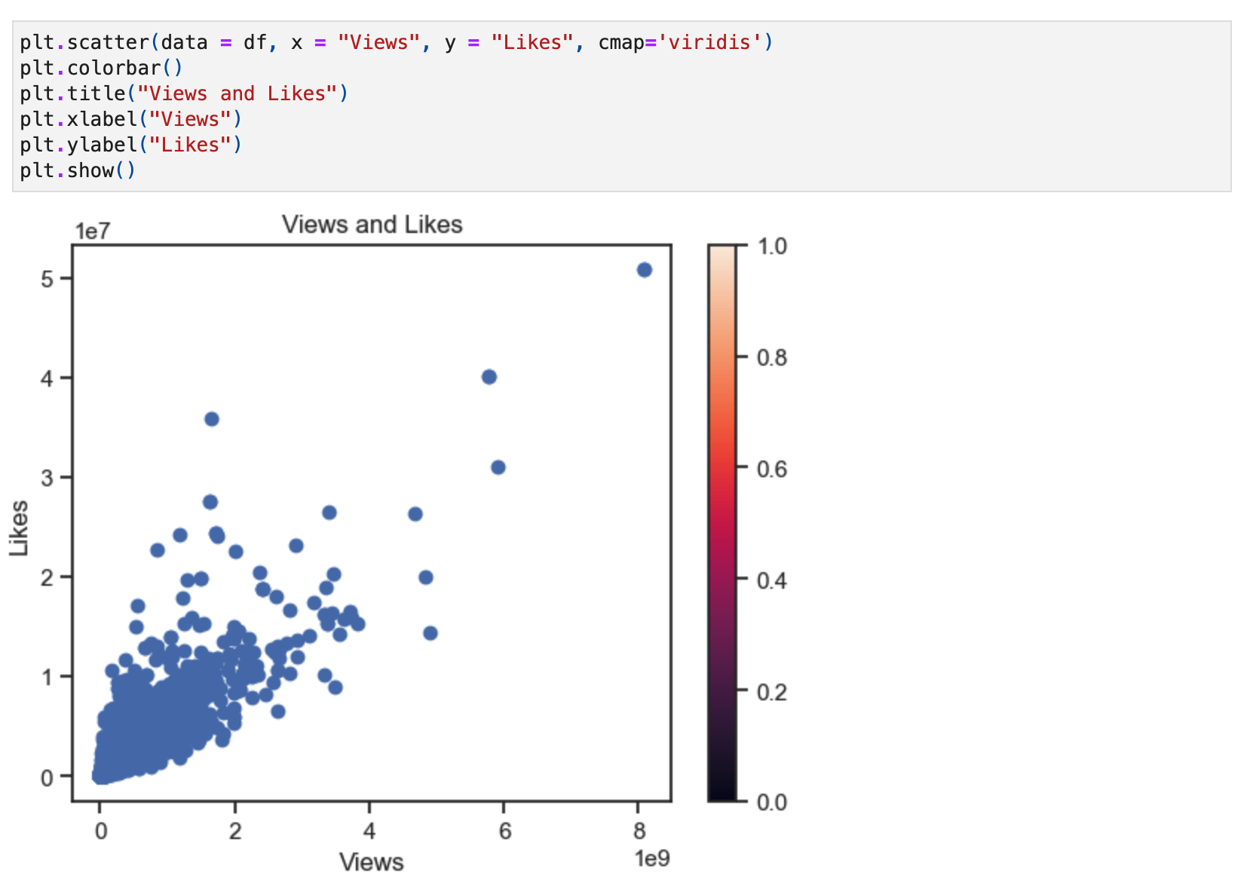

*Figure 44. scatter plot of Views and Likes distribution.*

An example got from the website Plotly using "Linear fit trendlines with Plotly Express Plotly Express is the easy-to-use, high-level interface to Plotly, which operates on a variety of types of data and produces easy-to-style figures.

Plotly Express allows you to add Ordinary Least Squares regression trendline to scatterplots with the trendline argument." (Plotly, 2024a)

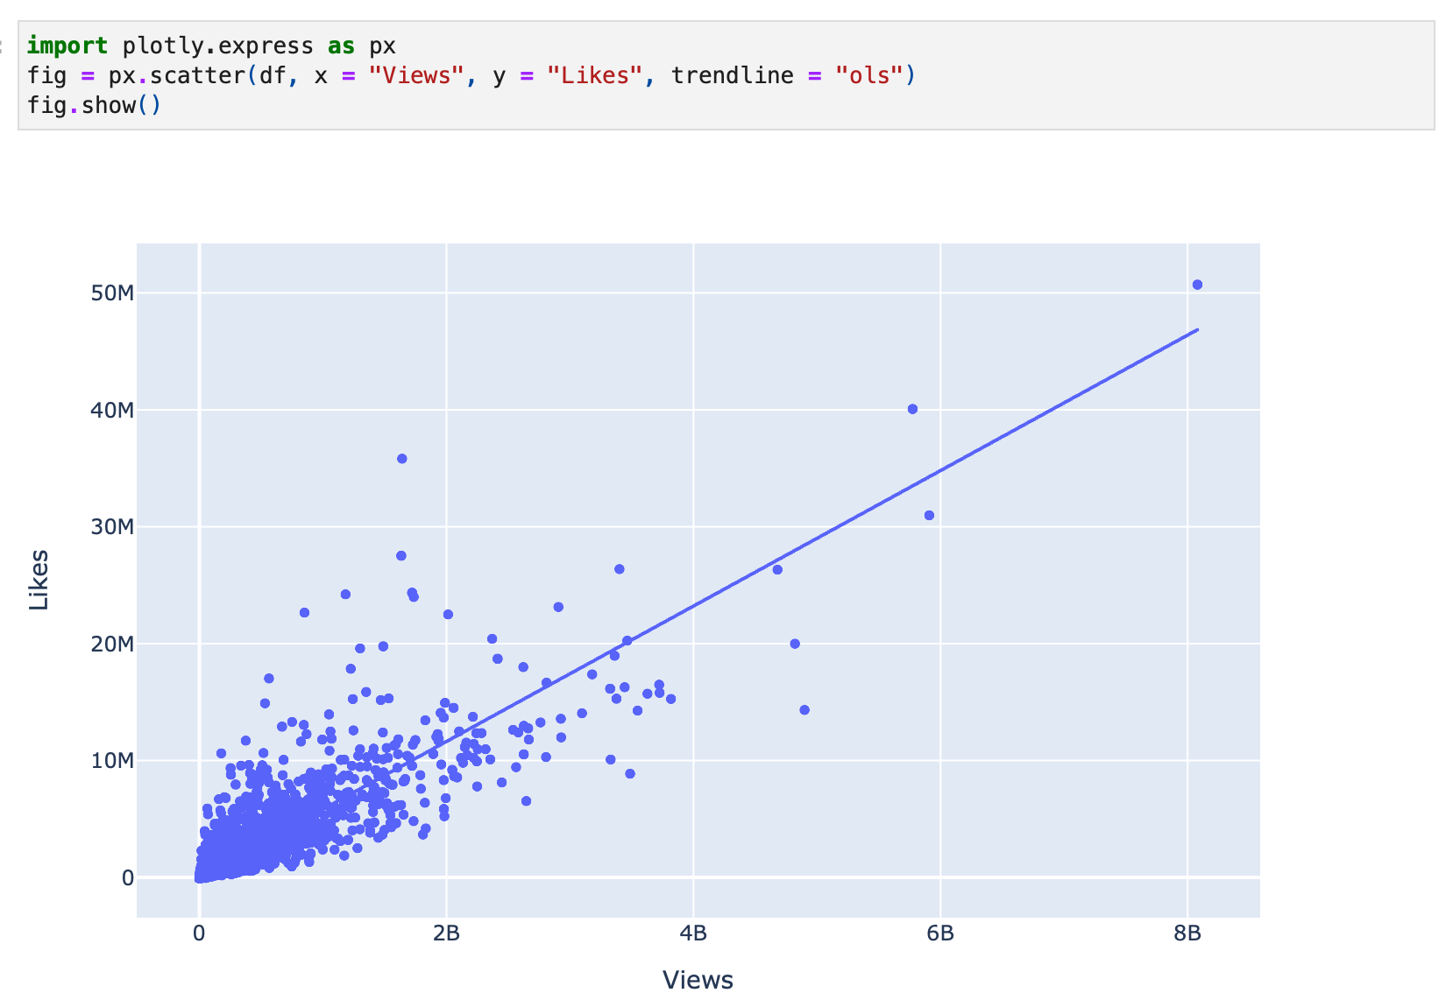

*Figure 45. scatter plot of Views and Likes distribution using plotly.express.*

Next, doing the same with Views and Comments using scatter plot.

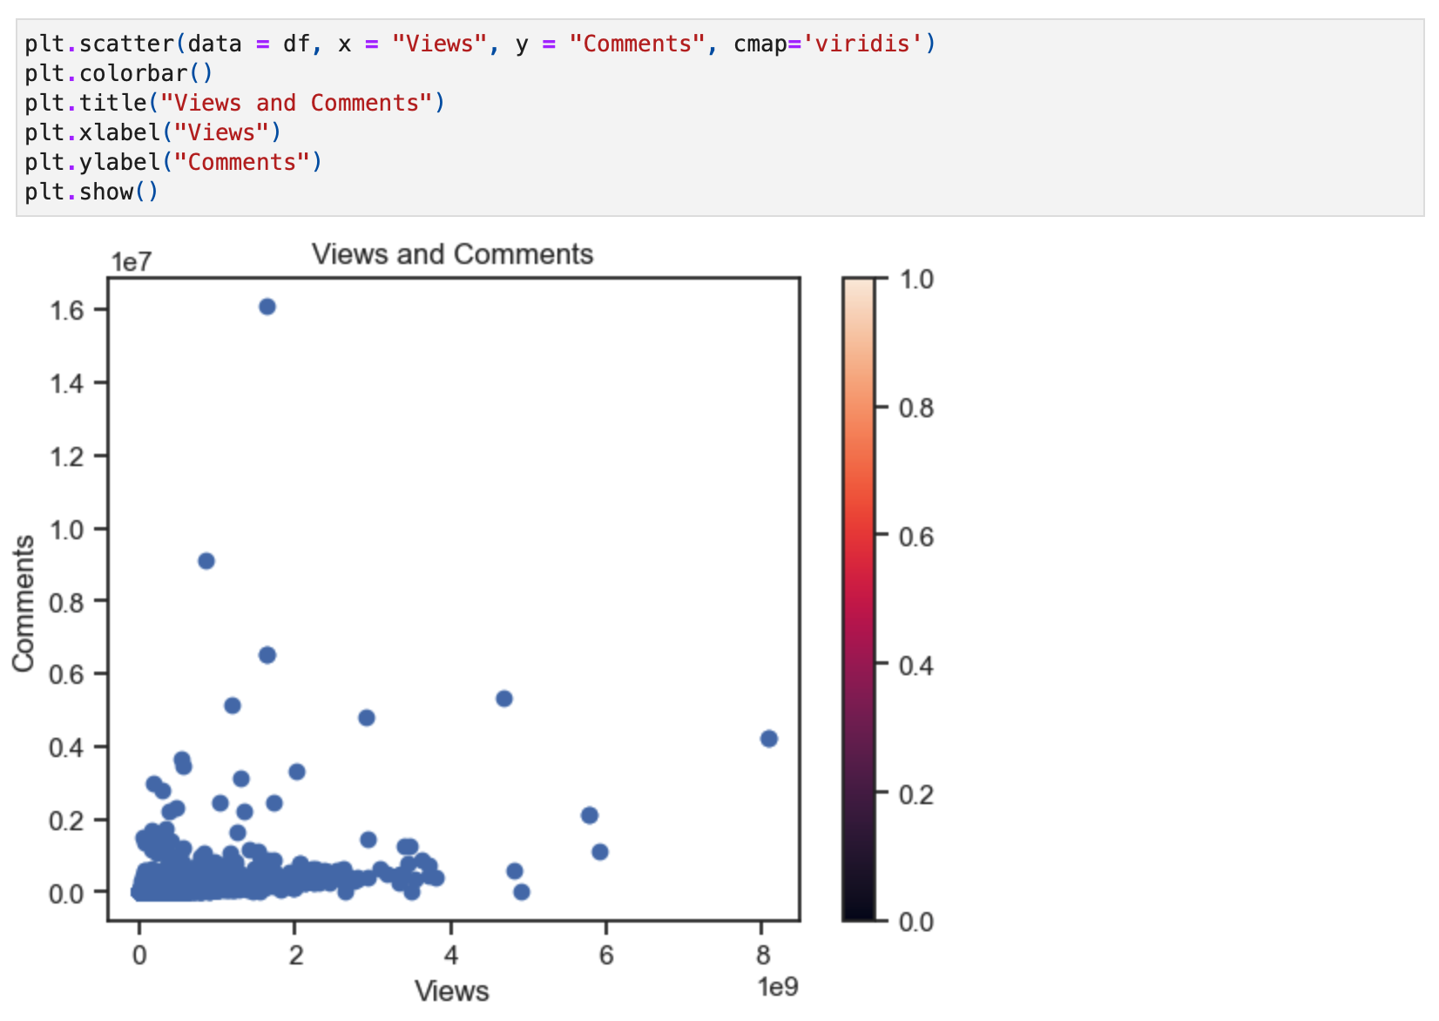

*Figure 46. scatter plot of Views and Comments distribution.*

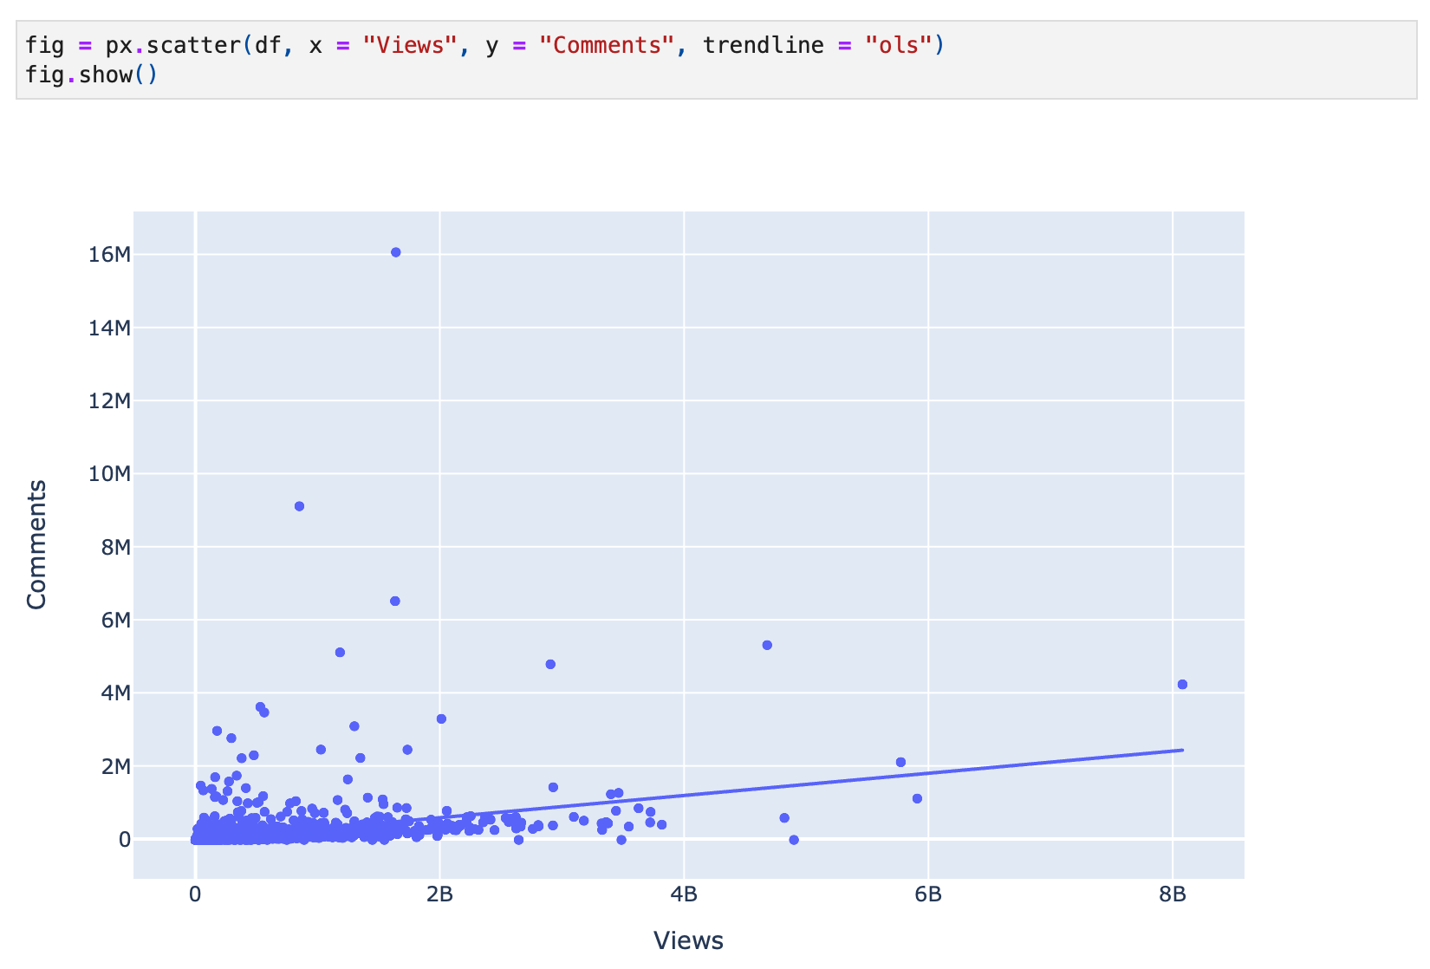

*Figure 47. scatter plot of Views and Comments distribution using plotly.express.*

Creating a Histogram from Artists with the most Views on YouTube, this example, got from plotly.com creating a Plotly histograms that "[...] is representation of the distribution of numerical data, where the data are binned and the count for each bin is represented." (plotlygraphs, 2019).

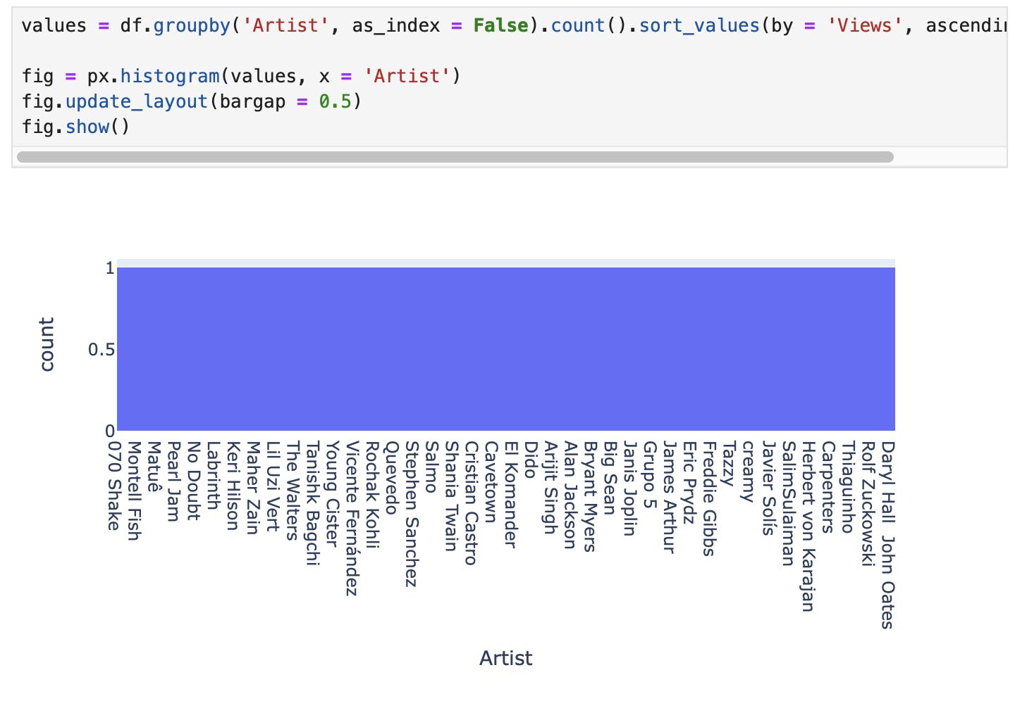

*Figure 48. histogram plot of the most views on YouTube by Artist using plotly.express.*

"Treemap of a rectangular DataFrame with plotly.express Hierarchical data are often stored as a rectangular dataframe, with different columns corresponding to different levels of the hierarchy. px.treemap can take a path parameter corresponding to a list of columns." (Plotly, 2024b).

Treemaps are an effective way of visualizing categorical data in a small space. (Madhugiri, 2021).

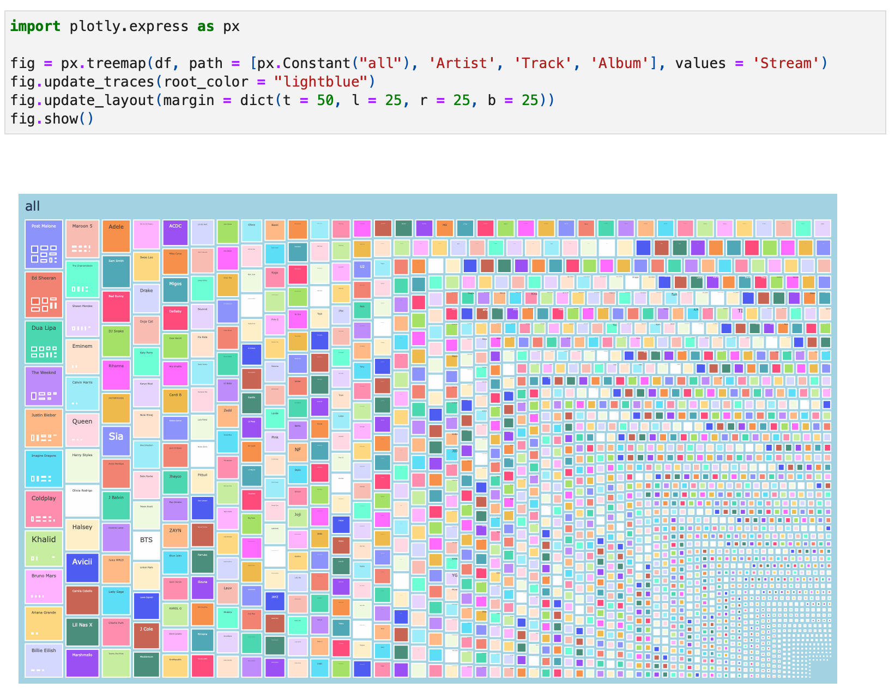

*Figure 49. treemap of the most Stream on Spotify by Artist using plotly.express.*

After lots of tests by myself and reading documents from: "pandas.DataFrame.sort_values" (The Pandas Development Team, 2024c), "pandas.DataFrame.groupby" (The Pandas Development Team, 2024b) and "pandas.DataFrame.agg" (The Pandas Development Team, 2024a), also a video on Youtube learning how to "Group By and Aggregate Functions in Pandas | Python Pandas Tutorials" (Alex The Analyst, 2023) by the Alex The Analyst YoutTube Channel and a topic create on Stack Overflow "pandas groupby, then sort within groups" (Stack Overflow, 2015) finally learned and got the results below.

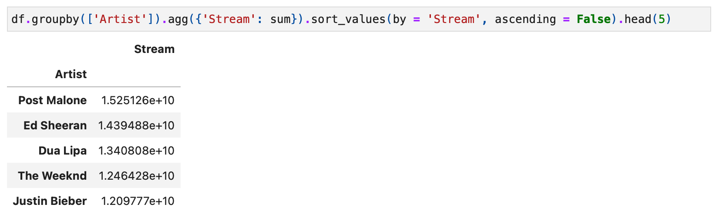

*Figure 50. table of the sum of the most Streams on Spotify by Artist.*

Below are created some code lines about statistics from the feature Danceability as a test and after using the “.describe” to check the values.

1. Mean: “numpy.mean” from numpy.org

2. Median: “numpy.median” from numpy.org

3. Mode: “pandas.DataFrame.mode” from pandas.pydata.org

4. Range: “numpy.max” minus “numpy.min” from numpy.org

5. Standard Deviation: “numpy.std” from numpy.org

6. Variance: “numpy.var” from numpy.org

7. Interquartile Range (IQR): “numpy.percentile” 75% - “numpy.percentile” 25% from numpy.org

8. Percentile 25%: “numpy.percentile” from numpy.org

9. Percentile 50%: “numpy.percentile” from numpy.org

10. Percentile 75%: “numpy.percentile” from numpy.org

11. Coefficient of Variation (CV): “numpy.std” divided by “numpy.mean” multiple by 100 from numpy.org

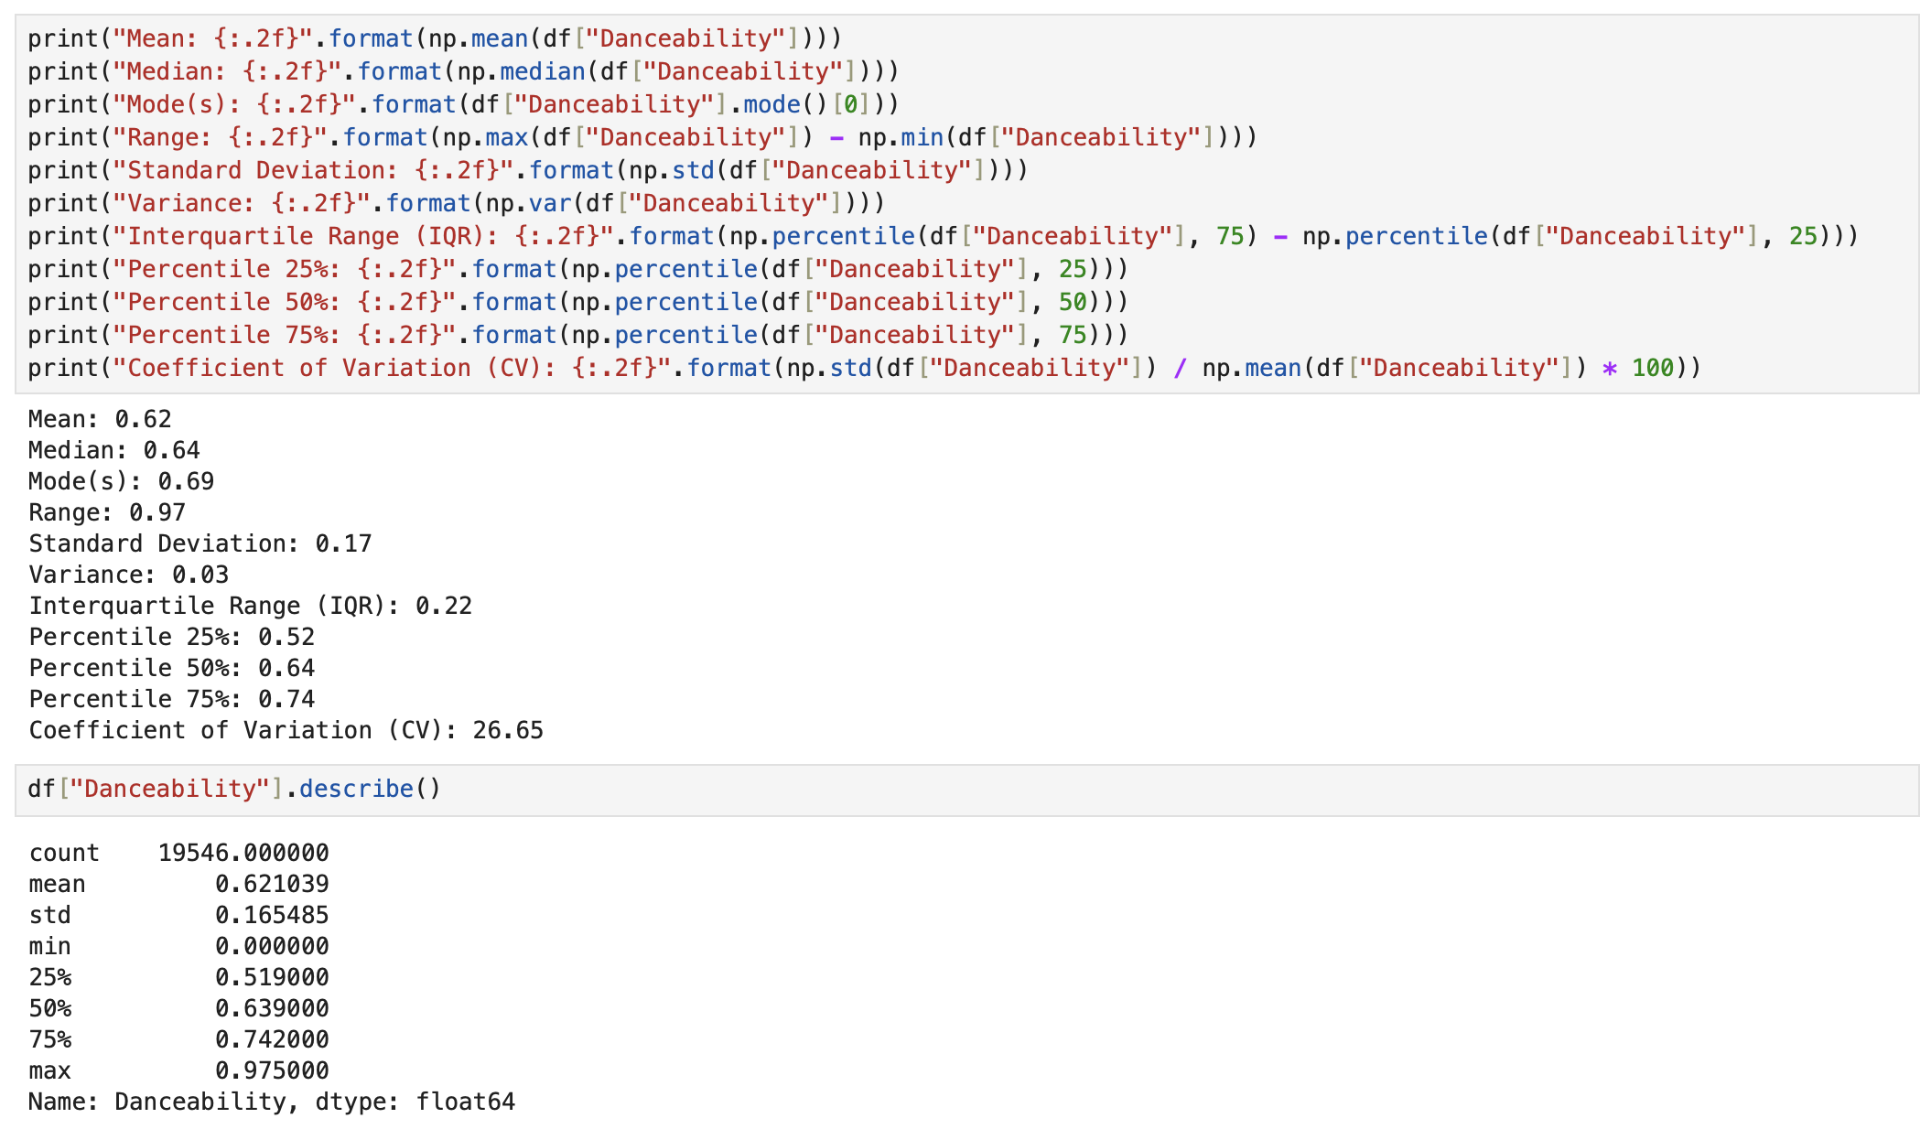

*Figure 51. Statistical results of the feature Danceability.*

|  |  |  |  |
| --- | --- | --- | --- |
| **Statistical math** | **Source** | **Formula** | **Image Formula** |
| Mean | numpy.mean | Mean = (Sum of all data points) ÷ (Number of data points) |  |
| Median | numpy.median | Median = [(n + 1)/2]th term  Median = [(n/2)th term + ((n/2) + 1)th term]/2 |  |
| Mode | pandas.DataFrame.mode |  |  |
| Range | numpy.max, numpy.min | R = Highest Value (H) - Lowest Value (L) |  |
| Standard Deviation | numpy.std |  |  |
| Variance | numpy.var |  |  |
| Interquartile Range (IQR) | numpy.percentile | Interquartile range = Upper Quartile – Lower Quartile |  |
| Percentile 25% | numpy.percentile |  |  |
| Percentile 50% | numpy.percentile |  |  |
| Percentile 75% | numpy.percentile |  |  |
| Coefficient of Variation (CV) | numpy.std, numpy.mean | CV = (σ/μ) |  |

*Table 01. Table of statistical math and their respective formulas.*

# **Dealing Outliers**

Checking how to manage the outliers in the features, first of all, it creates a copy of “df” data frame to not miss the data until here, in case success will keep the new feature created, whose name is "df_outliers" or copy to "df" again, next plotting a boxplot to check all features before handling outliers.

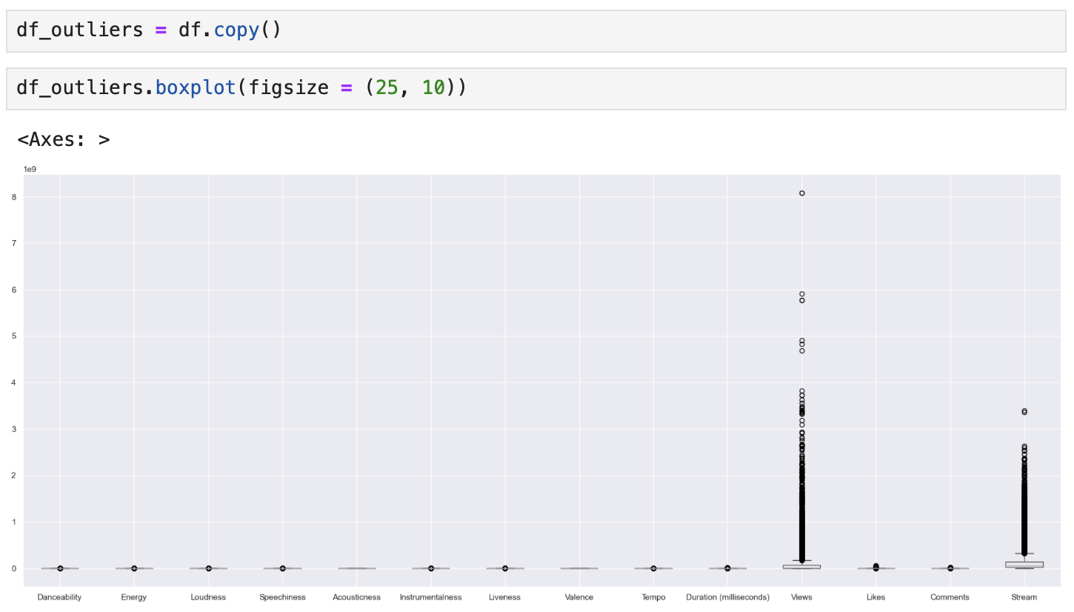

*Figure 52. boxplot of all features before handling outliers.*

Using the IQR (Interquartile Range) Scoring technique to detect and remove any outliers. "instead look at individual features and identify extreme values in those features using interquartile range (IQR)" (Albon, 2018, p.85) in "df_outliers".

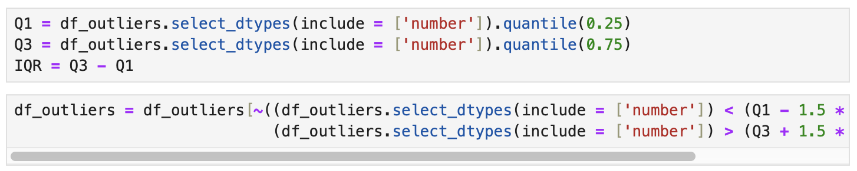

*Figure 53. Interquartile technique to handling outliers.*

Using ".shape" to check all many observations existent now in "df_outliers" after the IQR (Interquartile Range) changes to remove the outliers. The original data set in the beginning had 20718 observations, after dealing with missing data 19546 observations and after removing the outliers 8846 observations in total, less 10700.



*Figure 54. shape of df and df_outliers.*

Now plotting a boxplot once again to check what all features in “df_outliers” look like after dropping outliers.

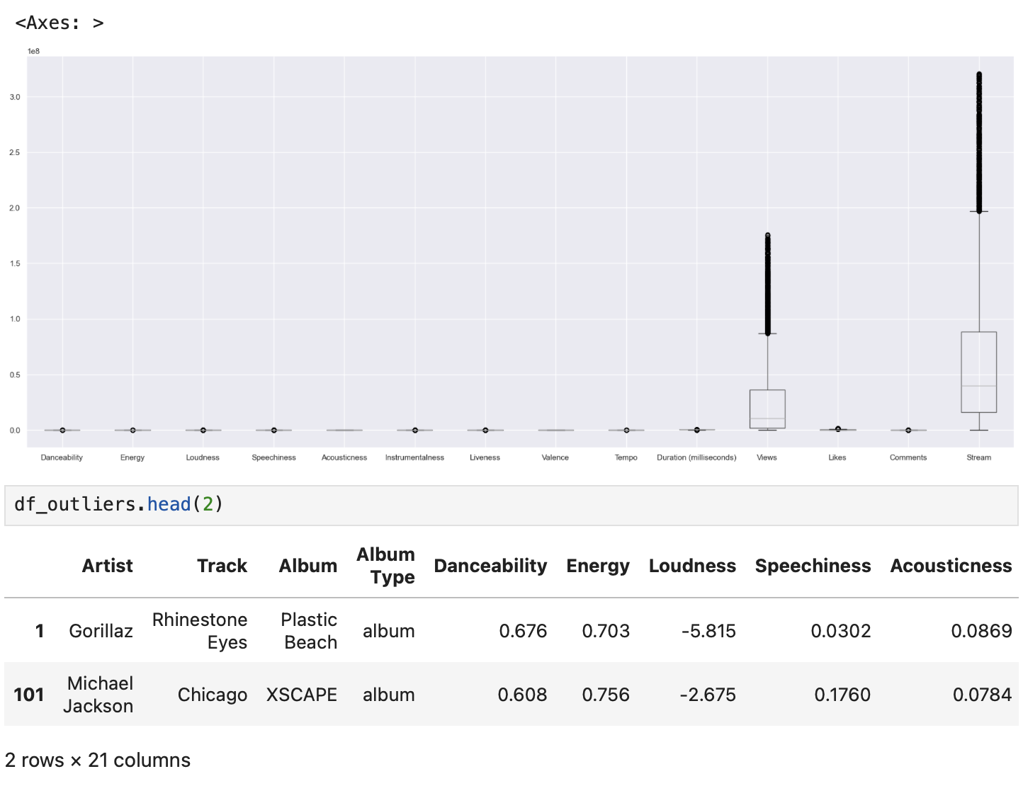

*Figure 55. boxplot of all features after handling outliers.*

In case one needs to use it until this part “df_outliers” data frame will be there ready.

# **Scaling / Transformation**

Other hypotheses were tested below, instead use “df_outliers” it will be using “df” and next applying the algorithms to remove outliers, which will be tested: MinMaxScaler, StandardScaler, Normalisation and RobustScaler. First of all, it creates a copy from df in df_MinMaxScaler, df_StandardScaler, df_Normalisation and df_RobustScaler to not miss the data until here, in case success will keep the results on the feature whose name will be "df_scaled".

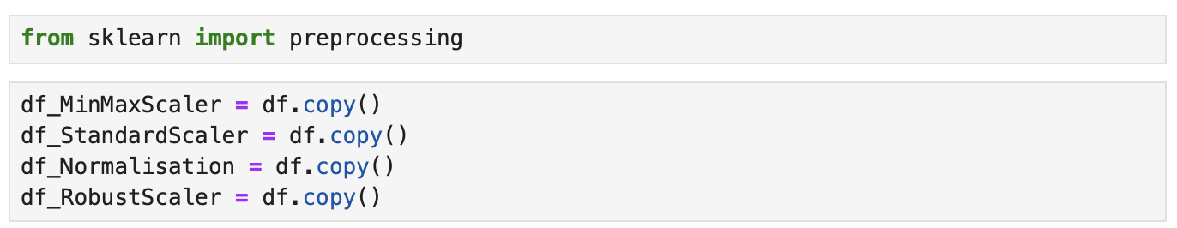

*Figure 56. New data frames to analyse scalation and outliers.*

Next, it applies the Scaler algorithms and plots a boxplot.

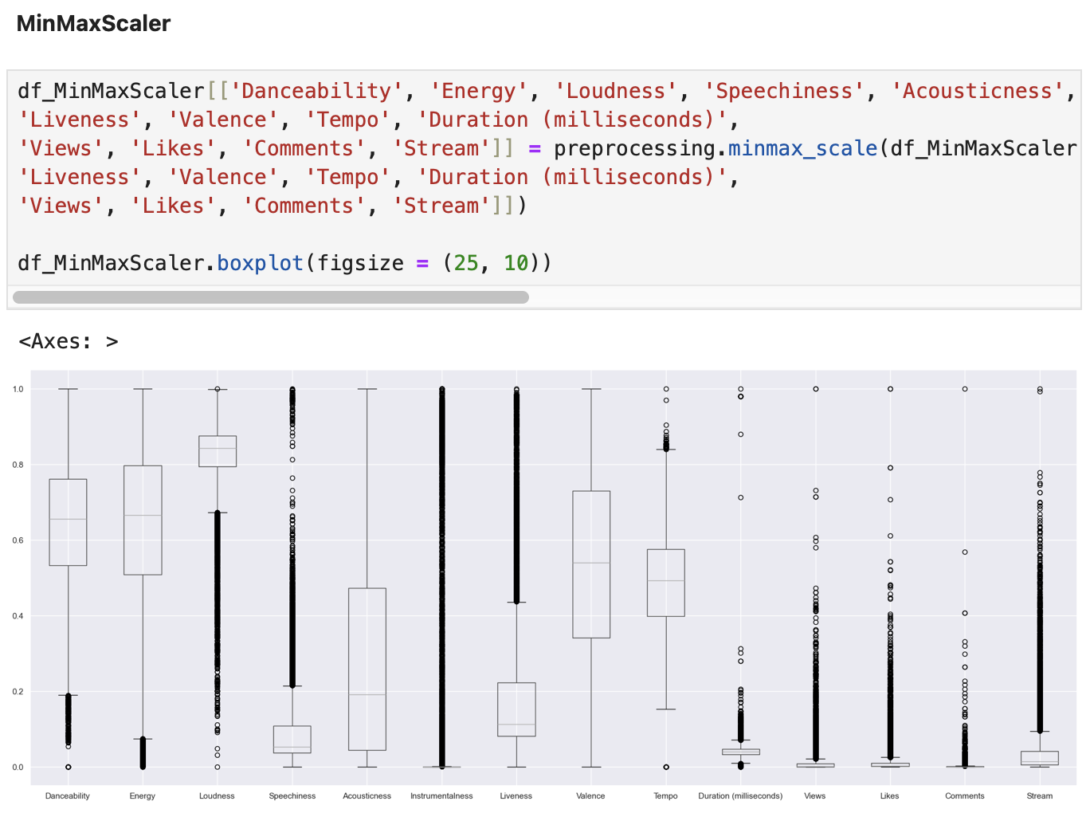

*Figure 57. boxplot of df_MinMaxScaler scaled.*

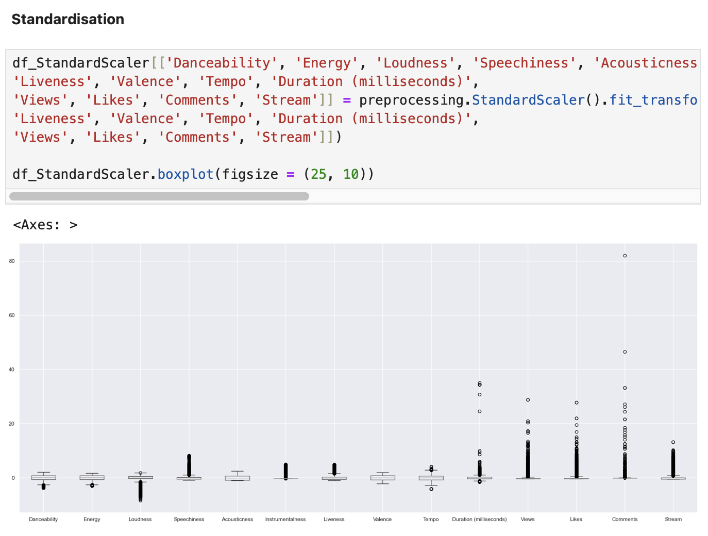

*Figure 58. boxplot of df_StandardScaler scaled.*

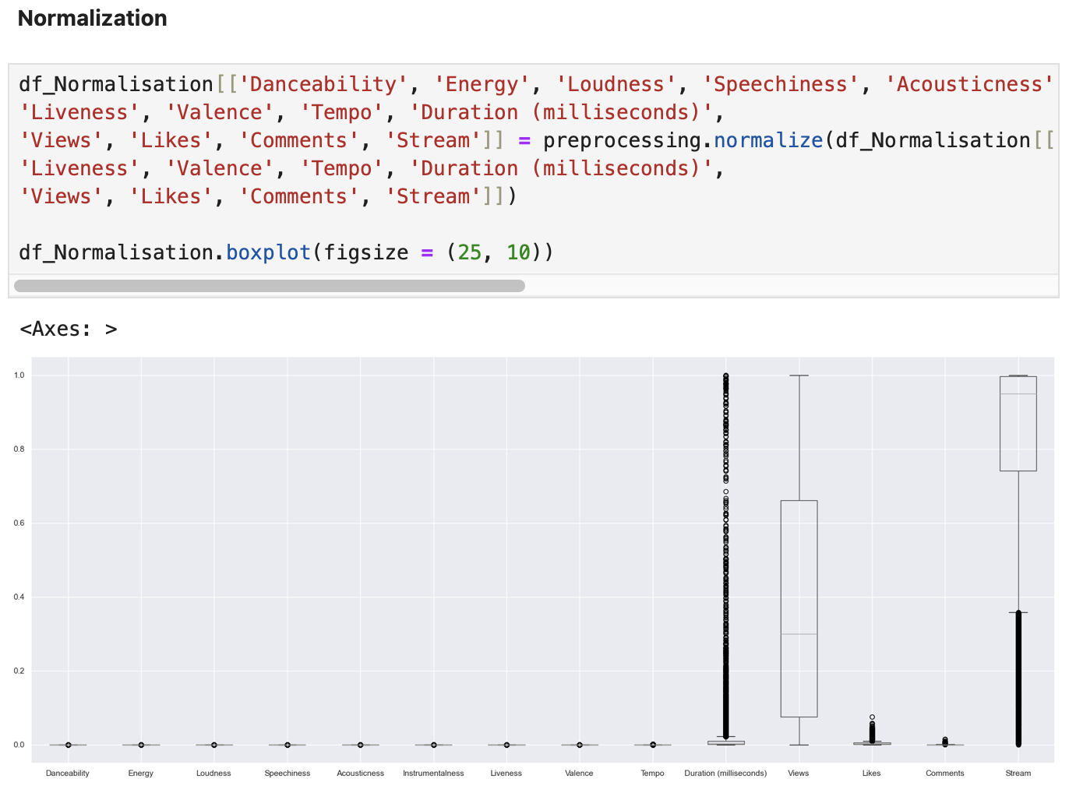

*Figure 59. boxplot of df_Normalisation scaled.*

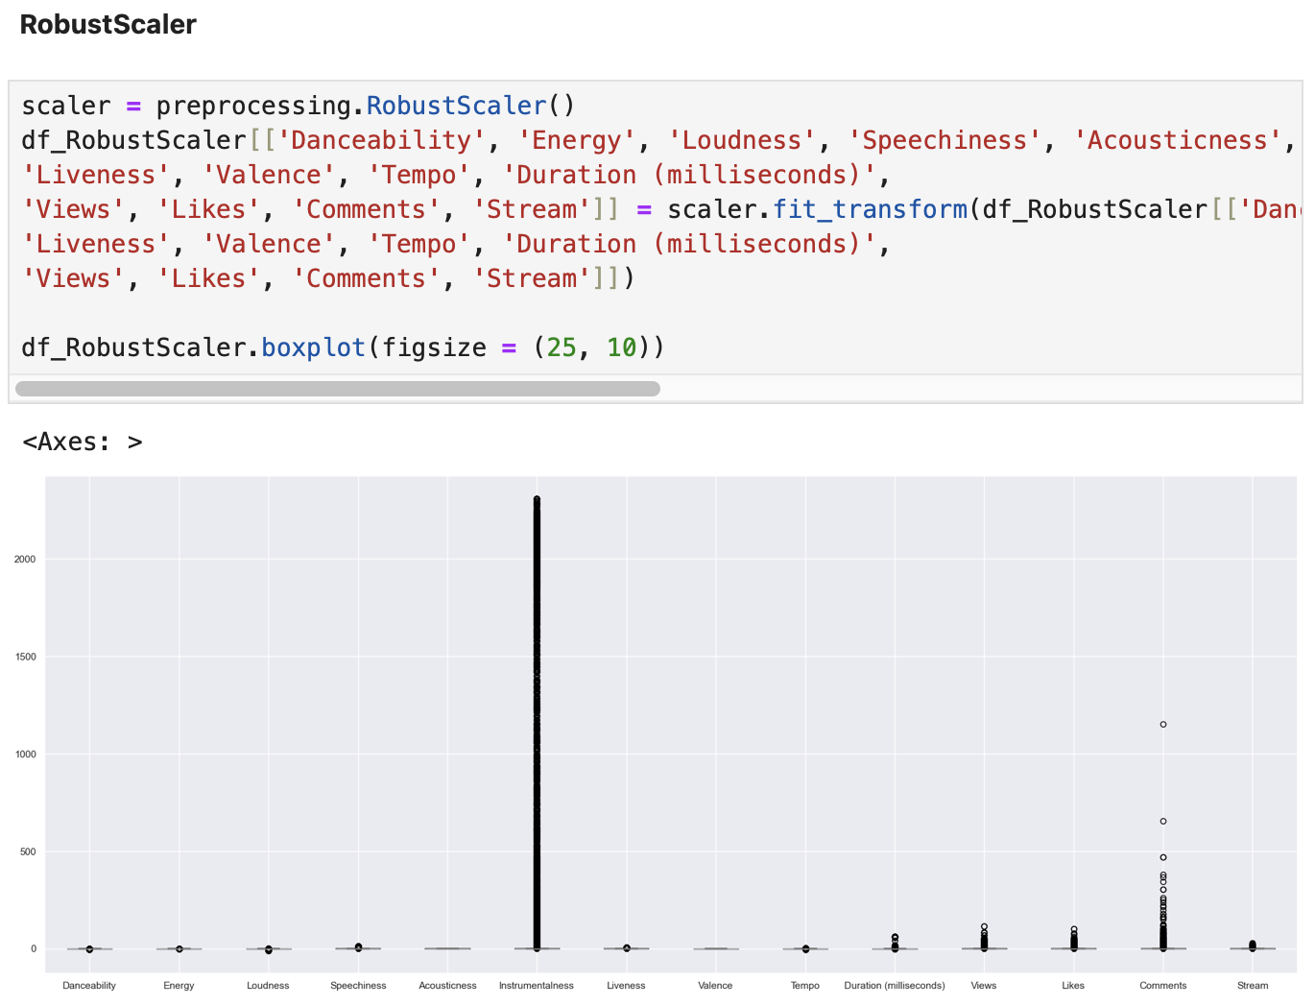

*Figure 60. boxplot of df_RobustScaler scaled.*

Next, it applies the "Interquartile Range" technique to detect and remove any outliers, plots a boxplot and shows the original “df” shape and the new one.

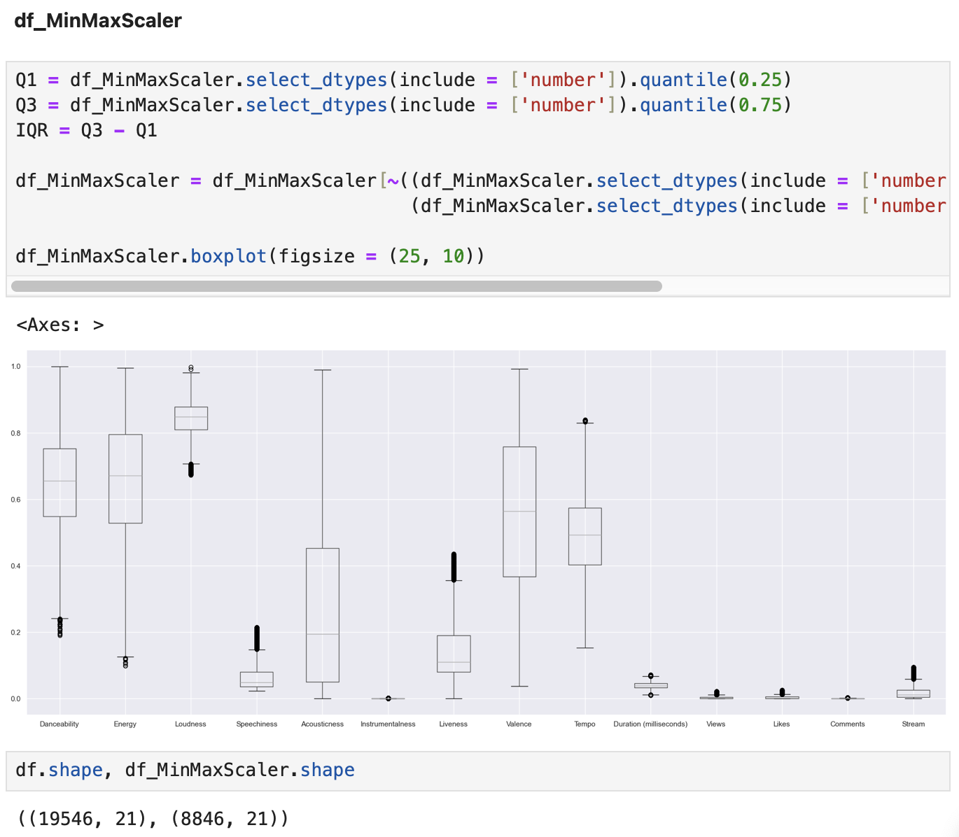

*Figure 61. boxplot of df_MinMaxScaler scaled and dealt with outliers.*

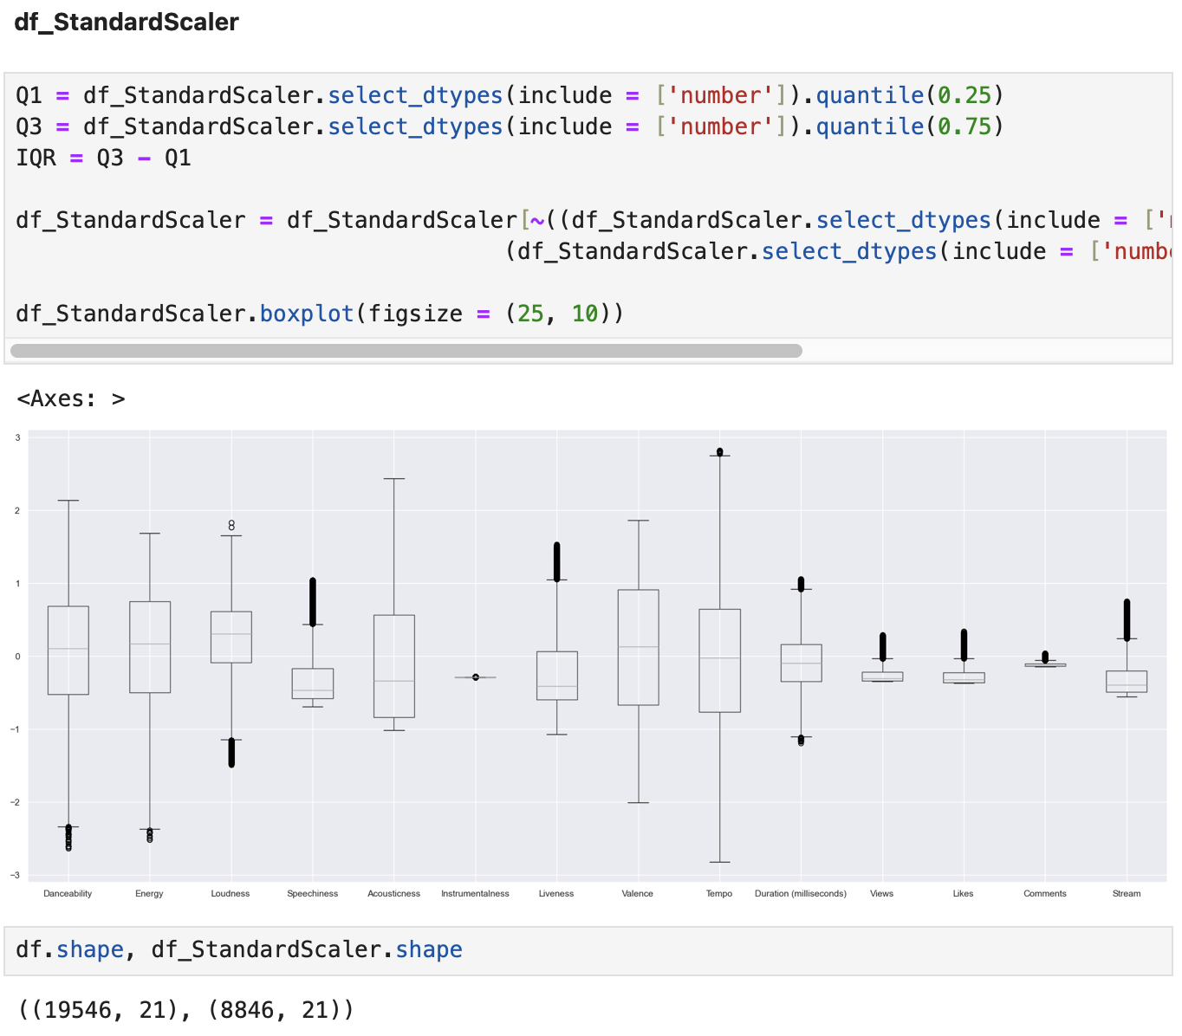

*Figure 62. boxplot of df_StandardScaler scaled and dealt with outliers.*

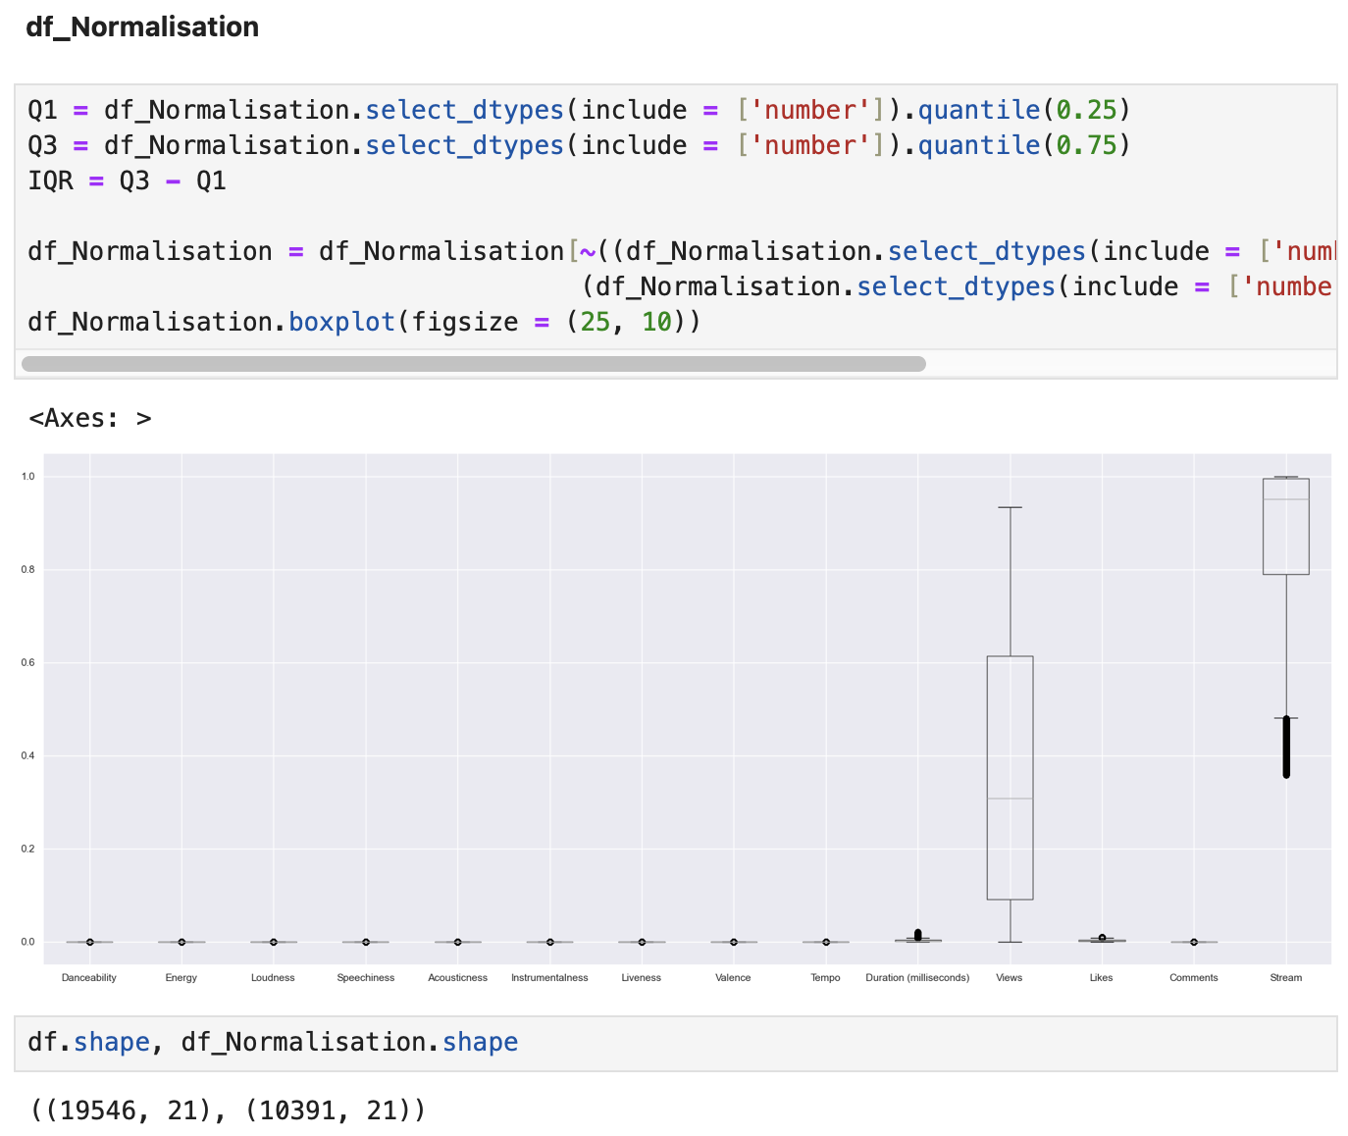

*Figure 63. boxplot of df_Normalisation scaled and dealt with outliers.*

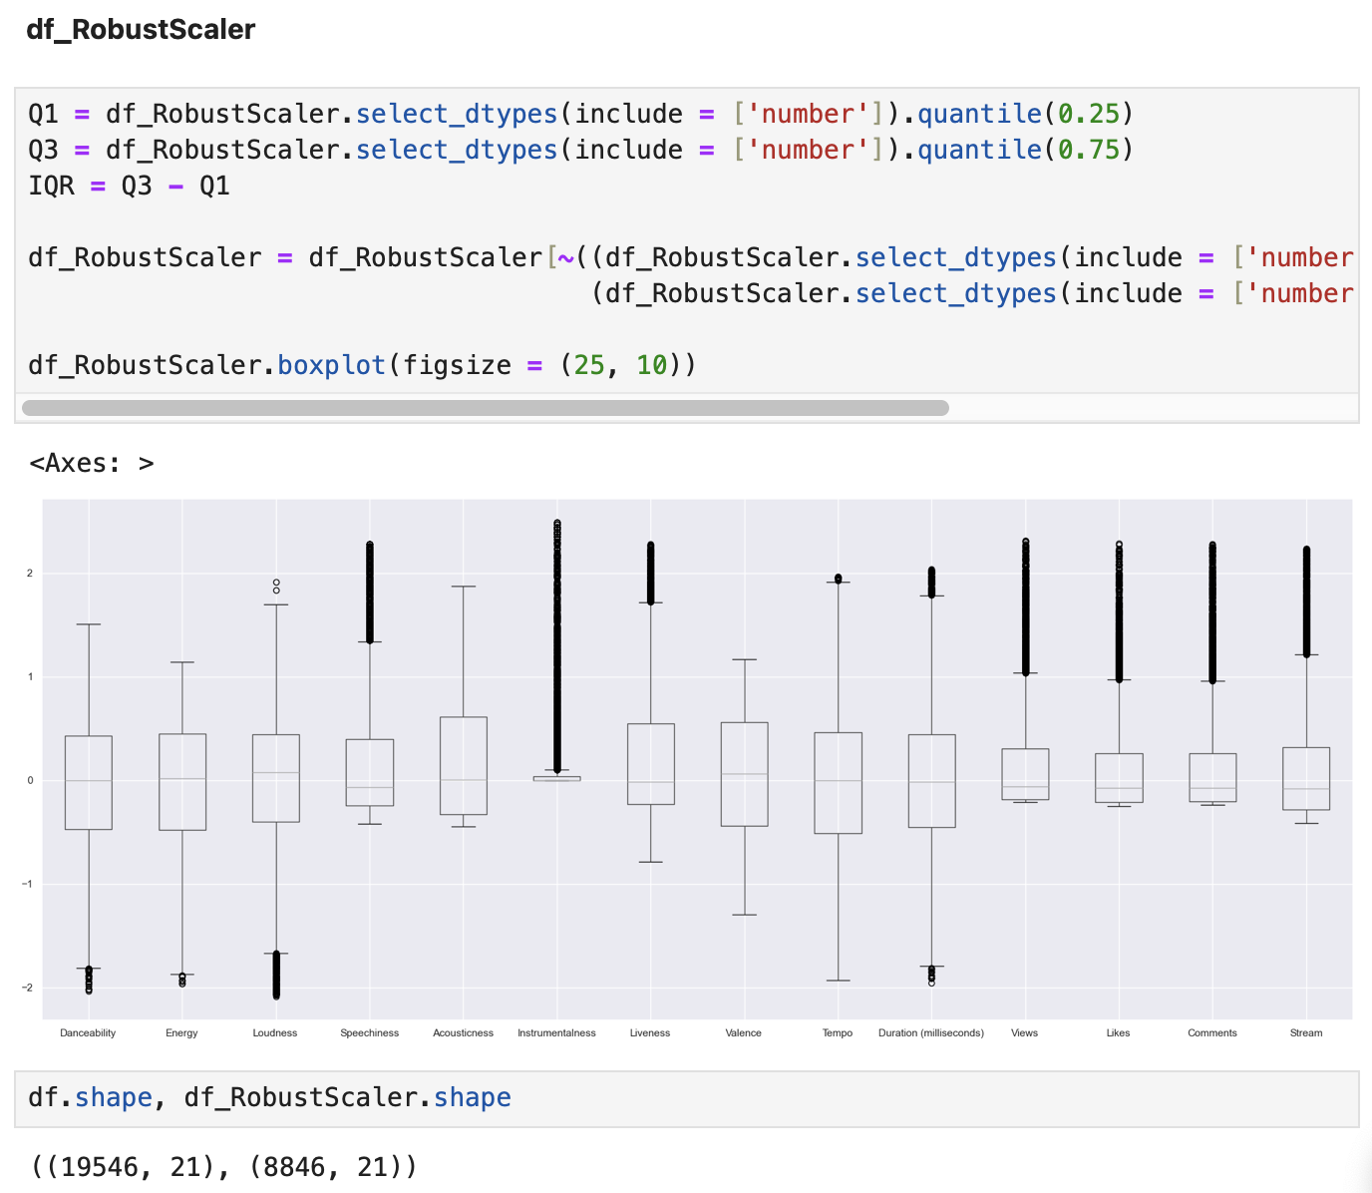

*Figure 64. boxplot of df_RobustScaler scaled and dealt with outliers.*

After analyses opted to keep RobustScaler as a good scaled this time due this algorithm being “[…] robust to outliers. This Scaler removes the median and scales the data according to the quantile range (defaults to IQR: Interquartile Range). The IQR is the range between the 1st quartile (25th quantile) and the 3rd quartile (75th quantile).” (scikit-learn developers, 2024).

For some reason after applying Normalisation the observations remained it was more than the other ones leaving 10391 from 19546 and all others leaving 8846 observations.

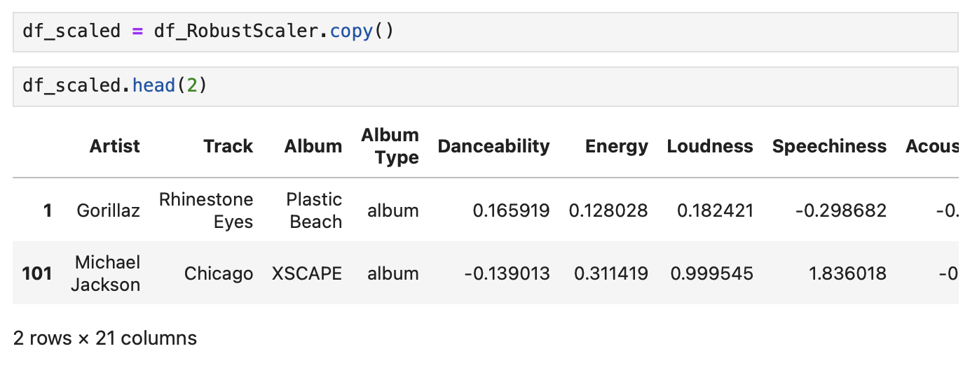

*Figure 65. Head of df_scaled after scaled and dealt with outliers.*

# **Creating Dummies**

Testing the algorithm Dummies in the Album Type feature to see how the result of a split in this feature or another feature if needed.

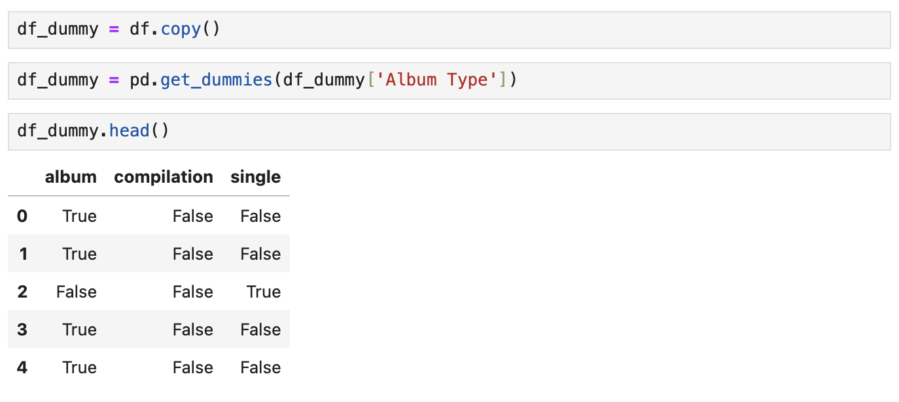

*Figure 66. Dummies in Album Type feature.*

# **MACHINE LEARNING - UNSUPERVISED LEARNING**

# **Principal Component Analysis (PCA)**

Using PCA to visualise the number of components that would be needed to describe the data by looking at the cumulative variance ratio plotted below and creating “no_label” variable to get all numerical features.

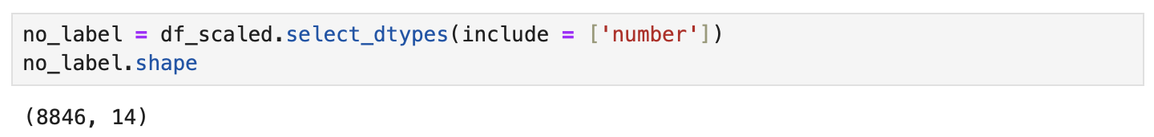

*Figure 67. no_label variable getting all numerical features.*

Importing PCA from “sklearn.decomposition” next a graphic plotted to analyse the number of components that will be needed to describe the data and show it in a plot graphic. In this case of 14-dimensional variance, we could choose 7 components approximately 80% of the variance.

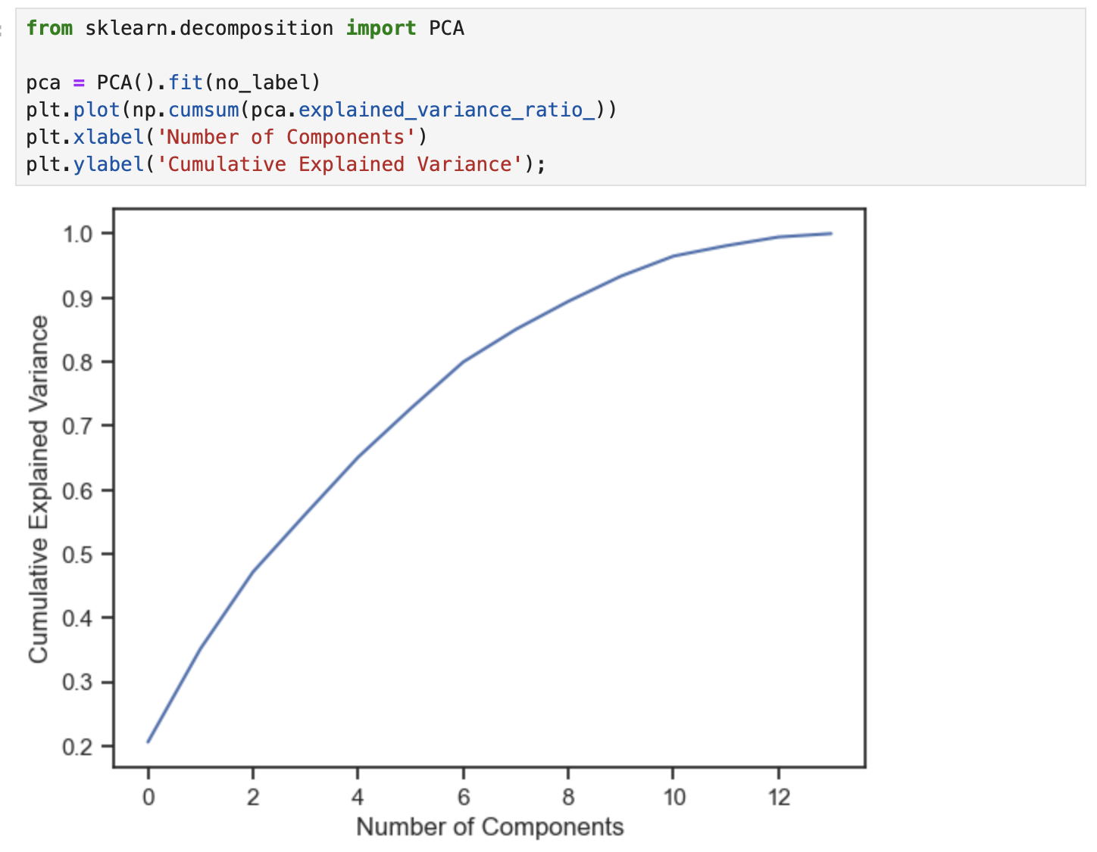

*Figure 68. PCA plot.*

Testing with 7 components, next transforming the data using PCA algorithms and saving on the 'df_pca' variable.

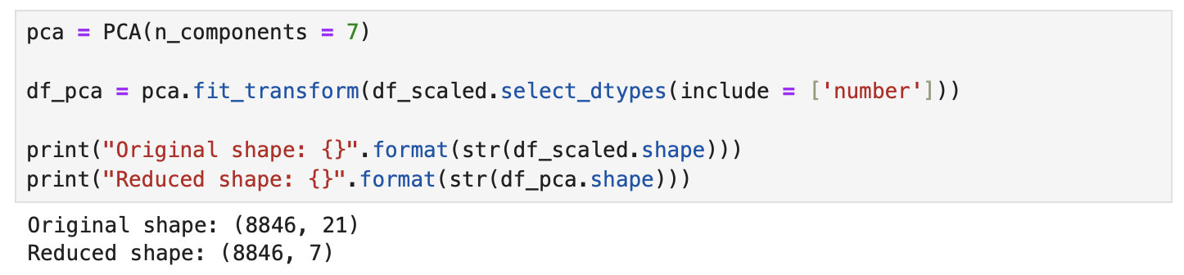

*Figure 69. PCA transform code.*

Getting the percentage and it is representing 79% of the data with 7 components.

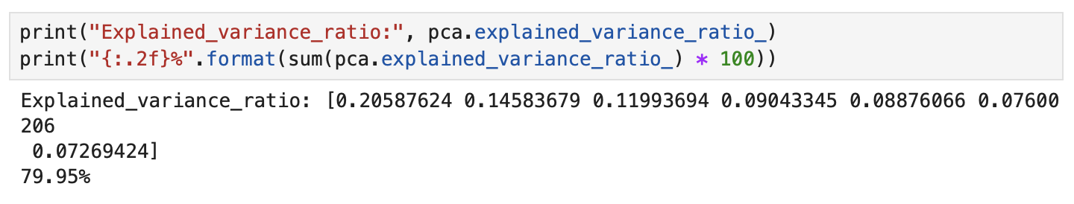

*Figure 70. PCA 7 components variance ratio.*

# **Creating examples to predict**

Goal: Create a new column with Top 500 Songs.

First, created an analysis of the data for a better understanding Checking how many unique artists exist in the data frame, in this case 1840.



*Figure 71. len of df Artist feature.*

Creating a new data frame copy whose name is “df_analysis” with just the features: Artist, Views, Likes, Comments, Stream.

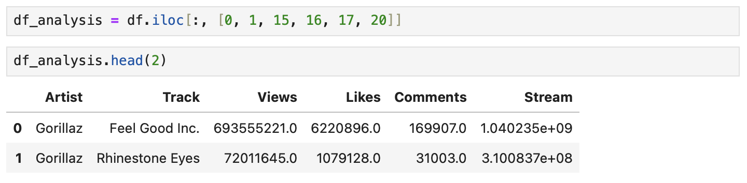

*Figure 72. df_analysis head.*

Getting the top 10 artists with the most views after performing the sum for each of them.

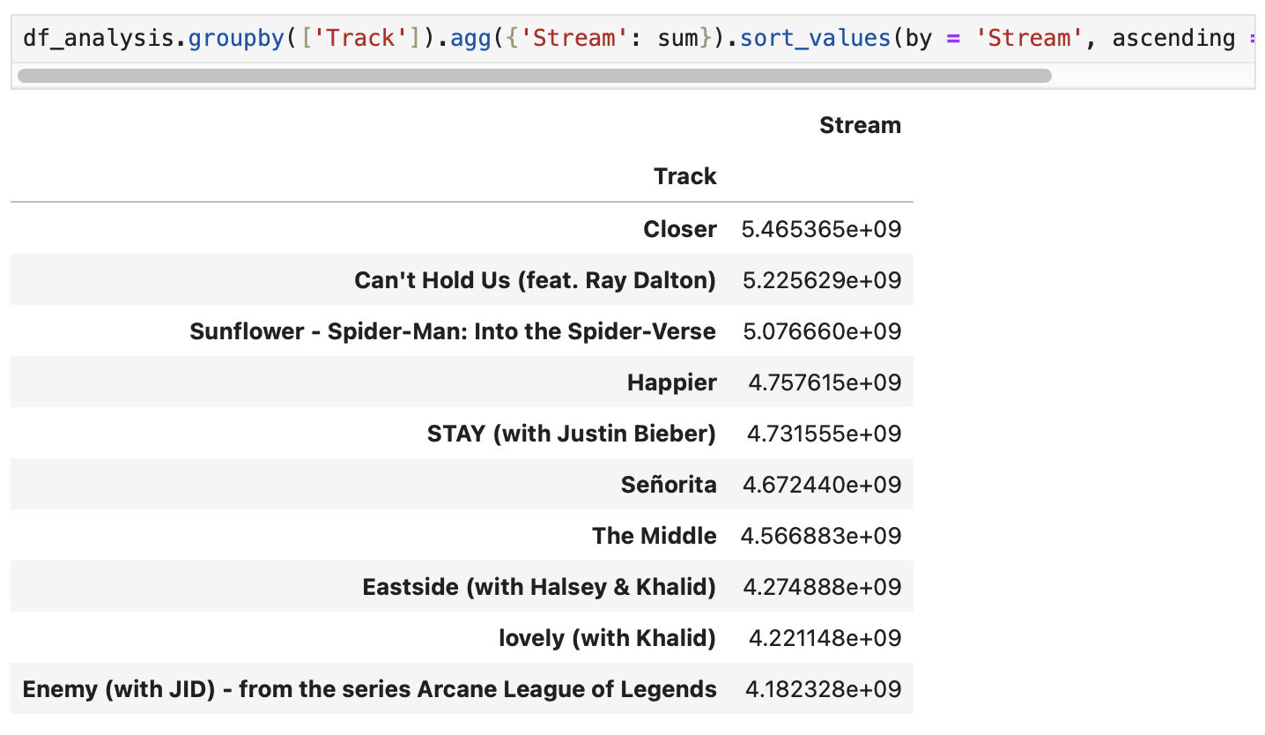

*Figure 73. Head of Top 10 artists.*

Using “sort_values” method to understand which Artist has the most of Stream without sum.

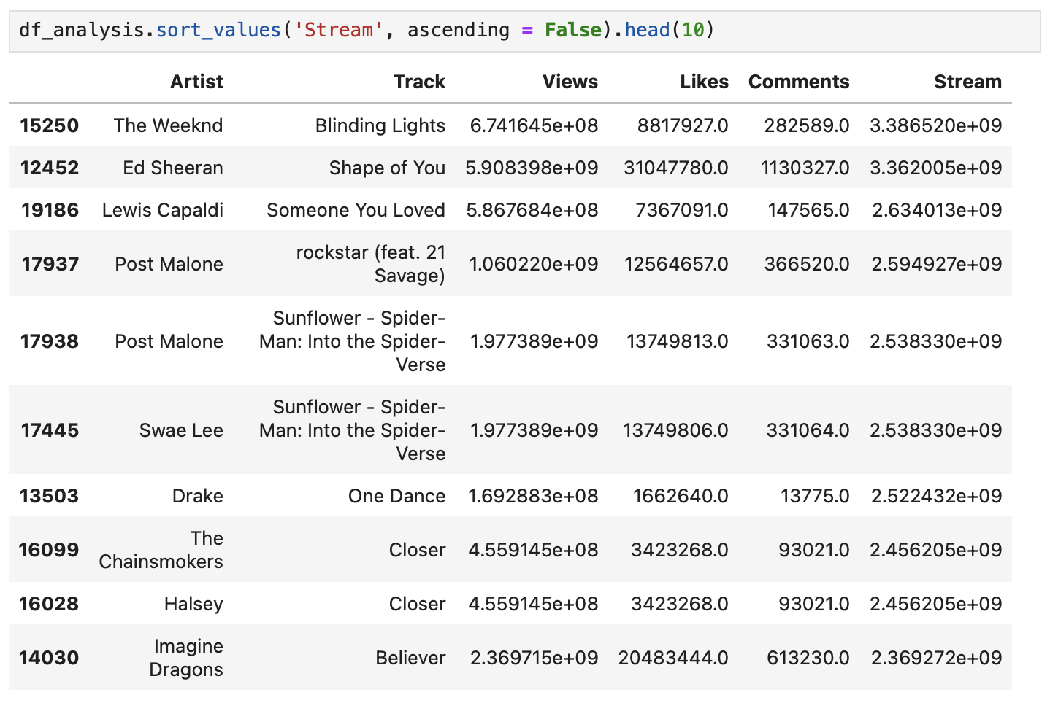

*Figure 74. sort_values of the most Artists on Stream value.*

Using the “agg” method to create a 5 list of Artists with the Features: Views, Likes, Comments and Stream returning below values such as mean, sum and count for each Artist, in this case, 070 Shake and other Artists were shown. Also create a new variable “df_analysis_sta” for save the values.

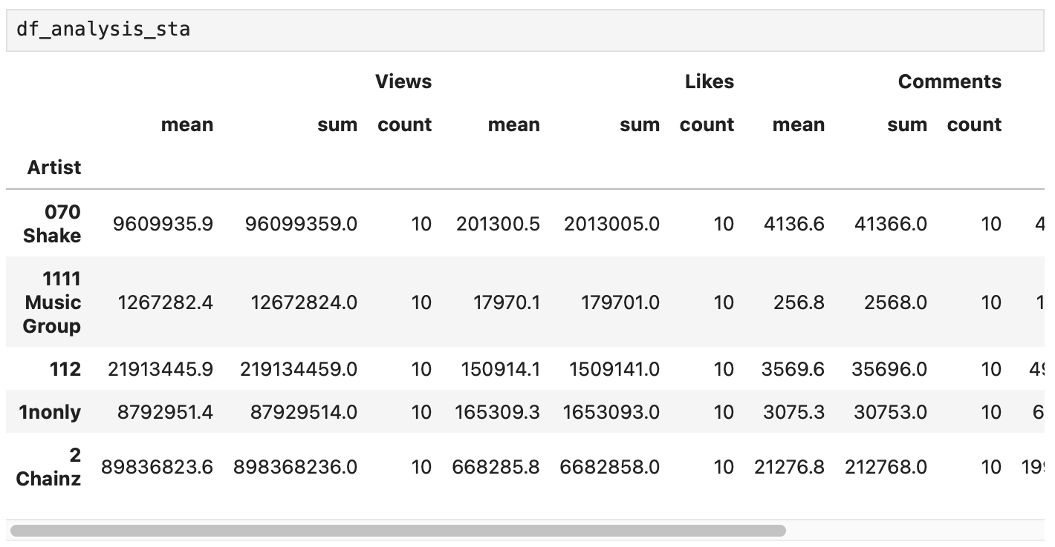

*Figure 75. Statistical values of Views, Likes, Comments and Stream.*

Below just using “ascending” parameter to show us the greatest number first.

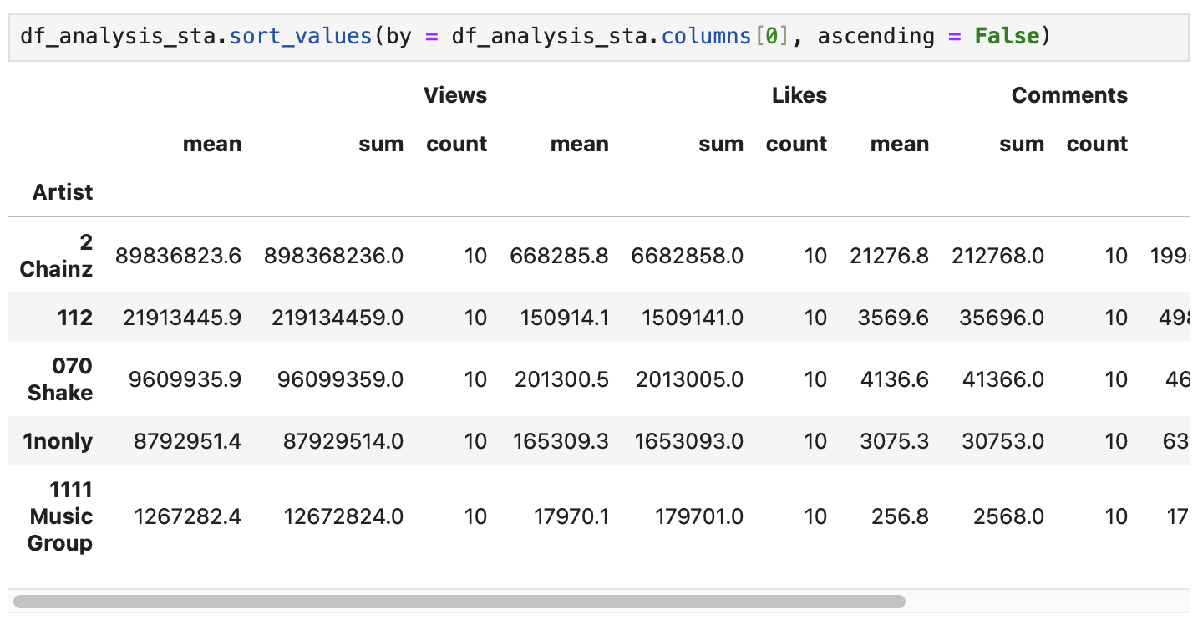

*Figure 76. Statistical values of Views, Likes, Comments and Streams in ascending order.*

After analysing the approach below it was chosen to perform the next steps to create a new feature with Top 500 Tracks.

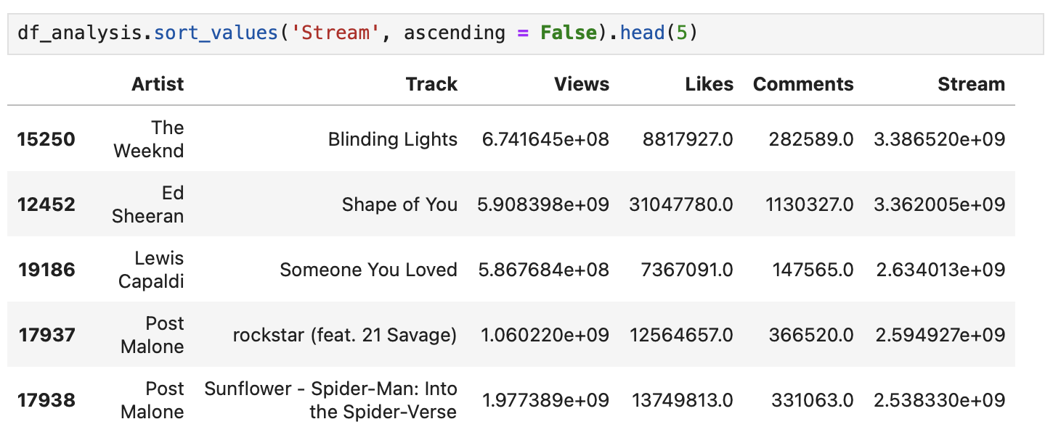

*Figure 77. Algorithm chosen using sort_values.*

Create a variable “stream_values” to save the values after got the result from 500 tracks.



*Figure 78. stream_values feature.*

Create a variable array_stream to save all unique values and sort the values from the min to the max value.



*Figure 79. array_stream array.*

Create a variable min_value to save the first index value from array_stream that it will return the min to the max value, in this case, 1786283585.0.

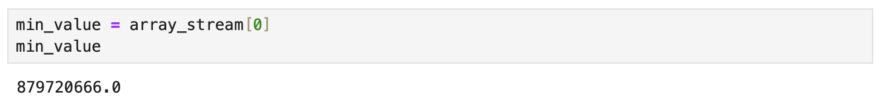

*Figure 80. Result of min values of array_stream.*

After finding and reading a tutorial on how "Add a Column to a Pandas DataFrame Based on an If-Else Condition" (Custer, 2020) and got the result below for each Stream value that is greater or equal to the min_value in this case, **1786283585.0** it will add a true Value otherwise False to the new feature Top_Tracks



*Figure 81. New feature Top_Tracks.*

Just checked below using .value_counts() if there are different values between and False, in this case, it was expected 500 True values

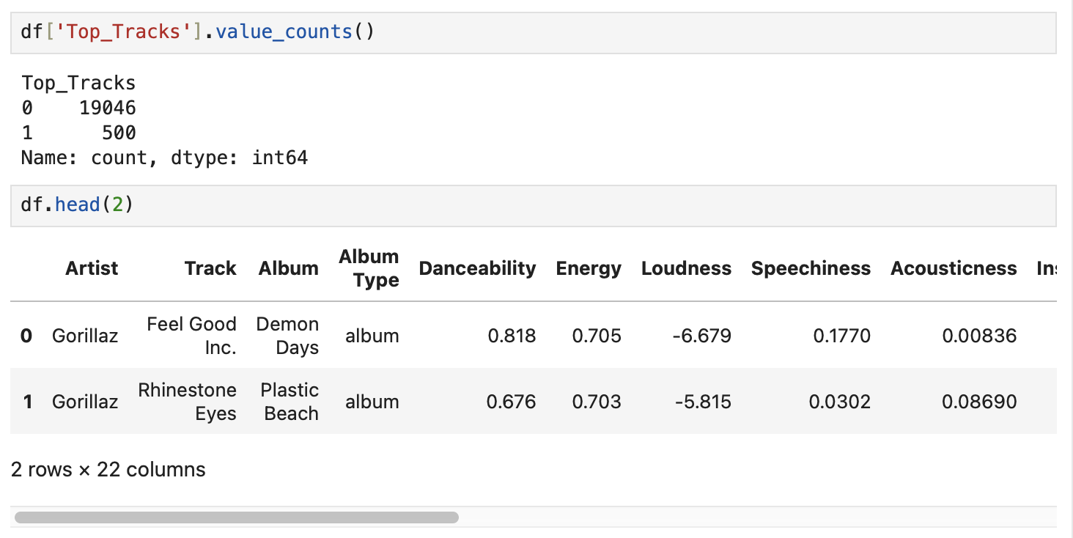

*Figure 82. New df Head.*

Next plotting using scatterplot with X in Views and Likes in Y, Top_Tracks as legend.

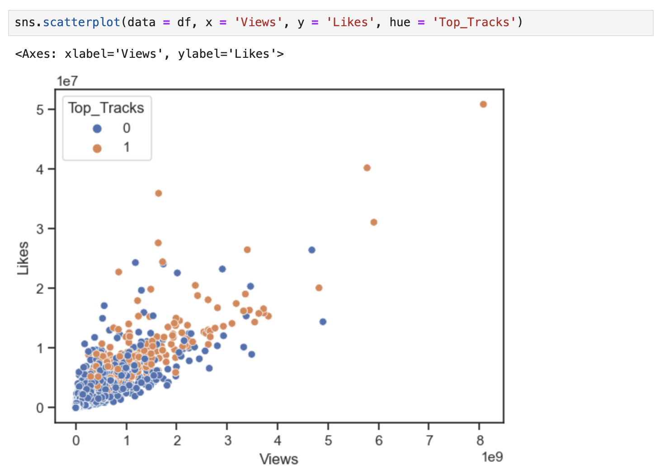

*Figure 83. scatterplot of Views and Likes as Top_Tracks hue.*

# **Preparing for Analyses**

Created a new copy of a data frame whose name is `df_pred` and applied the algorithms to remove outliers and scaling with RobustScaler.

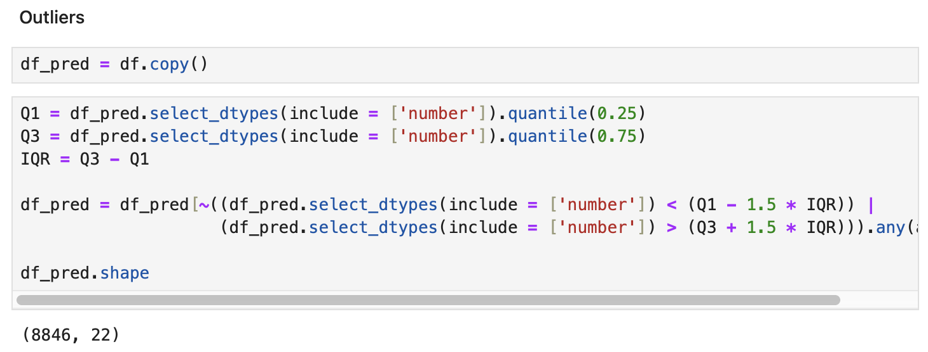

*Figure 84. Dealing outliers.*

But opted to leave the Ouliers algorithm commented once there was an impact in the Top_Tracks feature.

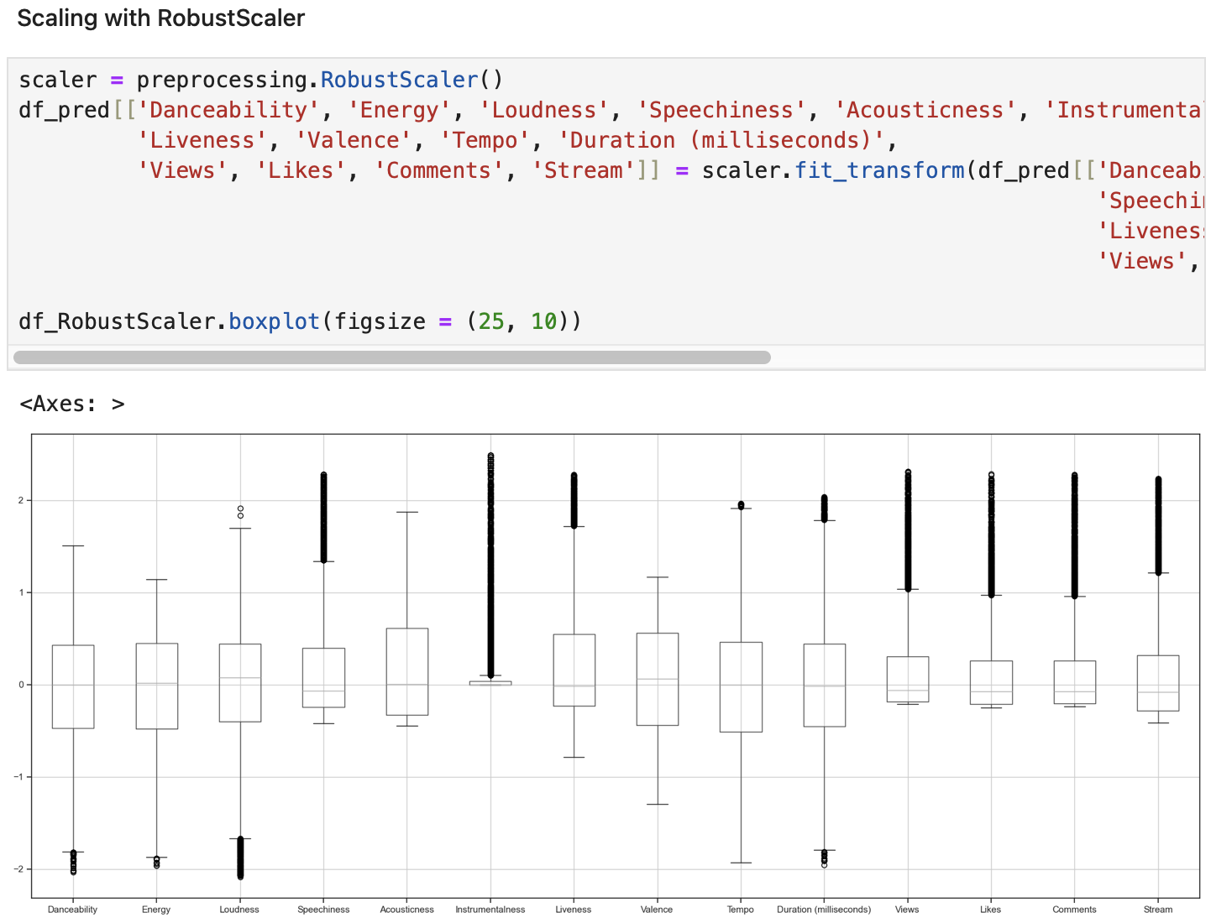

*Figure 85. Scaling df_pred data frame and plotting with boxplot.*

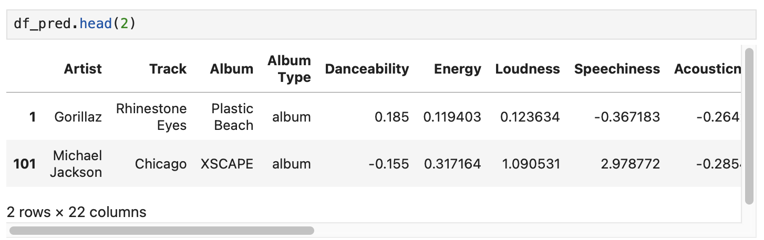

*Figure 86. Head of df_pred data.*

# **PCA**

Using PCA once again just to show with machine learning algorithm will be the best in this case of data.

Created no_label data frame to get all numeric features. Testing with 7 components, next transforming the data using PCA algorithms and saving on the 'projected' variable.

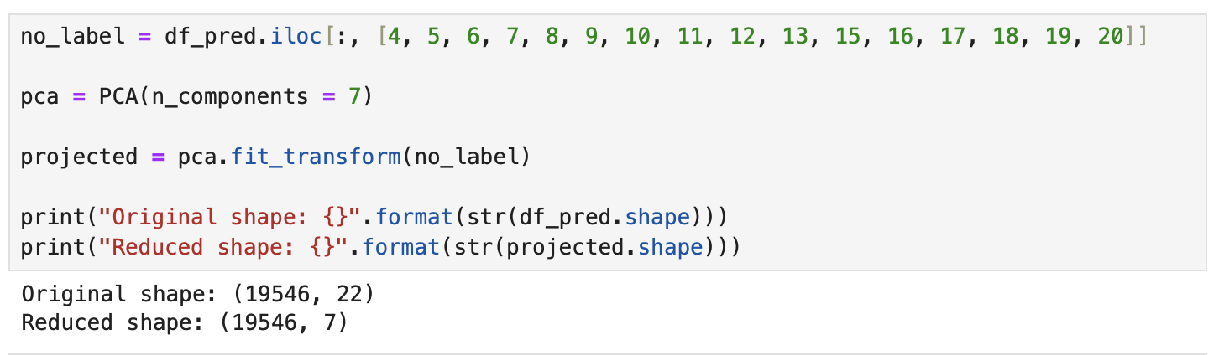

*Figure 87. PCA algorithms.*

Creating a new data frame "df_pca" to save the data after transforming with those new 7 features.

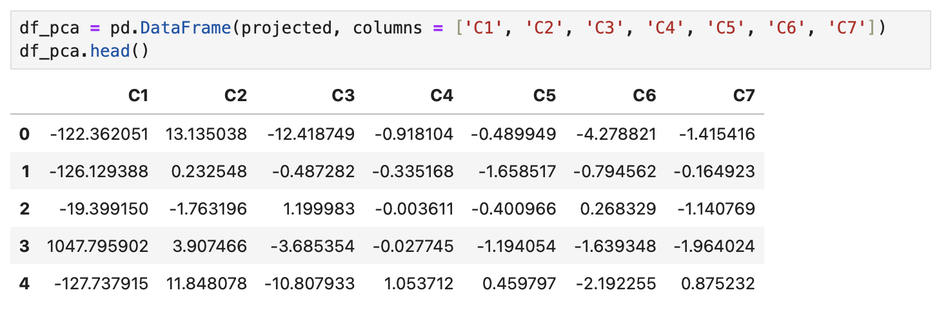

*Figure 88. Head of df_pca Data Frame.*

Creating a new column whose name is "Top_Tracks" copying from the original data frame "df_pred".

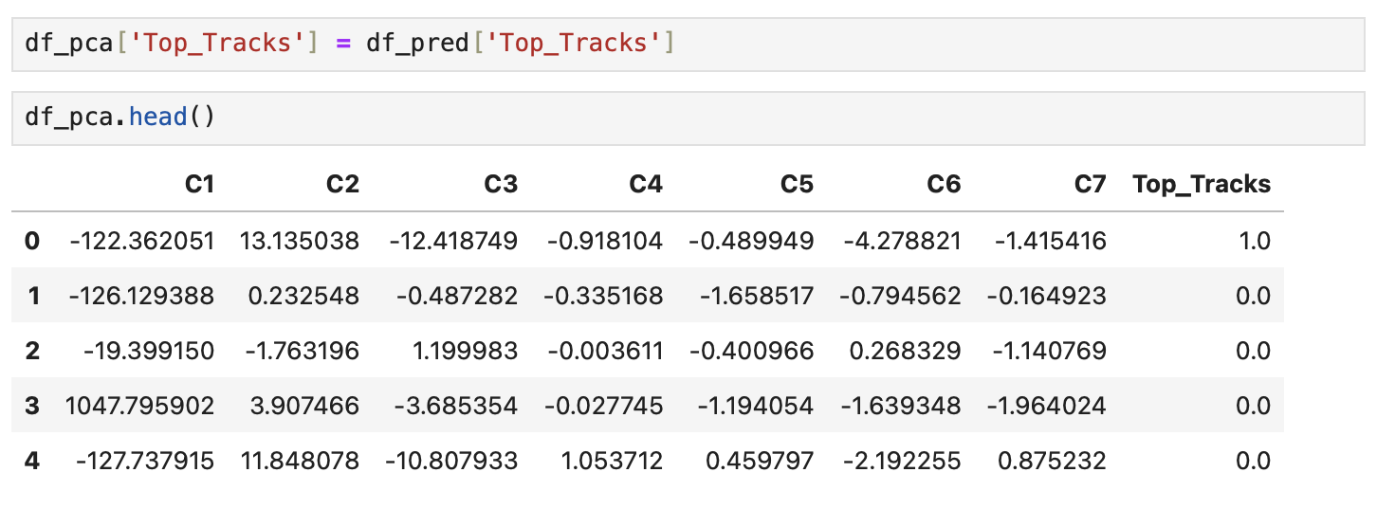

*Figure 89. Head of df_pca Data Frame with Top_Tracks.*

Check with "isnull().sum()" if there are any missing values after creating a new column.

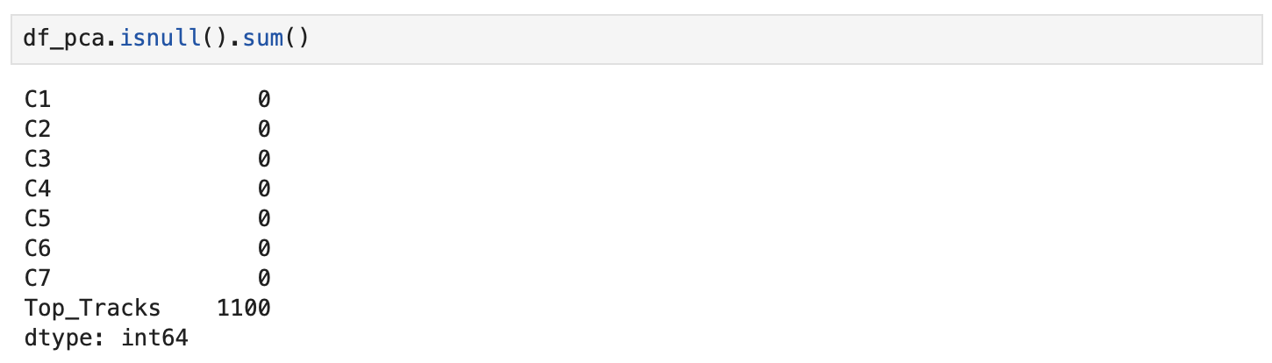

*Figure 90. df_pca checking null values.*

For any reason, there are missing values in the feature "Top_Tracks", in this case, it will be dropped using ".dropna(axis = 0)".

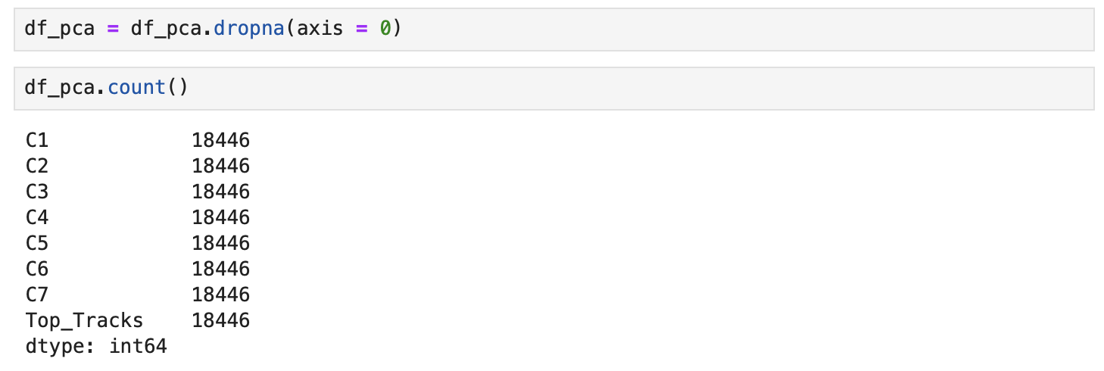

*Figure 91. df_pca after dropping null values.*

Creating an array variable to copy all ".values" from the data frame "df_pca" for use in machine learning.



*Figure 92. df_array of df_pca.*

Creating the variables X and y for use in the machine learning model algorithm:

* X for getting the features (Independent variables) and
* y for getting the feature Target for the prediction

Also creating the variables X_train, X_validation, Y_train, Y_validation, for training and test the model, chosen first with 20% of the data for testing with a seted random_state = 1, to split random 1 by 1 and 80% of the data for training.

80% Training, 20% Test.

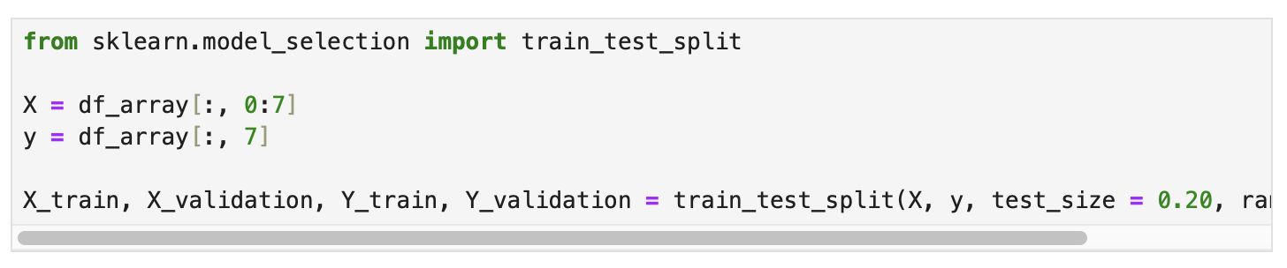

*Figure 93. Splitting the data into train and test.*

Importing some functions from "sklearn" to get an predict of each algorithm, and compare which of them should be better to use after analysis in the data.

Functions like: LogisticRegression, LinearDiscriminantAnalysis, KNeighborsClassifier, DecisionTreeClassifier, GaussianNB and SVC, also StratifiedKFold, cross_val_score, accuracy_score, confusion_matrix and classification_report.

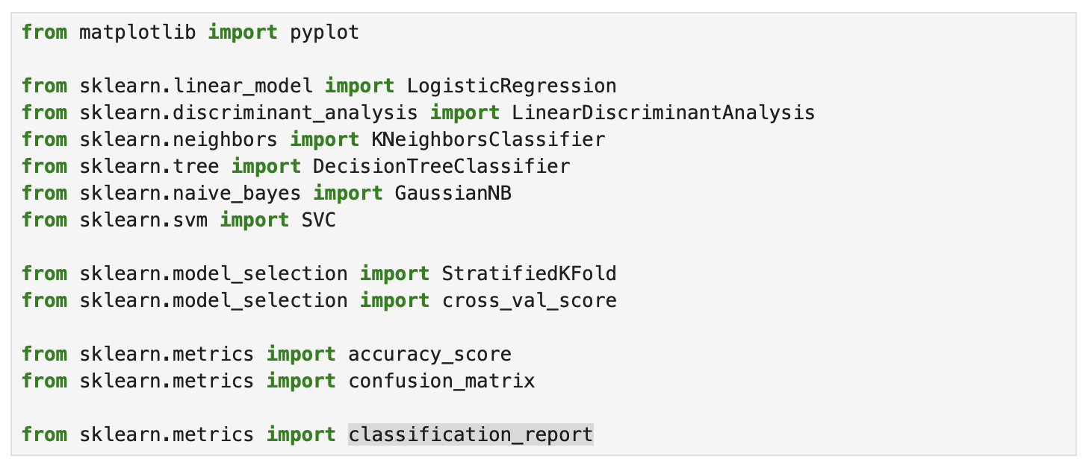

*Figure 94. Importing new classes, libraries and so on.*

Creating an empty list whose name is models and next using ".append" to add a short description and function.

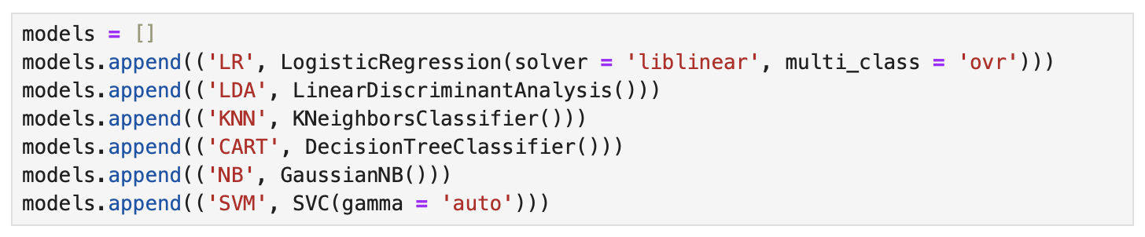

*Figure 95. models of Machine learning algorithms.*

Creating two empty list whose name are results and names, next, using a for loop for each name and model in models.

Using StratifiedKFold and cross_val_score to split, random values, shuffle and do a cross with the X and y variables to traind and getting a scoring and adding the results in results and names. Next, printing the short description of the function's name, the mean of the results and the standard deviation of them.

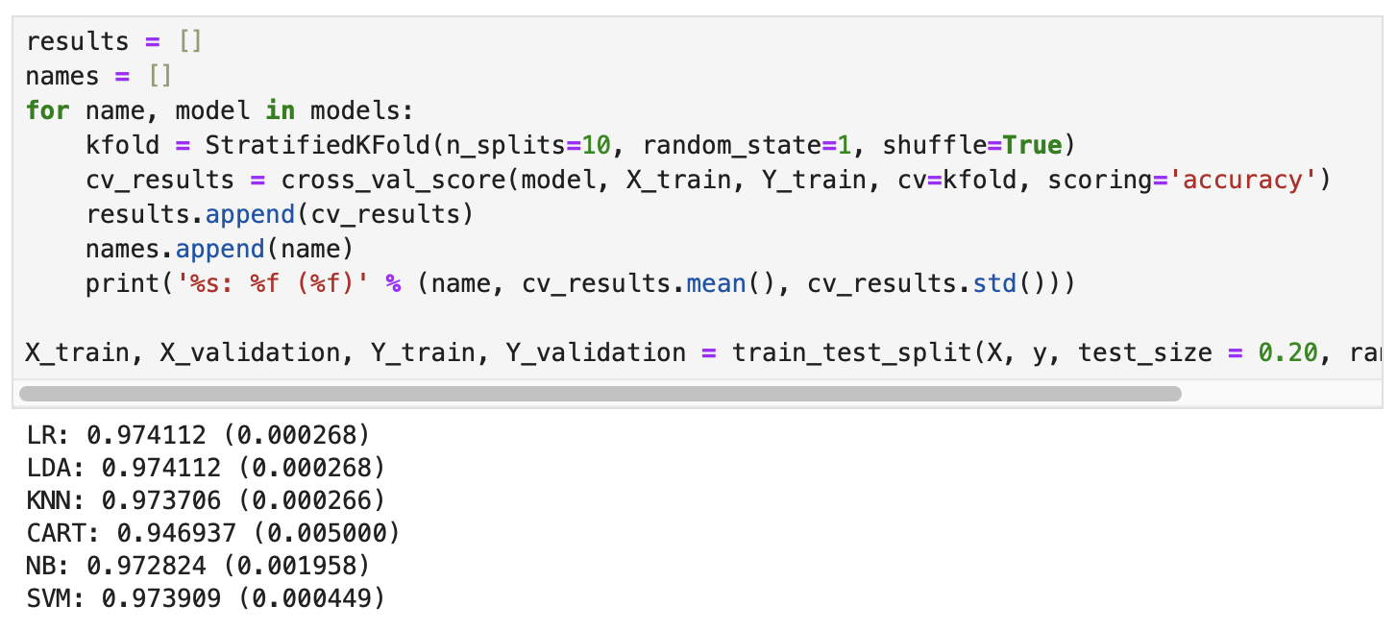

*Figure 96. Results of Machine Learning algorithms.*

* 'LR' to Logistic Regression
* 'LDA' to Linear Discriminant Analysis
* 'KNN' to K Neighbors Classifier
* 'CART' to Decision Tree Classifier
* 'NB' to Gaussian NB
* 'SVM' to SVC

The results got before the show that could be used: whatever of the functions LR, LDA, KNN, CART, NB or SVM.

The "boxplot" below shows in the graphic the difference scale between the Algorithm Comparison, however, CART - Decision Tree Classifier stands out more due to its distribution.

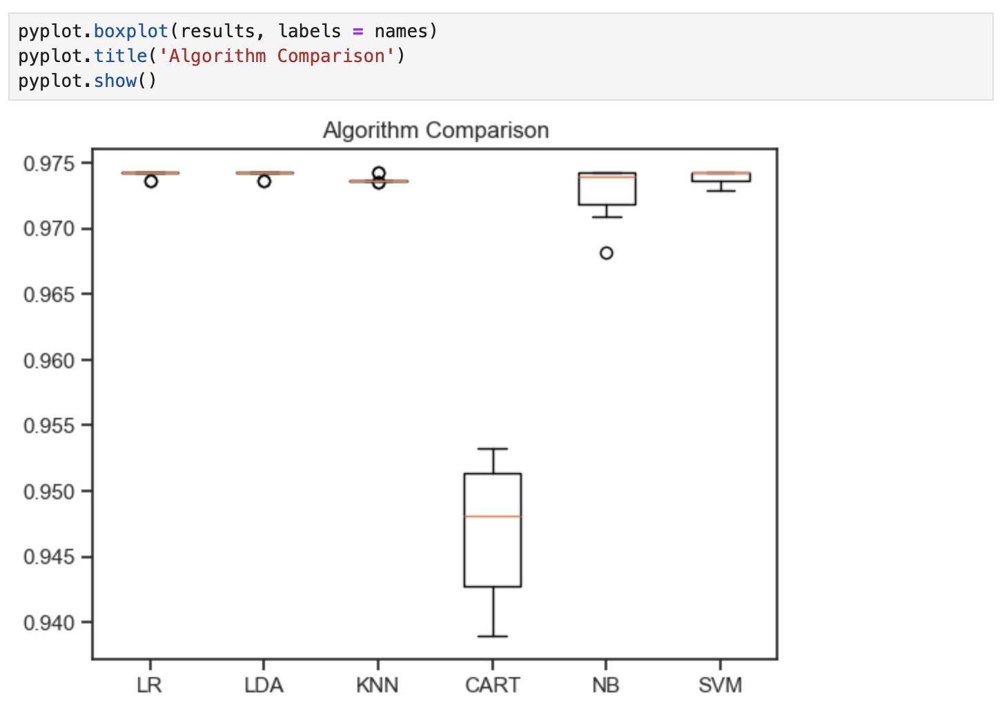

*Figure 97. boxplot of Machine Learning algorithms results.*

Next getting the results using the algorithm CART - Decision Tree Classifier to get the percentage of predictions the model can.

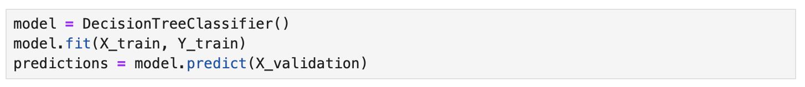

*Figure 98. model of Decision Tree Classifier.*

Printing the score of validation and predictions.



*Figure 99. Score of validation and predictions.*

Printing the confusion matrix of validation and predictions.

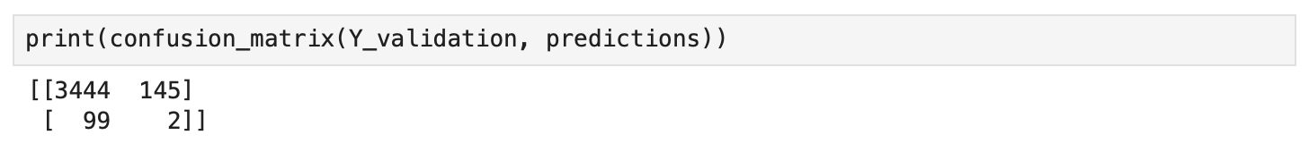

*Figure 100. Confusion matrix of validation and predictions.*

Printing the classification report of validation and predictions.

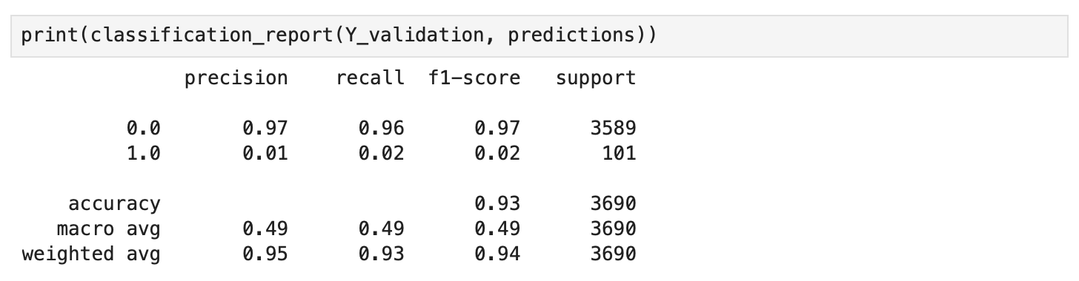

*Figure 101. Classification report of validation and predictions.*

# **CONCLUSIONS**

After finishing all analyses, understanding the chosen data dealt with the EDA data preparation by finding unique values, replacing values, dropping irrelevant columns and renaming, handling missing values, creating hypotheses for machine learning algorithms, checking duplicated, type of conversion, relationships between the features, statical analyses, encoding values, scaled the numeric values and dealt with outliers, the data it was ready to use in Machine Learn models.

Once the approach of Unsupervised learning was chosen the Principal Component Analysis (PCA) to predict the best Machine Learning algorithm to use, but first created a hypothesis for this possibility where it was created a new feature with the top 500 songs in the data frame, next prepared once again to the analyses, but this time just scaling the features, after using PCA it got a number of 7 components that should be approximately 79% of the data represented.

Next got good results in the machine learning models: Logistic Regression, Linear Discriminant Analysis, K Neighbors Classifier, Decision Tree Classifier, Gaussian NB and SVC where the tested Decision Tree Classifier after getting a plot comparison with an accuracy score of 0.93 also used an Confusion Matrix and Classification Report. Once this data frame was a good one to use, it was chosen to focus just on these approaches made until here, but there could be more analyses between the platforms Spotify and YouTube also, used some machine learning models.

# **DATA DICTIONARY**

**Track**: name of the song, as visible on the Spotify platform.

**Artist**: name of the artist.

**Url_spotify**: the Url of the artist.

**Album**: the album in wich the song is contained on Spotify.

**Album_type**: indicates if the song is relesead on Spotify as a single or contained in an album.

**Uri**: a spotify link used to find the song through the API.

**Danceability**: describes how suitable a track is for dancing based on a combination of musical elements including tempo, rhythm stability, beat strength, and overall regularity. A value of 0.0 is least danceable and 1.0 is most danceable.

**Energy**: is a measure from 0.0 to 1.0 and represents a perceptual measure of intensity and activity. Typically, energetic tracks feel fast, loud, and noisy. For example, death metal has high energy, while a Bach prelude scores low on the **scale**. Perceptual features contributing to this attribute include dynamic range, perceived loudness, timbre, onset rate, and general entropy.

**Key**: the key the track is in. Integers map to pitches using standard Pitch Class notation. E.g. 0 = C, 1 = C♯/D♭, 2 = D, and so on. If no key was detected, the value is -1.

**Loudness**: the overall loudness of a track in decibels (dB). Loudness values are averaged across the entire track and are useful for comparing relative loudness of tracks. Loudness is the quality of a sound that is the primary psychological correlate of physical strength (amplitude). Values typically range between -60 and 0 db.

**Speechiness**: detects the presence of spoken words in a track. The more exclusively speech-like the recording (e.g. talk show, audio book, poetry), the closer to 1.0 the attribute value. Values above 0.66 describe tracks that are probably made entirely of spoken words. Values between 0.33 and 0.66 describe tracks that may contain both music and speech, either in sections or layered, including such cases as rap music. Values below 0.33 most likely represent music and other non-speech-like tracks.

**Acousticness**: a confidence measure from 0.0 to 1.0 of whether the track is acoustic. 1.0 represents high confidence the track is acoustic.

**Instrumentalness**: predicts whether a track contains no vocals. "Ooh" and "aah" sounds are treated as instrumental in this context. Rap or spoken word tracks are clearly "vocal". The closer the instrumentalness value is to 1.0, the greater likelihood the track contains no vocal content. Values above 0.5 are intended to represent instrumental tracks, but confidence is higher as the value approaches 1.0.

**Liveness**: detects the presence of an audience in the recording. Higher liveness values represent an increased probability that the track was performed live. A value above 0.8 provides strong likelihood that the track is live.

**Valence**: a measure from 0.0 to 1.0 describing the musical positiveness conveyed by a track. Tracks with high valence sound more positive (e.g. happy, cheerful, euphoric), while tracks with low valence sound more negative (e.g. sad, depressed, angry).

**Tempo**: the overall estimated tempo of a track in beats per minute (BPM). In musical terminology, tempo is the speed or pace of a given piece and derives directly from the average beat duration.

**Duration_ms**: the duration of the track in milliseconds.

Stream: number of streams of the song on Spotify.

**Url_youtube**: url of the video linked to the song on Youtube, if it have any.

**Title**: title of the videoclip on youtube.

**Channel**: name of the channel that have published the video.

**Views**: number of views.

**Likes**: number of likes.

**Comments**: number of comments.

**Description**: description of the video on Youtube.

**Licensed**: Indicates whether the video represents licensed content, which means that the content was uploaded to a channel linked to a YouTube content partner and then claimed by that partner.

**official_video**: boolean value that indicates if the video found is the official video of the song.

# **References**

Albon, C. (2018). Machine learning with Python cookbook practical solutions from preprocessing to deep learning. Cambridge O’reilly.

Alex The Analyst (2023). Group By and Aggregate Functions in Pandas | Python Pandas Tutorials. [online] www.youtube.com. Available at: https://www.youtube.com/watch?v=VRmXto2YA2I&ab_channel=AlexTheAnalyst [Accessed 15 Apr. 2024].

Cereniyim (2019). Distribution plot with mean and median. [online] GitHub Gist. Available at: https://gist.github.com/cereniyim/df1c8646411cc34eb9720a79400a200f [Accessed 14 Apr. 2024].

Chun-Houh Chen and Al, E. (2016). Handbook of data visualization. Berlin: Springer.

Custer, C. (2020). Add a Column in a Pandas DataFrame Based on an If-Else Condition. [online] Dataquest. Available at: https://www.dataquest.io/blog/tutorial-add-column-pandas-dataframe-based-on-if-else-condition/.

Madhugiri, D. (2021). How To Build A Treemap In 3 Ways Using Python. [online] Analytics Vidhya. Available at: https://www.analyticsvidhya.com/blog/2021/10/how-to-build-a-treemap-in-3-ways-using-python/ [Accessed 14 Apr. 2024].

Marco Guarisco, Marco Sallustio and Salvatore Rastelli (2023). Spotify and Youtube. [online] www.kaggle.com. Available at: https://www.kaggle.com/datasets/salvatorerastelli/spotify-and-youtube/data.

Myrianthous, G. (2022). How To Remove Punctuation From Pandas. [online] Medium. Available at: https://towardsdatascience.com/remove-punctuation-pandas-3e461efe9584.

NumPy Developers (2022). Overview — NumPy v1.21 Manual. [online] numpy.org. Available at: https://numpy.org/doc/stable/index.html.

Plotly (2024a). Linear. [online] plotly.com. Available at: https://plotly.com/python/linear-fits/.

Plotly (2024b). Treemap. [online] plotly.com. Available at: https://plotly.com/python/treemaps/.

plotlygraphs (2019). Histograms. [online] plotly.com. Available at: https://plotly.com/python/histograms/.

scikit-learn developers (2024). sklearn.preprocessing.RobustScaler — scikit-learn 0.24.2 documentation. [online] scikit-learn.org. Available at: https://scikit-learn.org/stable/modules/generated/sklearn.preprocessing.RobustScaler.html.

Seaborn (2012). seaborn.kdeplot — seaborn 0.9.0 documentation. [online] Pydata.org. Available at: https://seaborn.pydata.org/generated/seaborn.kdeplot.html.

Stack Overflow (2015). pandas groupby, then sort within groups. [online] Stack Overflow. Available at: https://stackoverflow.com/questions/27842613/pandas-groupby-then-sort-within-groups [Accessed 15 Apr. 2024].

The Matplotlib Development Team (2024). matplotlib.pyplot.axvline — Matplotlib 3.8.4 documentation. [online] matplotlib.org. Available at: https://matplotlib.org/stable/api/_as_gen/matplotlib.pyplot.axvline.html#matplotlib.pyplot.axvline [Accessed 14 Apr. 2024].

The Pandas Development Team (2024a). pandas.DataFrame.agg — pandas 1.5.0 documentation. [online] pandas.pydata.org. Available at: https://pandas.pydata.org/pandas-docs/stable/reference/api/pandas.DataFrame.agg.html.

The Pandas Development Team (2024b). pandas.DataFrame.groupby — pandas 1.3.0 documentation. [online] pandas.pydata.org. Available at: https://pandas.pydata.org/pandas-docs/stable/reference/api/pandas.DataFrame.groupby.html.

The Pandas Development Team (2024c). pandas.DataFrame.sort_values — pandas 2.2.1 documentation. [online] pandas.pydata.org. Available at: https://pandas.pydata.org/pandas-docs/stable/reference/api/pandas.DataFrame.sort_values.html.

The Pandas Development Team (2024d). pandas.DataFrame.value_counts — pandas 2.1.0 documentation. [online] pandas.pydata.org. Available at: https://pandas.pydata.org/docs/reference/api/pandas.DataFrame.value_counts.html#pandas.DataFrame.value_counts.

W3Schools (2024). Matplotlib Pie Charts. [online] www.w3schools.com. Available at: https://www.w3schools.com/python/matplotlib_pie_charts.asp.

Yashmeet Singh (2022). Boxplot With Separate Y-Axis for Each Column | Proclus Academy. [online] proclusacademy.com. Available at: https://proclusacademy.com/blog/quicktip/boxplot-separate-yaxis/ [Accessed 14 Apr. 2024].